
0

LECTURE NOTES
ON

RAILWAY AND BRIDGE ENGINEERING
Compiled by
Ms.Sasmita Kumari Das
Lecturer, Department of Civil Engineering,
GANDHI ACADEMY OF TECHNOLOGY AND ENGINEERING

R&B

CONTENT

Chapter No. | TopicName | PageNo.
1 | Section –A:RAILWAYS  Introduction | 2 to 3
2 | Permanent way | 4 to 6
3 | Trackmaterials | 7 to 31
4 | GeometricforBroadgauge | 32 to 36
5 | Pointsand crossings | 37 to 41
6 | Laying&maintenanceoftrack | 42 to 44
7 | Section–B: BRIDGES  Introductions | 45 to 50
8 | BridgeSiteinvestigation,hydrology& planning | 51 to 59
9 | Bridgefoundation | 60 to 71
10 | Bridgesubstructureandapproaches | 72 to 75
11 | Permanentbridges | 76 to 86
12 | Culvert&causeways | 87 to 90

SECTIONA

RAILWAYENGINEERING INTODUCTION

Indian Railways is an Indian state-owned enterprise, owned and operated by the Government of India through the Ministry of Railways. It is one of the world's largest railwaynetworks.

RailwayswerefirstintroducedtoIndiaintheyear1853fromBombaytoThane ,nationalizedasone unit, the Indian Railways, becoming one of the largest networks in the world. IR operates both long distance and suburban rail systems on a multi-gauge network of broad, metre and narrow gauges. It also owns locomotive and coach production facilities at several places in India and are assigned codes identifying their gauge, kind of power and type of operation.

On23April2014,IndianRailwaysintroducedamobileappsystemtotracktrainschedules.

Rolling stock used on railways in the earliest days evolved fromcarriages and wagons which ran on highways to carry both people and bulk materials.
As railway experience was gained, the design of rolling stock also evolved. Springing, body structure, wheels and axles all are subject to varying loads and stresses, when comparing slower speeds on rough roads to much faster speeds on railways, with a comparatively smoother ride.
Railway rolling stock generally runs on hard wheels on hard rails. The wheels are not onlysupported by the rails but are guided by them. The only exception to this is for a small number of metros where rubber tyres have been introduced. In this case the supporting function of the rail may be separated from the guiding function.
In all casesrailwayrollingstockwill transmit vertical,horizontal and longitudinal forcestothe track and its supports. Most railways have adopted twinrails and flanged wheels. Forces aretransmitted to the rail structure either by direct bearing on the rail top from the wheel tyre, or by bearing laterally through the flange, or by longitudinal friction. Potential ‘overturning’ forces, caused by centrifugal force on curves, coupled with wind forces on exposed locations are resisted by vertical dead weight and super-elevation or ‘cant’ on curves.

Advantagesof Railways
Therailwaysoffervariousadvantagesandforthepurposeofconvenience,theycanbedescribedin following three categories.
- EconomicAdvantages
  - Employmenttopeopleintheformofstaffrequiredforsmoothworkingofrailways.
  - Encouragementtocommercialfarming.
  - Increaseincostoflandtherebyincreaseofnationalwealth.
  - Industrialdevelopmentandgrowthbecauseofmobilityoflabourandrawmaterials.

  - Stabilizationofpricesduetoeasy,speedy&efficientmobilityofproducts&natural resources.
  - Increaseinmobilityofpeopleandtherebyrelievingsomeextentthecongestionofbigcities.
  - Transportingfoodandclothesintimesofemergencieslikefloodsandfaminesetc.
- PoliticalAdvantages
  - Easycontrolofthecentraladministration.
  - Developmentofanationalmentalityinthemindsofpeople.
  - Migratingpopulationonamassscale.
  - Mobilizingtroopsandwarequipmentintimeofwarandemergencies.
  - Unityofpeopleofdifferentcastes,customsandreligions.
- SocialAdvantages
  - Broadeningthesocialoutlookofmassesaspeoplecanvisitallthepartsofcountryandbe proud of this great country.
  - Easyaccesstoreligiousplacesofimportance.
  - Providingconvenientandsafemodeoftransport.
  - Removaloffeelingofisolationastherailwayhasprovedtobethemostsafe,economicand comfortable mode of conveyance.

ClassificationofIndianRailways

Indianrailwaysystemsaccordingtothreeclasses:-

Class I- RailwayswithgrossannualearningsofoverRs50lakhs(Rs50,00,000).¹ Class II - Railways with gross annual earnings of between Rs 10 and 50lakhs.
ClassIII-RailwayswithgrossannualearningsofunderRs10lakhs.

CHAPTER-2

Permanent way
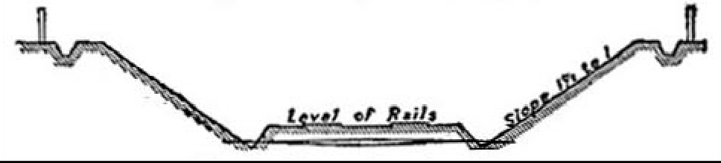

TypicalSectionofRailwayincutting.

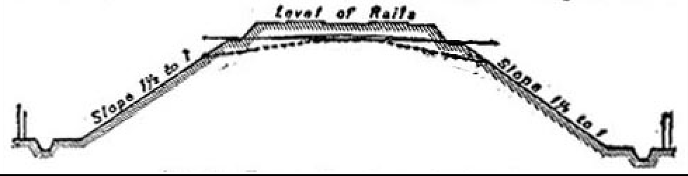

TypicalSectionofRailwayinembankment.
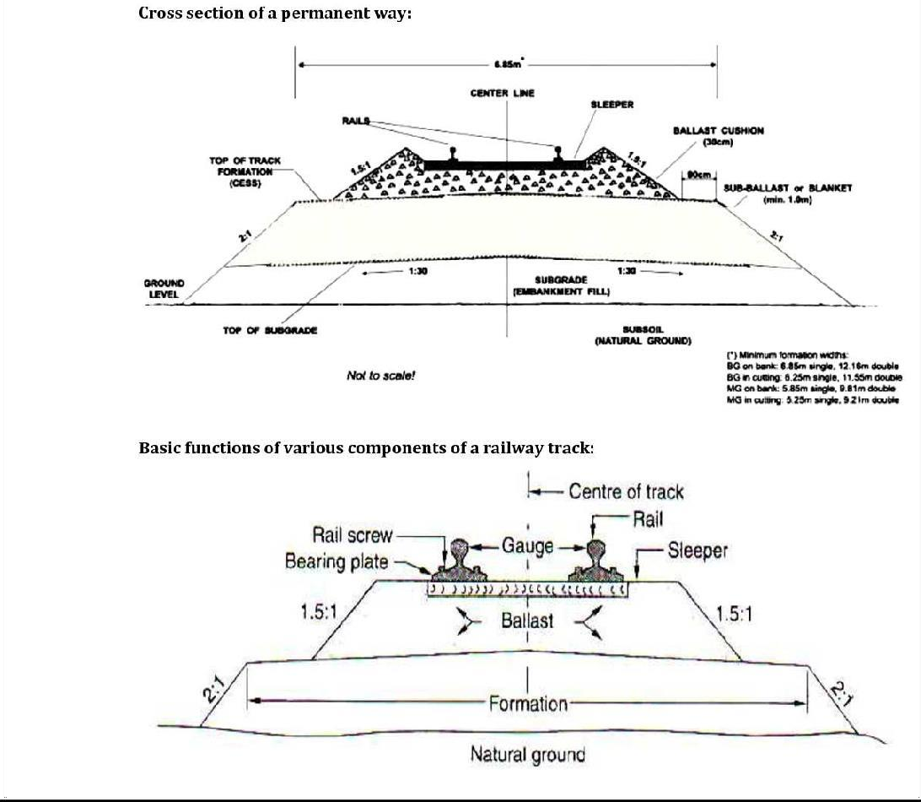

ThefinishedorcompletedtrackofarailwaylineiscommonlyknownasPermanentWay.Itessentially consists of following three parts.

- Rails
- Sleepers
- Ballast

The rails are fixed with each other by means of various rail fastenings and they rest on sleepers which are laid at right angles to them. The sleepers in turn rest on ballast which is spread over the formation ground prepared for the railway track.

Requirementsofanidealpermanentway
- Thegaugeoftrackshouldbeuniformandthereshouldnotbevaryinggauges.
- Thereshouldbeminimumfrictionbetweenthewheelsofrollingstockand therails.
- Facilitiesshouldbeprovidedatvariouspointsalongthepermanentwaytorepair,replaceorrenew the damaged portion of the track.
- Thedesignofthepermanentwayshouldbesuchthattheloadofthetrainisuniformlydistributed over it.
- Thecomponentsofthepermanentwayshouldbesoselectedastoproduceapermanentwaywitha certain degree of elasticity to prevent the shocks due toimpact.
- Thegradientprovidedonthepermanentwayshouldbeevenanduniform.
- Thespecialattentionshouldbegivenonthedesignofpermanentwayoncurves.
- Theoverallconstructionofthepermanentwayshouldbesuchthatitrequiresminimum maintenance.
- Thepermanentwayshouldpossesshighresistancetodamageatthetimeofderailment.
- Thedrainagefacilityshouldbeperfect.
- Therailjointsshouldbeproperlydesignedandmaintained.
- Theprecautionsshouldbetakentoavoidtheoccurrenceofcreep.
- Variouscomponentsofthepermanentwayshouldpossessanti-sabotageandanti-theftqualities.

RailGauges
In India, the gauge of a railway track is defined as the clear minimum perpendicular distance between the inner faces of the two rails.
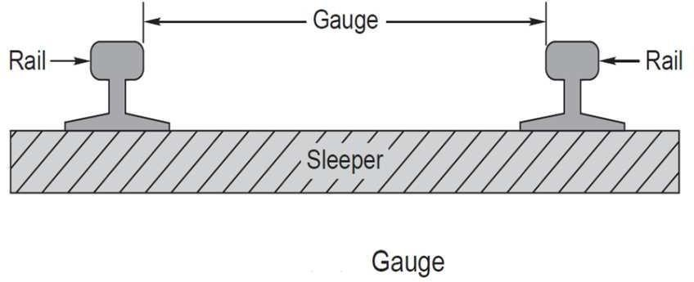

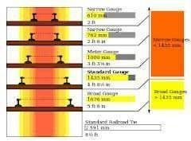

ThedifferentgaugesusedinIndiacanbebroadlyclassifiedasfollowingfour types.

- BroadGauge:Width1676mmto1524mm.
- StandardGauge: Width1435mmand1451mm.
- MeterGauge:Width1067mm,1000mmand915mm.
- NarrowGauge:Width762mmand610mm.

Suitabilityofthesegaugesunderdifferentconditions

- TrafficconditionIftheintensityoftrafficonthetrackislikelytobemore,agaugewider htanthestandardgaugeissuitable.
- Development of poor areas  The narrow gauges are laid in certain parts of the world to developa poor area and thus link the poor area with the outsidedeveloped world.
- CostoftrackThecostofrailwaytrackisdirectlyproportionaltothewidthofgauge.Hence,if the funds available is not sufficient to construct a standard gauge, a meter gauge or a narrow gauge is preferred rather than to have no railways at all.
- Speedof movement Thespeedofatrainisafunctionofthediameter of wheelswhichin turnis limitedbythe gauge.Thewheel diameter isusuallyabout 0.75times thegauge widthandthus,the speed of a trainis almost proportional to the gauge. If higher speeds are to be attained, the B.G. track is preferred to the M.G. or N.G. track.
- NatureofCountryInmountainouscountry,itisadvisabletohaveanarrowgaugeoftracksnice itismoreflexibleandcanbelaidtoasmallerradiusonthecurves.Thisisthereasonwhysome important railways, covering thousands of kilometers, are laid with a gauge as narrow as 610mm.
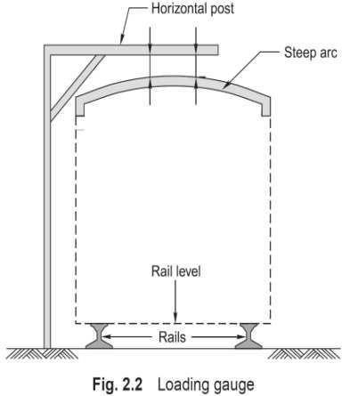

CHAPTER-3

TRACK MATERIALS

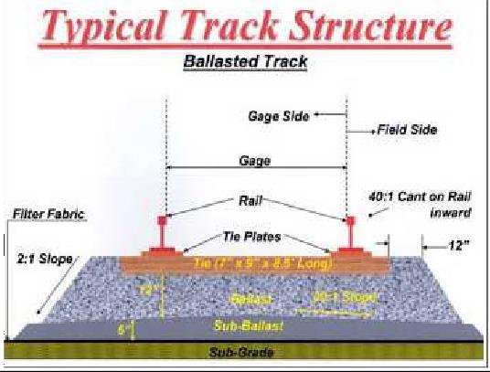

RAILS
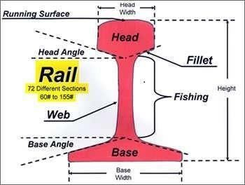

Functionof Rails

Totransmitthemovingloadstothesleepers

Toprovidestrong,hardandsmoothsurfaceforthetrainjourney.

Tobearthestressesdevelopedinthetrackduetotemperaturechangesandloadingpatterns. To serve as lateral guide to the running wheels.
Toresistbreakingforcescausedduetostoppageoftrains.

RequirementsofanIdealRail
- The rail section consists of three components: head, web and foot. It should be designed foroptimum nominal weight to provide for the most efficient distribution of metal in its various components.
- The bottom of head and top of the foot should be given such shapes that fish-plates can easily be fitted.
- The C.G. of the rail section should be located very near to the centre of height of rail so that maximum tensile and compressive stresses are more or less thesame.
- Thedepthofheadofrailshouldbesufficienttoallowforadequatemarginofverticalwear.
- Therailshouldpossessadequatelateralandverticalstiffnesses.
- Thereshouldbebalanceddistributionofmetalinthehead,web andfootofrailsothateachofthem is able to fulfill its assignedfunction.
- Thesurfaceofrailtableandgaugefaceofrailshouldbehardandshouldbecapableofresisting wear.
- Thethicknessofwebofrailshouldbesufficienttotakesafelytheloadcomingontherail.

TYPESOFRAILSECTIONS

Doubleheadedrails:

These were the rails which were used in the beginning, which were double headed and consisting of a dumb-bellsection.Theideabehindusingtheserailswasthatwhentheheadwasworn outincourseoftime, the rail can be inverted and reused. But as time passed indentations were formed in the lower table due to which smooth running over the surface at the top was impossible.

Bullheadedrails:

Inthistypeofrailtheheadwasmadealittlethickerandstrongerthanthelowerpartbyaddingmore metal to it, so that it can withstand the stresses.

Flatfootedrails:

These rails are also called as vignole's rails. Initially the flat footed rails were fixed to the sleepers directlyand no chairs and keys were required. Later ondue to heavytrain loads problems arose which lead tosteel bearingplatesbetweenthesleeper andtherail.at railjointsandother important placesthesearethe rails which are most commonly used in India.

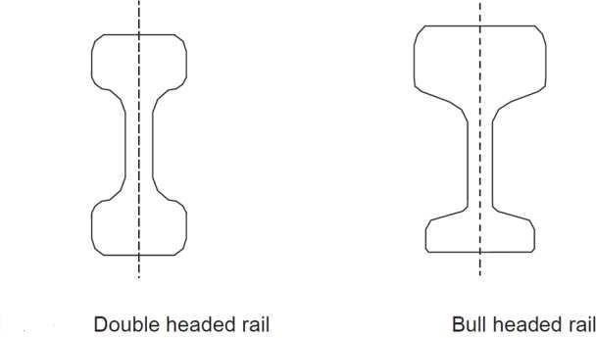

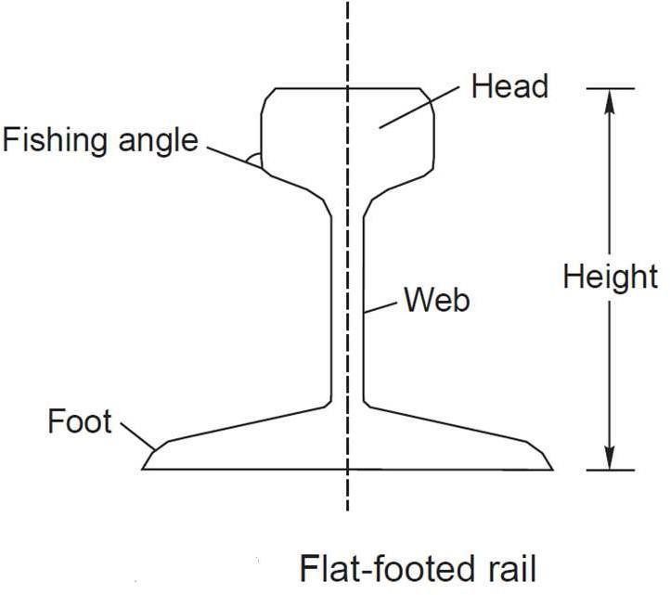
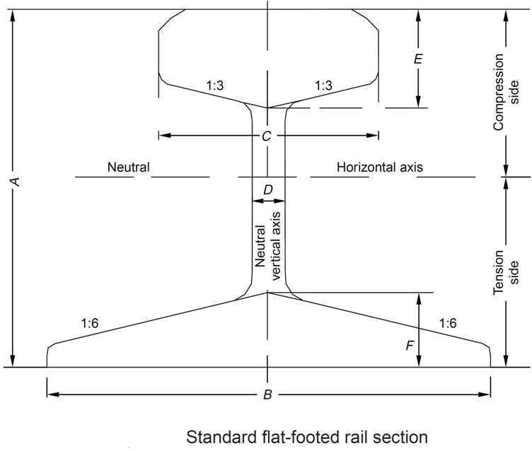

LengthoftheRails:
From the consideration of strength of the track maximum possible length is advisable as it will reduce the number of the joints, less number of fittings and fixtures and economical maintenance. But in practice the following factors are considered to decide the length of rails.

  - Easeoftransportation
  - Reasonablecostof manufacture
  - Easeinloadingintotheavailablewagons
  - Developmentoftemperature stresses
IndianRailwayshaveadoptedthefollowinglengthofrailsinpractice.
- ForBGtracks=13 m(42’)
- ForMG&NGtracks=12m(39’)

RailJoints

Railjointsarenecessarytoholdtheadjoiningendsoftherailsin thecorrectposition,bothinthehorizontal and vertical planes.

TypesofRailjointsThefollowingarethetypeofrailjoints

Supportedrailjoints:

Whentherailendsrestonasinglesleeperitistermedassupportedjoint.Theduplexjoint sleeperwithother sleepers is an example of the supported joint.

Suspendedrail joint:

Whenrailendsareprojectedbeyondsleepersitistermedassuspendedjoint.Thistypeofjointisgenerally used with timber and steel through sleepers.

Bridgejoints:

Whentherailendsareprojectedbeyondsleepersasinthecaseofsuspendedjointandtheyareconnectedby a flator corrugated plate called as bridge plate it is termed as a bridge joint.

Insulatedjoint:

Whenaninsulatingmediumisinsertedinarailjointot stoptheflowofcurrentbeyondthetrackcircuited part then that type of joint is called an insulated joint.

Compromisejoint:

Wheretwodifferentrailsectionsarerequiredtobejoinedtogether itisdonebymeansoffishplatedwhich fit both rails and this joint is termed as compromise joint.

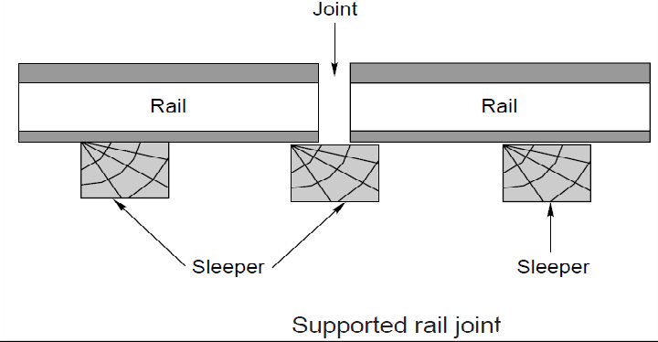
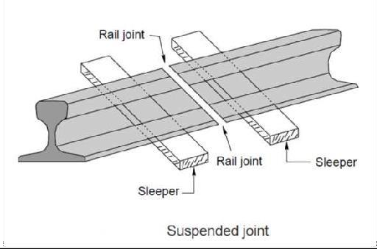
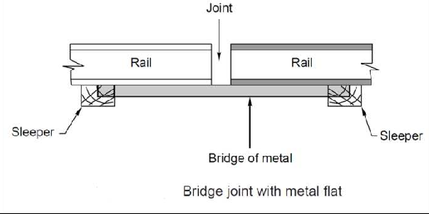
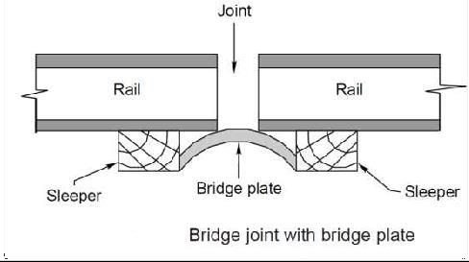

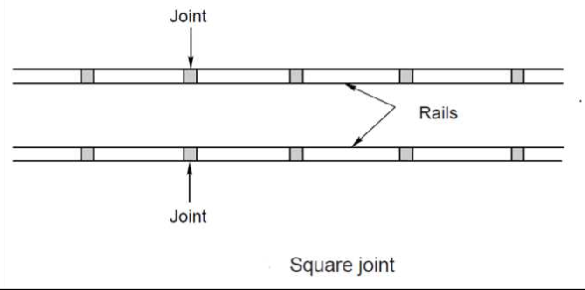

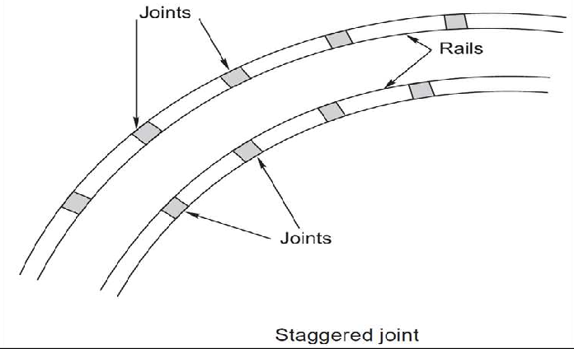

RequirementsofanIdealRailJoint
- Endstoremaintrue
- Shouldbestrongandstiff
- Provisionforexpansion
- Perfectlyelastic
- Endsshouldnotgetbattered
- Provisionforeasyremovalandreplacement
- Economicalin cost

PurposeofWeldingofRails
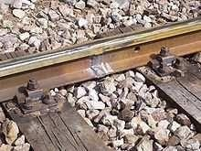

Welded rail joint Purposeofwelding:
- Toincreasethelengthoftherails
- Torepairthewornoutor damagedrails
- Tobuildupwornoutpointsandrailsonthesharpcurves

Advantagesofweldingrails:

- Reducesthecreepandfrictionduetoincreaseinlengthofrail.
- Expansioneffectduetoreductionintemperature.

- Increasethelife oftherailsduetodecreaseinwear.
- Itfacilitatestrackcircuitingonelectrifiedtracks.
- Thecostdecreasebecauseasthelengthincreaseautomaticallythenumberofjointsdecreases.
- Highfrequencyvibrationsduetoheavymovingloadsaredecreasedduetotheheavinessof therails.

CREEP
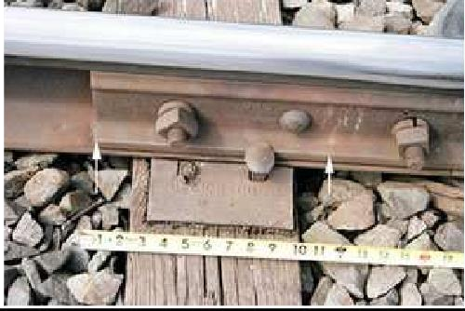
Creepinrailsdenoteslongitudinalmovementofrailsinthetrack.
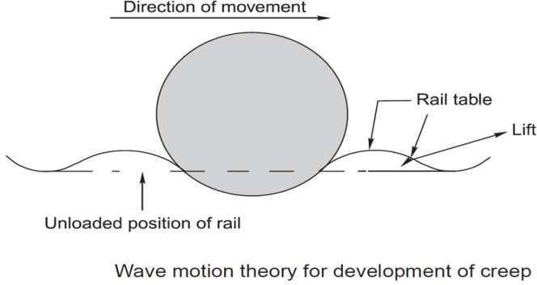
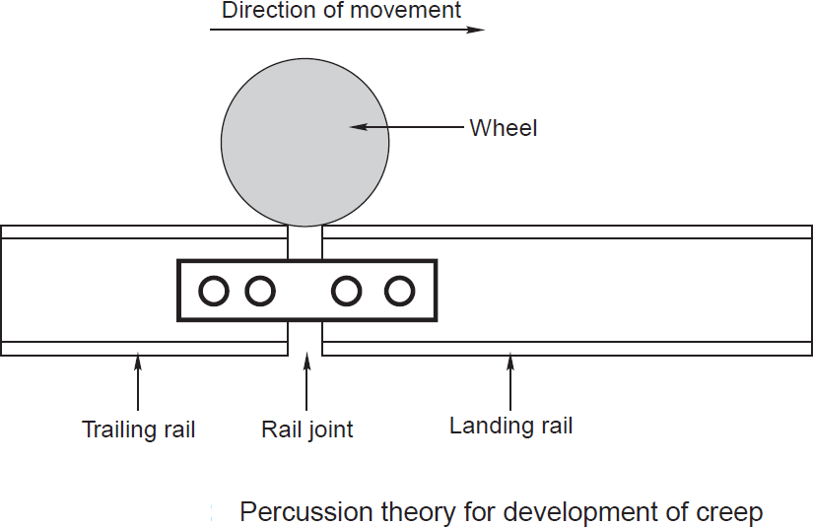

ThefollowingfigureshowsatypeofFairV-anchorwhichisusedinthetracktopreventcreepof rails.
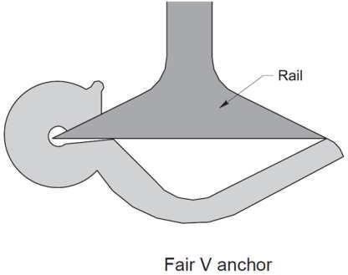

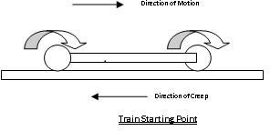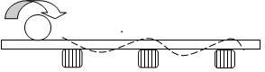

Itisdefinedasthelongitudinalmovementofrailswithrespecttosleepersinatrack.

Causesof creep:

- Closingofsuccessiveexpansionspacesatrailjointsinthedirectionofcreepandopeningout of joints at the point from where the creep starts.
- Marksonflangesandwebsofrailsmadebyspikeheadsbyscrapingorscratchingastherailsslide.

EffectsofCreep:

- Sleepersmoveoutofpositionwhichleadstothechangeingaugeandalignmentofthetrack.
- Railjointsareopenedoutoftheirlimit insomecaseandstressesaresetupinfishplatesandbols which leads to the breakage of the bolts.
- Pintsandcrossingsgetdisturbed.
- Maintenaceandreplacementoftracksbecomesdifficult.
- Smashingoffishplatesandbolts,bendingofbars,kinksat jointsareothereffectsofcreep.

Sleepers&Ballast

Definition:
Sleepers (known in the US as railroad ties) are used as a base for laying railway tracks. Sleepers were traditionallymade fromwood butare nowusuallymade fromconcrete.Ties arelaid ontop of sand,gravel or heavy crushed stone - called ballast.

Functionsofsleepers

Thefunctionsofsleepersareasfollows

- Toholdtherailsincorrectgaugei.e.exactgaugeinthecaseofstraightandflatcurves,loose gauge in the case of sharp curves and tight gauge in the case of diamondcrossings.
- Toactasanelasticmediumbetweentheballastandrailtoabsorbtheblowsandvibrationsof moving loads.
- Theyalsoaddtothelongitudinalandlateralstabilityofthepermanenttrackonthewhole.
- Theyalsoprovidemeanstorectifytrackgeometryduringservicelife.
- Tosupporttherailsatproperlevelinstraighttracksandatpropersuperelevationoncurves.
- Todistributetheloadfromtherailstotheindexarea ofballast underlyingit ortothegirdersinthe case of bridges.
- Toholdtherailsinproperlevel.

RequirementsofGoodSleepers

- Itshouldbe economical
- Itshouldbeminimumpossibleinitialandmaintenancecosts.
- Thefittingsshouldbesuchthattheycanbeeasilyadjusted.
- Weightshouldnotbetooheavyortoolight.
- Itshouldnotbeeasilydamagedbyanti-Nationals.
- Theyshouldbecapableofresistingshocksandvibrations.
- Theinsulationofrailsshouldbepossiblefortrackcircuiting,ifrequired throughsleepers.
- Itshouldbedesignedthatitcouldnotbedisturbedfromitspositioneasilybythepassageoftrains.

Classificationof Sleepers

Sleeperscanbeclassifiedintothefollowingtypesaccordingtothematerialof construction.

Woodensleepers

- Metalsleepers

  - Castironsleepers
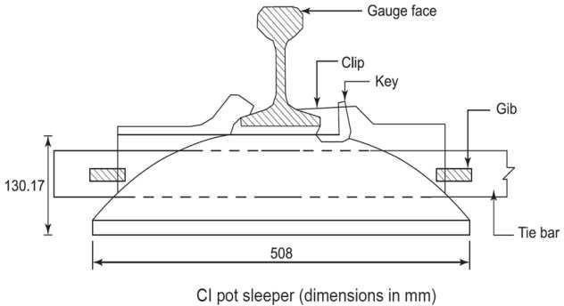

Steelsleepers

- Concretesleepers

  - Reinforceconcretesleepers
  - Prestressedconcretesleepers

TimberorWoodenSleepers
Woodensleepersareregardedasthebest astheysatisfyalmost alltherequirementsofagoodsleeper.The life of timber sleepers depend upon their ability to resist

  - Wearandtear
  - Decay
  - Attackbywhiteants
  - Qualityofthetimberused

Advantages:

ItiseasilyavailableinallpartsofIndia Fittings are few and simple in design
Theyareeasytolay,relay,pack,liftandmaintain They are suitable for all types of ballast
Theyare abletoresist the shocks and vibrationsoftheheavymovingloads They are economical

Disadvantages:

Theyare subjected todecay, attackbywhiteants, warping, crackingandend splitting It is difficult to maintain the gauge in the case of wooden sleepers.
Itisdifficulttomaintainthealignmentinthecaseof woodensleepers.

Theyhavegotminimumservicelife(12to15yrs.)ascomparedtoothertypesofsleepers

CastIronsleepers
Cast iron sleepers are widely used in the world especially in Indian railways. They are available in 2 types, pot type sleepers and plate type sleepers. Pot type sleepers are not suitable for curves sharper than 4 degrees. Cast iron plate type sleepers are more famous in Indian railways.

Advantages:
- Servicelifeisverylong
- Lessliabletocorrosion
- Formgoodtrackforlighttrafficupto110kmphastheyformrigidtracksubjectedtovibrationsundermoving loads without any damping
- Scrapvalueishigh

Disadvantages:
- Gaugemaintenanceisdifficultastiebarsgetbentup
- Notsuitableforcircuitedtrack
- Needlargenumberoffittings
- Suitableonlyforstoneballast
- Heavytrafficandhighspeeds(>110kmph)willcauselooseningofkeysanddevelopmentofhighcreep

ConcreteSleepers

Concrete sleepers are made of a strong homogeneous material, impervious to effects of moisture and unaffected by the chemical attacks. It is moulded easily to size and shape required and it is an ideal material to with stand stresses introduced by fast and heavy traffic.

Advantages

- Theconcretesleepersarequiteheavyandthusprovidelongitudinal,lateralandverticalstability. Because of their weight, these sleepers are more suitable to LWR(Long Welded Rail)tracks.
- Theconcretesleepersresultinreducedrailbendingstresses.
- Theconcretesleepersreducethe wearofrollingstocks.
- Theconcretesleepersproducelessverticalmotionandthusprovideacomfortablejourneydueto less noise.
- Theconcretesleepershaveflatbottoms.That’swhymeanmodernmethodoftrackmaintenancei.e. MSP (Measured Shovel Packing) and machine maintenance can be suitably employed.
- Theconcretesleepersareneitherinflammablenorsubjectedtodamagebycorrosionortermite.
- Thesesleepershavealongusefullifeof50years.Itmeansrailandsleeperrenewalscanbe matched.
- Theconcretesleeperswiththeirfasteningsystemmaintaingauge,crosslevels,twist,alignment, longitudinal level and unevenness of the track.
- Theconcretesleepersaresuitablefortrackcircuiting.
- Theconcretesleeperscanbemanufacturedfromlocalresources.

Disadvantages

- Theyarenoteconomicalbecauseofhighcostofconstruction.
- Incaseofderailments,heavydamageiscaused.
- Highstandardofmaintenanceoftrackisrequired.
- Thedesignandconstructionarebothcomplicated.
- Theyaremorerigid.
- Theydonot haveanyscrapvalue.

Steelsleepers
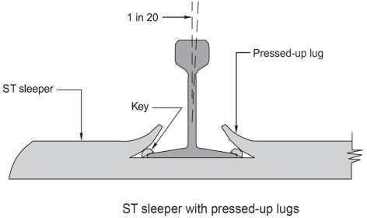

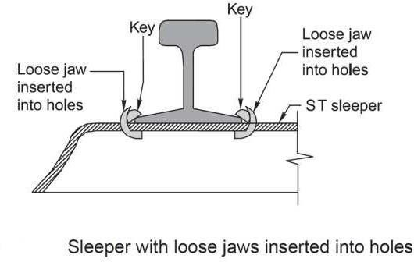

Steelsleepersarelightweight,dimensionallymoreaccuratethanwoodenorconcreteandregardedasan effective technical solution for modern rail networks.

AdvantagesofsteelSleepers

- Theyaremanufacturedbyasimpleoperation.
- Theycanbeeasilyhandledasthesearelightinweightascomparedtoothertypesofsleepers. Hence, damages during handling and transporting are less.
- Lessnumberoffasteningsarerequiredandthattoosimpleinnature.
- Themaintenanceandadjustmentofgaugeareeasyascomparedtotheotherofsleepers.
- Thesesleepersarerolledsectionsinonepiece.
- Theirlifeislongerthanthatofothertypesofsleepers.
- Theyprovidebetterlateralrigiditytothetrack.
- Theyarenotattackedbyvermin.
- Theyarenotsusceptibletofirehazards.
- Theirscrapvalueisgood.

DisadvantagesofSteelofSleepers

- Thesteelsleeperspossessthefollowingdisadvantages:
- Theygeteasilyrustedandcorroded.
- Theydevelopcracksatrailseatsornearlugs.
- Theirlugsgetbrokeneasily.
- Thesteelsleepersdonotprovideeffectivetrackcircuiting.
- Thesteelsleeperscanonlybeforthetypeofrailsforwhichthesesaremanufactured.
- Thesedevelopthetendencytobecomecenterboundbecauseofslopeatbothends.
- Theoverallcostofsteelsleepersismorethanthatoftimbersleepers.

Ballast

Definition:
Itisalayerofbrokenstones,graveloranyothersuchgrittymateriallaidandpackedbelowandaround sleepers.

Functionsofballast:

  - Todistributetheloadsuniformlyoverthesubgrade.
  - Toprovidegooddrainageforthetrackstructure.
  - Toprovideelasticityandresiliencetotrackforgettingproperridingcomfort.
  - Toheldthetrackstructuretolineandgrade.
  - Toreducedust.
  - Topreventgrowthofbrushandweeds.

RequirementsofGoodBallast

- Itshouldbetoughandshouldnotcrumbleunderheavyloads.
- Itshouldnotmakethetrackdustyormuddy.
- Itshouldofferresistancetoabrasionandweathering.
- Itshouldnotproduceanychemicalreactionwithrailsandsleepers.
- Thematerialsshouldbeeasilyworkable.
- Itshouldretainitspositionandshouldnotbedistributed.

MaterialsusedasBallast

- Broken Stone Broken stone is one of the best materials for railway ballast to be used on the railway tracks. Almost all the important railway tracks are provided with broken stone. The stone to be used as railway ballast should be hard, tough nonporous and should not decompose when exposed to air and light. Igneous rocks like quartzite and granite forms the excellent ballast materials. When these are not available then lime stone and sand stone can also be used as good ballast material.
AdvantagesofBrokenStone
  - Itholdsthetrackinposition
  - Itisgoodforheavy traffic
  - Itcanservehighspeedsequallywell. Disadvantages of Broken Stone
- Themaindisadvantageisthatitisexpensiveinitsinitialcost.
- GravelGravelranksnextinitssuitabilityforuseasmaterialsforballastandisusedinmany countries of the world in very large quantities. Gravel consists of worn fragments of rocks occurring in naturaldeposits. Gravel or shingle may be obtained from river bed or it may be dug out from gravelpits.

AdvantagesofGravel
  - Itischeaperinitscostasithasnottobebrokenaslikestoneballast
  - Ithasgotexcellentdrainageproperties,ifproperlycleaned Disadvantages of Gravel
- Iteasilyrollsdownunderthevibrationsandpackingunderthesleepersgettense
- Thevariationinsizeisconsiderableandhencerequiresscreeningbeforeuse
- Grovelasobtainedfromgravelpits,isfullofearthandhencerequirespropercleaningifproper drainage of the track is to bedone.
- CindersOrAshesTheresiduefromthecoalinlocomotivesorotherfurnacesiscalledcinderorashes. Itisoneoftheuniversalformsofballastasitisabyproductofalltherailwaywhichusescoalasafuel.
AdvantagesofCindersorAshes
  - Handlingofthematerialisnotcumbersomethismaterialcanbehandleeasily
  - Costisverylowandhencecanalsobeusedforsidings
  - Ithasgotfairlygooddrainageproperties
  - Largequantitiesofthismaterialcanbemade availableatshortnotice.
  - In case of emergence such as caused by the destruction of portion of railway track during floods. This material proves to be very useful and is used in the formation repairing as well as for packingof track.
DisadvantagesofCindersorAshes
- Itishighlycorrosiveandcannotbeusedwheresteelsleepersarefixed
- Thefootoftherailsgetaffectedduetouseofthistypeofmaterialasballast
- Itisverysoftandcaneasilybereducedtopowderundervibrationsandhencethe trackbecomes very dusty. This is objectionable particularly in dryweather.
- SandSandisanothergoodmaterialsforrailwayballast,coarsersandistobepreferredtofinersand and the best sand is that which contains a quantityof fine gravel varying in size from1/8upwards.
AdvantagesofSand
  - Ifthesandisfreefromearthandvegetationthenithasgoodexcellentpropertiestodrainoff water immediately
  - Itischeaperifavailableinnearbylocality
  - Itproducesverysilenttrackandhencearesuitableforpackingcastironpotsleepers. Disadvantages of Sand
- Itgetseasilydisturbedundervibrationsandhenceitsmaintenanceisverydifficult
- Thesandcanbeeasilywashedofforblownawayandhencerequiresfrequentrenewal.
- Thesandparticlesmayget intothemovingpartsofthevehiclesandproducesfriction.Thisleads to heavy wear of vehicles.
- KankarKankaralimeagglomerateisfoundinmanyplaces intheform of nodules of varyingsizes. Advantages of Kankar
  - KankarissuitableMaterialsforballastwhenothergoodmaterialforballastisnotavailableorif available

uneconomically.
  - Kankarisgoodforlighttrafficonmetreandnarrowgauges Disadvantages of Kankar
- Itisverysoftandcanbereducedtopowderformeasily,hence,makingthetrackdusty.
- Themaintenanceoftrackisverydifficult
- Moorum  The decomposition of laterite results intothe formation of moorum. It has redandsometimes yellowcolor. Thebest moorum is thatwhich containslargequantitiesof small laterite stones.
AdvantagesofMoorum
  - Moorumisgoodmaterialsforballastwhenothermaterialforballastisnotavailable.
  - Moorumcanbesafelyusedonnewlylaidtrackandactsasasolingwhenbrokenstonesarelaid afterwards.
  - Moorumhasgotgooddrainageproperties Disadvantages of Moorum
- Moorumisverysoft andreducestopowderandhencetodustforminshorttime.
- Maintenanceoftrackslaidwiththismaterialisdifficult
- BrickBallastOrBrickBatsSometimesthebrokenpiecesofoverburntbricks,calledbrickbats,are used as materials for ballast.
AdvantagesofBrickBallast
  - Ithasgotexcellentdrainageproperties
  - Theycanbeusedasgoodballastmaterialwheresuitablematerialforballastiseither unavailable or uneconomical
DisadvantagesofBrickBallast
- Brickbatsturndownintopowderformeasilyandhencethetrackbecomesdusty
- Maintenanceofthetracklaidwiththismaterialasballastisverydifficult.
- Railsareoftencorrugatedonthetracks laidwiththismaterialasballast
- SelectedEarthSelectedearth maybeused asmaterialforrailwayballastfor sidingsand also fornewly laid tracks.

TrackfixturesforBG

Railjoints–Fishplates –Fishbolts-Fangbolts-Hookbolts–Railchairsandkeys–Bearingplates– Blocks – Spikes-Elastic fastenings- Anchors & Anti creepers

Fastening

A rail fastening system is a means of fixing rails to railroad ties. The terms rail anchors, tie plates, chairs and track fasteners are used to refer to parts or all of a rail fastening system. Various types of fastening have been used over the years.

FishPlates
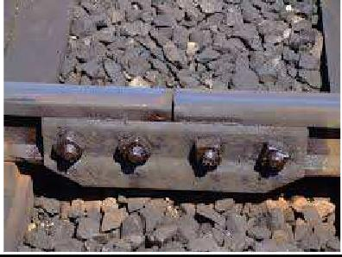

In rail terminology, a fishplate, splice bar or joint bar is a metal bar that is bolted to the ends of two rails to join them together in a track. The name is derived from fish, a wooden bar with a curved profile used to strengthen a ship's mast. The top and bottom edges are tapered inwards so the device wedges itself between the top and bottom of the rail when it is bolted into place. In rail transport modelling, a fishplate is often a small copperornickelsilver platethat slips ontobothrailsto providethe functions ofmaintainingalignment and electrical continuity.
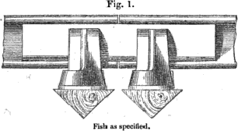

Thefirstrailwayfishplate

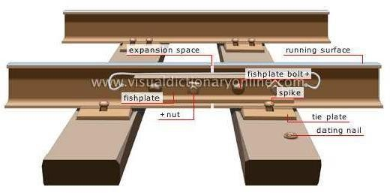

RAIL-TO-RAILFastenings

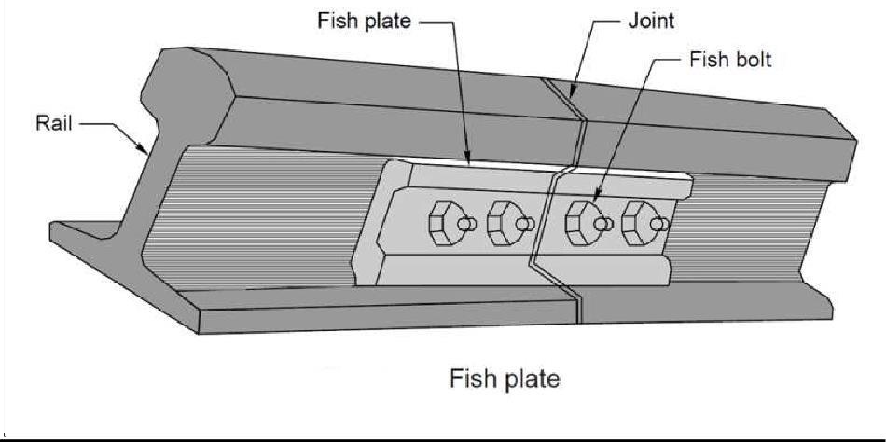

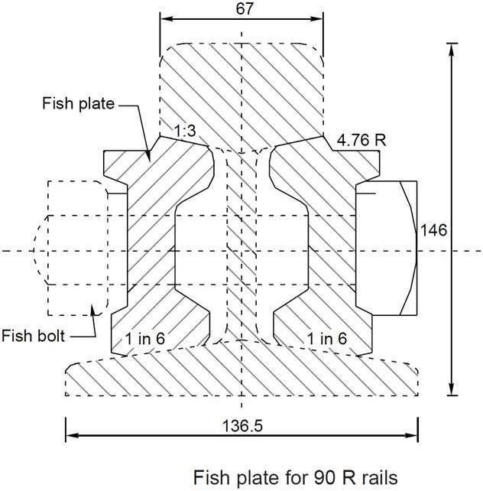

CombinationFishPlates

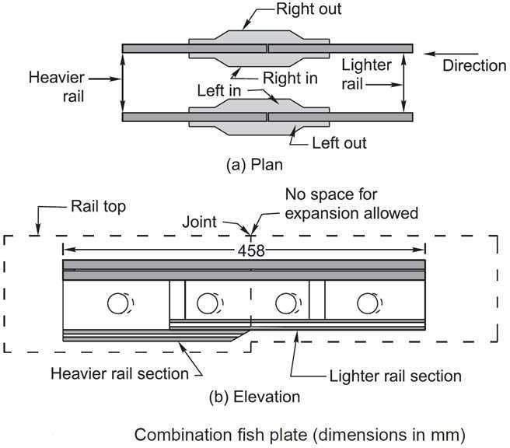

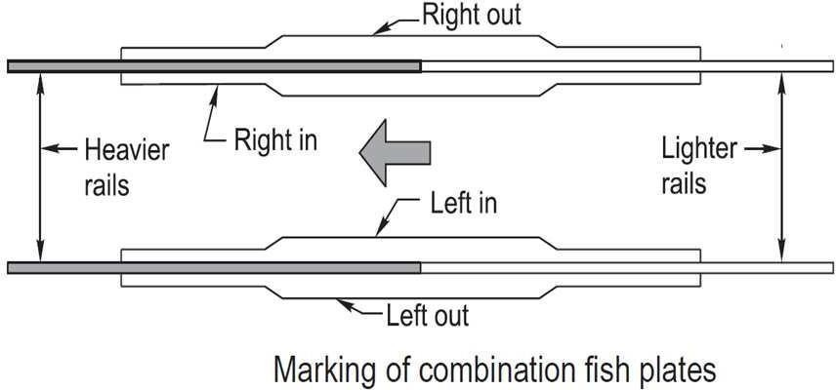

FangBolts

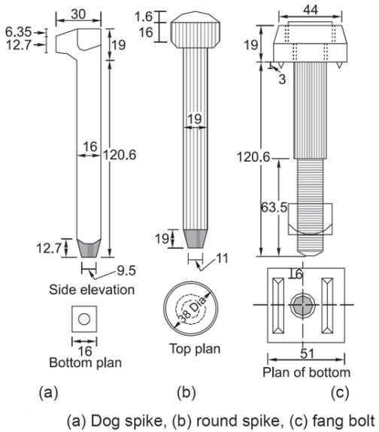

*ScrewSpikes/

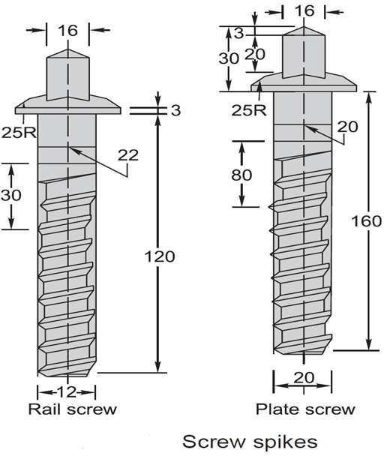

BearingPlates

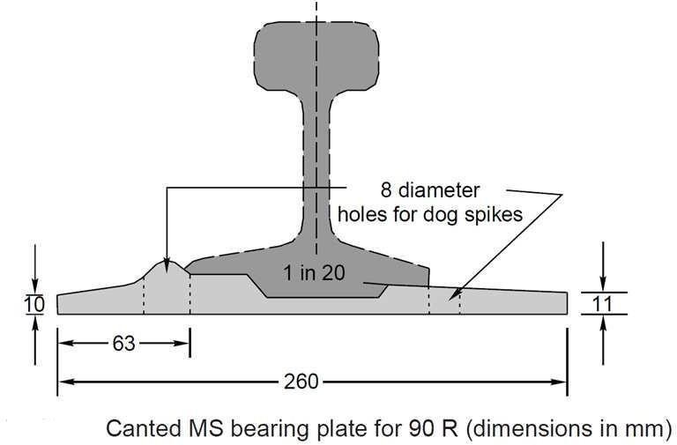

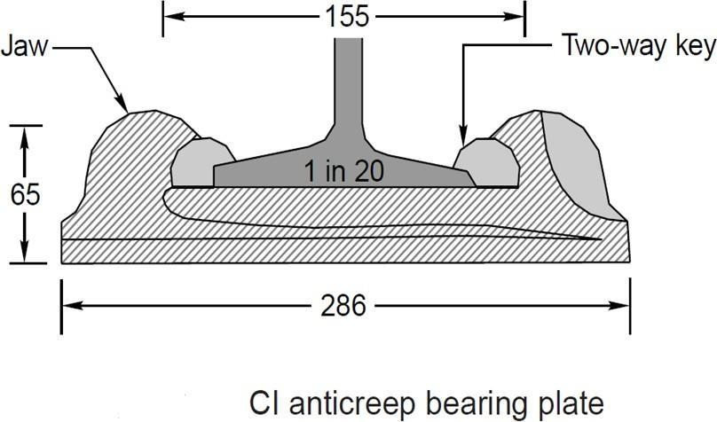

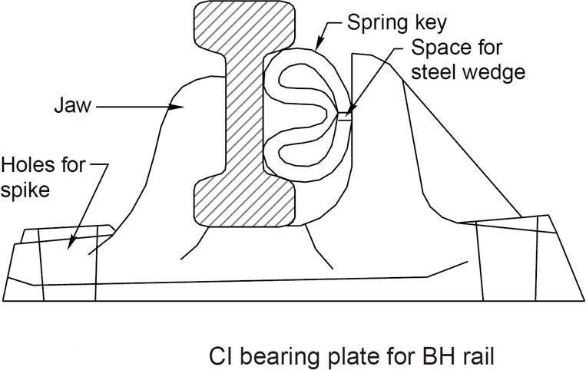

Fittingsof SteelTroughSleepers

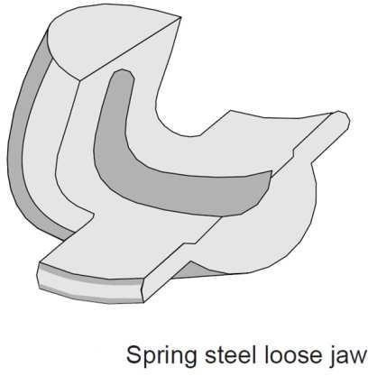

STEELSLEEPERSFITTINGS

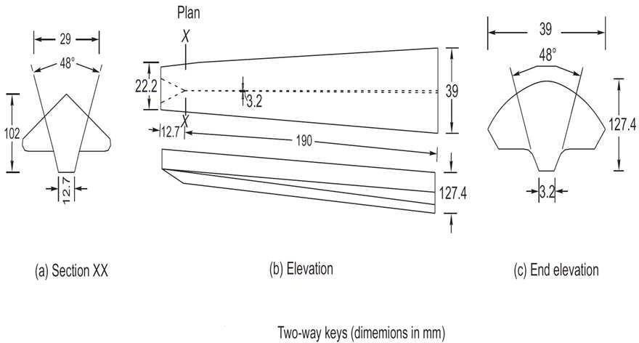

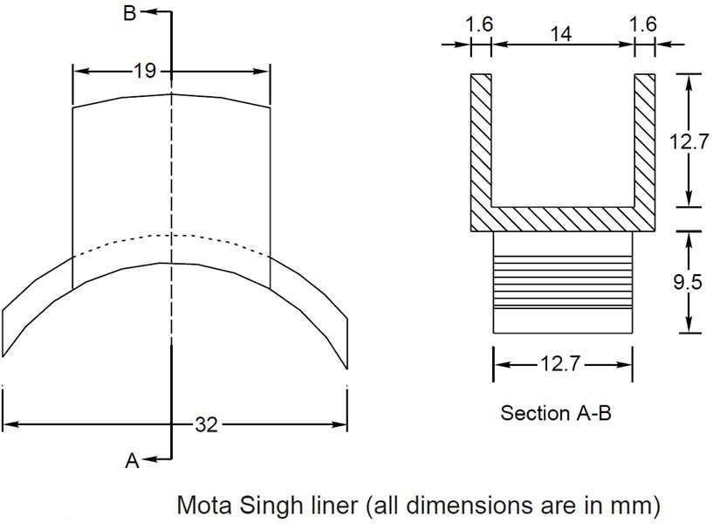

CASTIRONSLEEPERFITTINGS
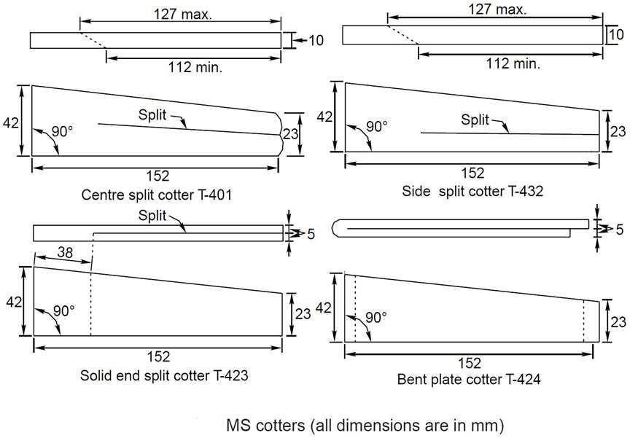
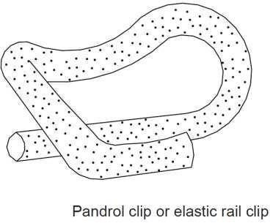

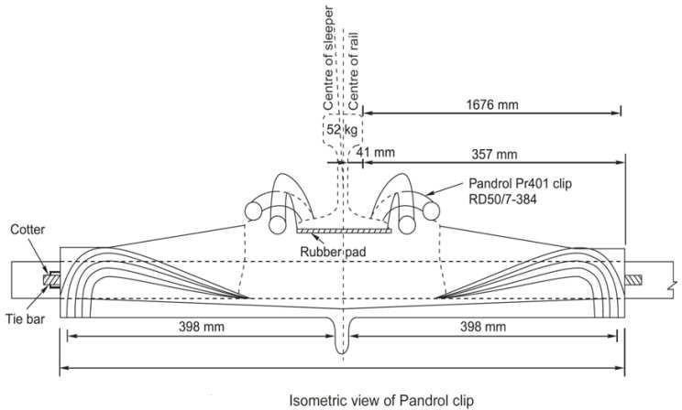

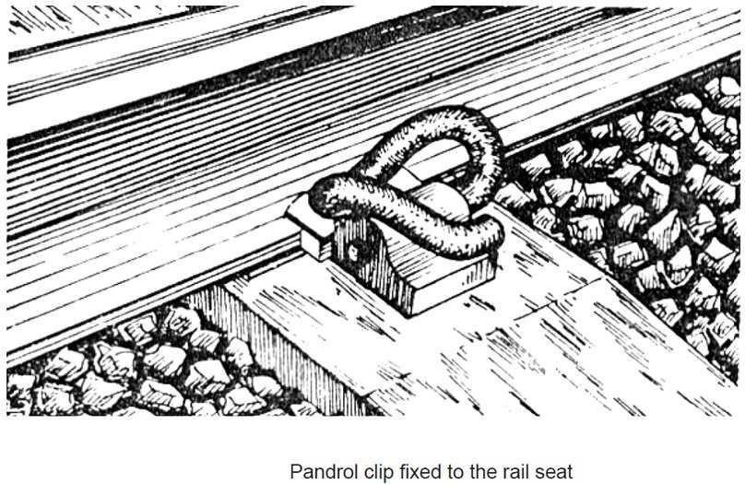

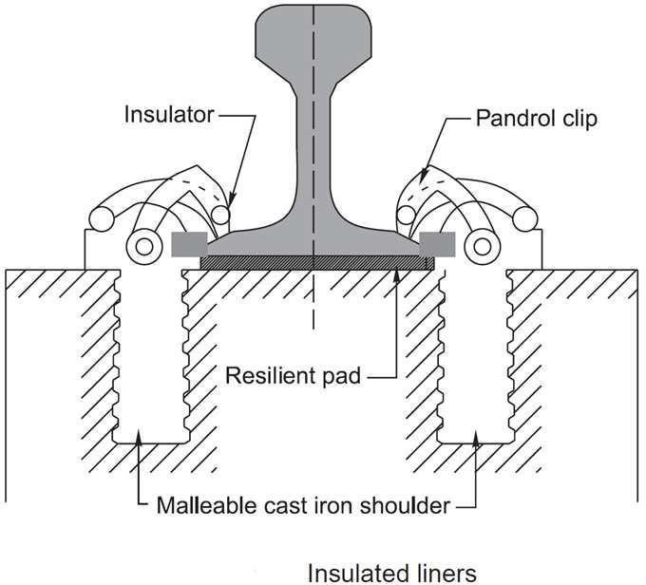
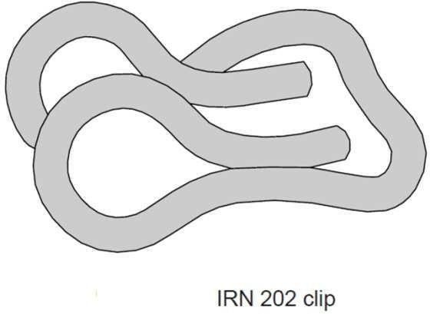

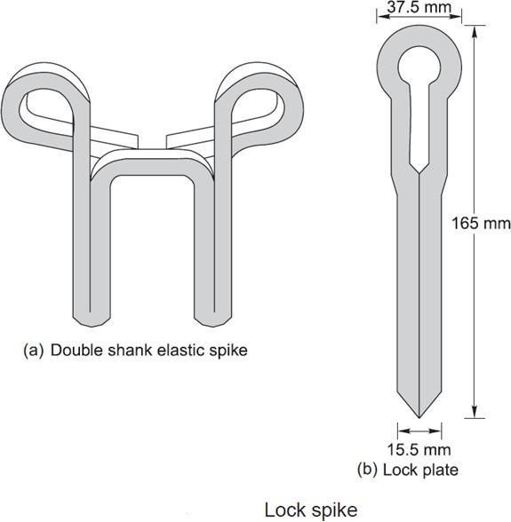

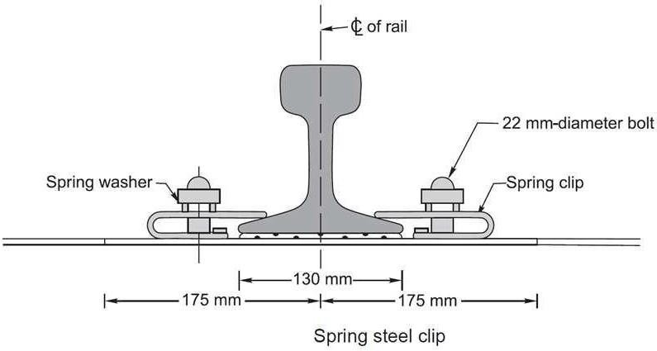

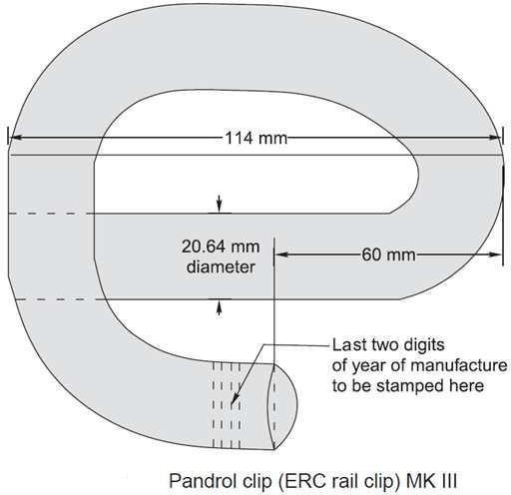

NewElasticFastening(GClip)
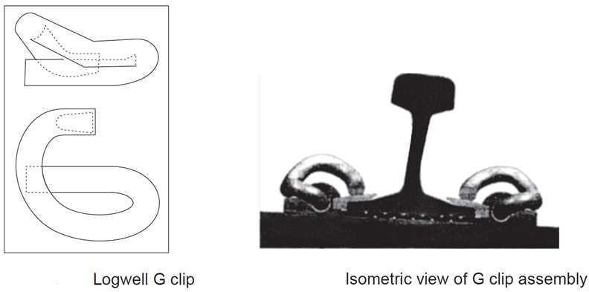

CHAPTER-4

GeometricforBroad gauge

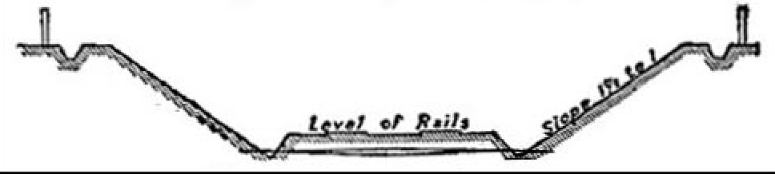

TypicalSectionofRailwayinCutting.

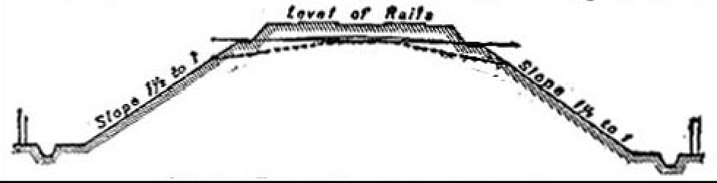

TypicalSectionofanembankment.

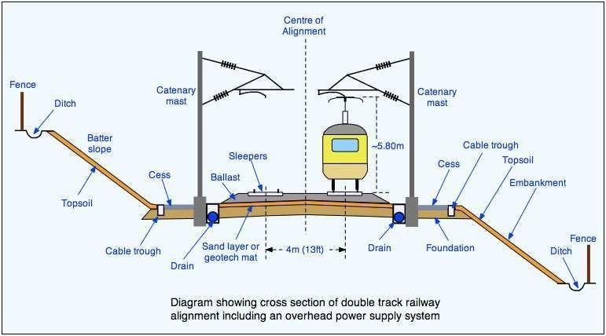

Classificationof RailwayLand: Witha viewtodetermine what the dispositionof the land willprobablybe on the completion of the work for which it had been acquired, the classification given in paragraph 818 etc. should be adopted.

Onrailways,landisdividedintotwoclasses,viz.,

- (i)permanentlandwidth

- (ii)temporarylandwidth

Permanent land width is land which will be required permanently after the railway is open for traffic and the work of construction is complete. Under this head will be included all land to be occupied by the formation of the permanent line of railway with side slopes of banks and cuttings, and the berms connected therewith; catch water drains and borrow pits or such parts of them as it is necessary to retain; the entrances to tunnels and shafts belonging to them; the sites of bridges, and protection or training works; station yards; landing places for railway ferries; ground to be occupied by works belonging to the railway such as gas works, arrangements for water supply, septic tanks, collecting pits, filter beds and pumping installations, & c., ground for the storage manufacture or acquisition of materials; land for sanitary zones, cemeteries, churches, plantations; gardens, and recreation grounds, sites for stations, offices, workshops; dwellinghouses and other buildings required for the purposes of the railway, or the accommodation of the staff, with the grounds, yards, roads, & c., appertaining thereto. Under this head will also be included land outside the permanent railway boundary, which will be required for the permanent diversion of roads or rivers, or for other works incidentalto the constructionoftherailway, which are made forpublic purposes and will noton completion of the works be maintained by the railwayauthorities.

Temporary land width is land which is acquired for temporary purposes only, and which is disposed of after the work of construction is completed.

Gradientsfor drainage

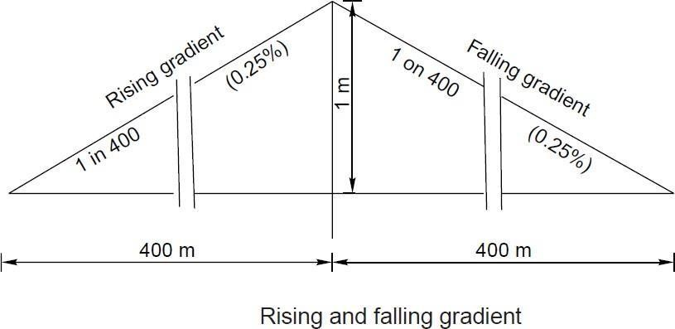

Drainage is defined as interception, collection and disposal of water away from track. Drainage isthe most important factor in trackmaintenance andfor stabilityof banks/cuttings. When water seeps into the formation, it weakens the bonds between the soil particles, softens the soil and results in creation of ballast pockets. On one hand, ingress of water into bank/cutting adds to weight of soil mass trying to slide, thereby increasing propensity for slope-slide, on the other hand, it reduces shear strength of soil, thereby decreasing factor of safety for stability of slope. Therefore, quick disposal of water from formation top/slopes is very essential.Drainagesystemshould beeffective inpreventingthestagnation of water and allowquickdisposal of water. At present, drainage is not being given its due importance in field. Provisions relating to drainage

have been detailed in various guidelines issued by RDSO(Research Design and Standards Organisation)from time to time, however, the present Guidelines highlight the salient features of drainage arrangement in embankment as well as cuttings.

CONVENTIONALDRAINAGESYSTEMS
- SURFACEDRAINAGE
- SIDEDRAINS
- CATCHWATERDRAINS
- SUBSURFACEDRAINS

SUPERELEVATION

- Cantorsuperelevationistheamount bywhichonerailisraisedabovetheotherrail.It ispositive when the outer rail on a curved track is raised above inner rail and is negative when the inner rail on a curved track is raised above the outer rail.
- Equilibriumspeedisthespeedatwhichthecentrifugalforcedevelopedduringthemovementof the vehicle on a curved track is exactly balanced by the cantprovided.
- Cantdeficiency-Cantdeficiencyoccurswhenatraintravelsaroundacurveataspeedhigherthan the equilibrium speed. It is the difference between the theoretical cant required for such higher speed and actual cant provided.
- Cant excess - Cant excess occurs when a train travels around a curve at a speed lower than the equilibriumspeed.Itisthedifferencebetweentheactualcantandthetheoreticalcantrequiredforsucha lower speed.
- Maximumpermissiblespeedofthecurve-Itisthehighestspeedwhichmaybepermittedonacurve takinginto consideration the radius ofthe curvature, actual cant, cant deficiency, cant excess andthe length oftransition.Whenthemaximumpermissiblespeedon acurveislessthanthemaximumsectionalspeed of the section of a line, permanent speed restriction becomes necessary.
- Cantgradientandcantdeficiencygradientindicatetheamountbywhichcantordeficiencyofcant isincreasedorreducedinagivenlengthoftransitione.g.,1in1000meansthatcantordeficiencyofcantof 1 mm. is gained or lost in every 1000mm. of transitionlength.
- Rate of change of cant or rate of change of cant deficiency is the rate at which cant or cant deficiencyisincreasedorreducedpersecond,atthemaximumpermissiblespeedofthevehiclepassingover the transition curve, e.g., 35 mm. per second means that a vehicle when traveling at a maximum speed permitted will experience a change in cant or deficiency of cant of 35mm. in each second of travel over the transition.
- Transition curve is an easement curve, in which the change of radius is progressive throughout its length and is usually provided in a shape of a cubic parabola at each end of the circular curve. It affords a gradualincreaseofcurvaturefromzeroatthetangentpointtothespecifiedradiusofcircularareandpermits a gradual increase of super elevation, so that the full superelevation is attained simultaneously with the curvature of the circular arc.

Superelevation,CantdeficiencyandCantexcess

- Super elevation/cant

(a)Theequilibriumsuperelevation/cantnecessaryforanyspeediscalculatedfromtheformula
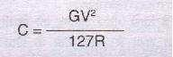

WhereCiscant/superelevationinmm.Gisthegaugeoftrack+widthofrailheadinmm.Ristheradius of the curve in metres.

Necessityof SuperElevation

In order to counteract the effect of centrifugal force the outside rail of the curve may be elevated above the inside rail effectively moving the centre of gravity of the rolling stock laterally toward the inside rail. This procedure is generally referred to as super elevation.

If the combination of lateral displacement of the centre of gravity provided by the super elevation, velocity of the rolling stock and radius of curve is such that resulting force becomes centered between and perpendicular to a line across the running rails the downward pressure on the outside and inside rails of the curve will be the same.

Thesuper elevation thatproducesthis condition for agiven velocityand radius of curve is known as the balanced or equilibrium elevation.
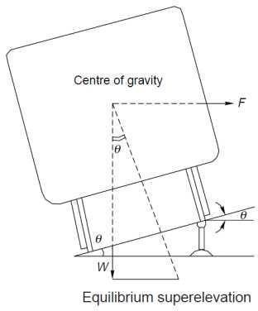

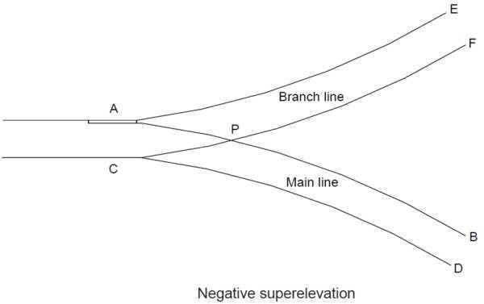

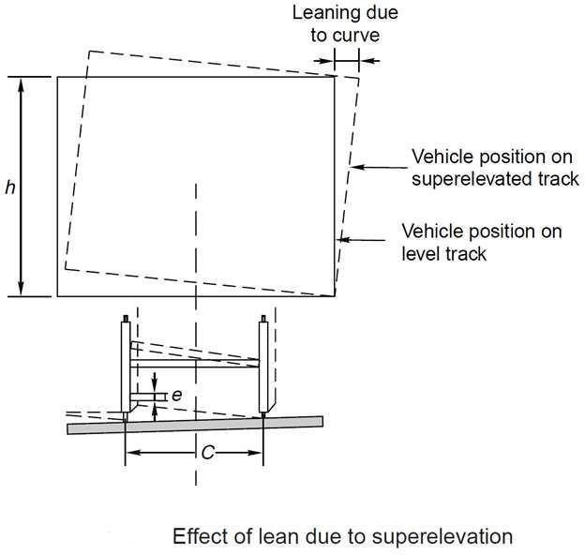

LimitationofSuperelevation

ForMixedPassenger&Freight Routes

Typical early railway operation resulted in rolling stock being operated at less than equilibrium velocity (all wheels equally sharing the rolling stock weight), or coming to a complete stop on curves. Under such circumstances excess super elevation may lead to a downward force sufficient to damage the inside rail of the curve, or cause derailment of rolling stock toward the centre of the curve when draft force is applied toa train. Routine operation ofloaded freight trains at low velocityon a curve super elevated to permit operation of higher velocity passenger trains will result in excess wear of the inside rail of the curve by the freight trains.

Thusonthesetypesof routes,superelevationisgenerallylimitedtonotmorethan6inches. For High Speed Passenger Routes
Modern high speed passenger routes, donotcarryslower speed trains,nor expect trains to stop oncurves, so it is possible to operate these routes with higher track super elevation values. Curves on these types of route are also designed to be relatively gentle radius, and are typically in excess of 2000m (2km) or 7000m (7km) depending on the speed limit of the route.

CHAPTER-5.0

POINTSANDCROSSING

DEFINITION:Thearrangementwhichisusedtotransferthetrain fromonetracktoanotherisknownaspointsand crossings.

Necessity:-

- Pointsandcrossingareprovidedtohelptransferrailwayvehiclefromonetracktoanother.
- The track may be parallel to diverging from or converging with each other point and crossing are necessary because the wheels of railway vehicles are provided with inside flange and therefore they require this in special arrangement in order to navigate their way on therail.
- The points or switches aid in diverting the vehicles and the crossing provide gaps in the rails so as to help the flanged wheels to roll over them.
- Acompletesetofpointsandcrossings,alongwithleadrails,iscalledaturnout.

Pointsor Switches

Apairoftonguerailandstockrailwithnecessaryconnectionandfittingformsaswitch

Crossing:-itisadeviceintroducedatthejunctionwheretworailscrosseachothertopermitthewheel flanges of a railway vehicle to pass from one track to another

Switches

  - Apairofstockrail,ABandCDmadeofmedium-manganesesteel.
  - A pair of tongue rails, PQ and RS also known as switch rails made withstand wear. The tongue rails are machined to very thin section to obtain a snug fit with the stock rail is called ‘toe’ and thicker end is called the ‘heel’
  - Ano.ofslidechairstosupportthetonguerailandenableitsmovementtowardsorawayfromthe stockrail.
  - Twoormorestretcherbarsconnectingboththetonguerailsclosetothetoe forthepurposeof holding them at a fixed distance from each other.
  - Agaugetiesplatetofixgaugesandensurecorrectgaugeatthepoints.
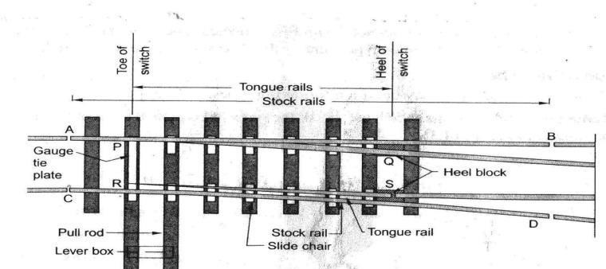

FIGURE:DETAILSOFSWITCH

TypesofSwitches

Switchesareoftwotypes,namely‘studswitches’and‘split switch’.

In‘studswitch’noseparatetonguerailisprovidedandsomeportionofthetrackismovedfromone side to the other side.
In‘splitswitch’apairofstockrailandapairoftonguerailsarepresent. Split switches are two types:-

LooseHeeltype:-
  - Inthistypeofsplitswitch,theswitchortonguerailfinishesattheheeloftheswitchtoenable movement of the free end of the tongue rail.
  - Thefishplatesholdingthetonguerailmaybestraightorhightlybent.
  - Thetonguerailisfastenedtothestockrailwiththehelpofafishingfitblockandfourbolts.
  - All the fish bolts in the lead rail are tightened while those in the tongue rail are kept loose or snug to allow free movement of thetongue.
  - As the discontinuity of the track at the heel is a weakness in the structure, the use of these switches is structures, the use of these switches is notpreferred.

FixedHeel Type:-
In this type of split switch the tongue rail does not end at the heel of the switch, but extends further and is rigidly connected. The movement at the toe of the switch is made possible on account of flexibility of tongue rail.

Crossing:-
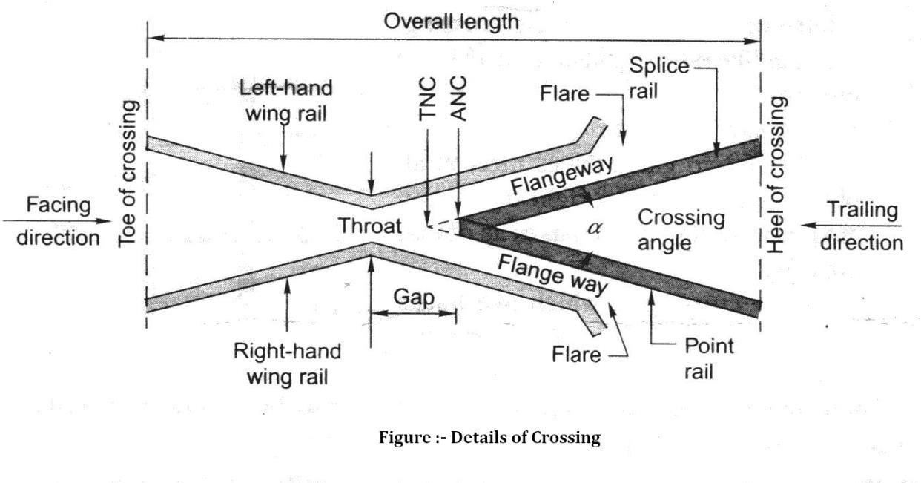AcrossingorFrogisadeviceintroducedatthepoint/junctionwheretwogaugefaces/railscross each other to permit the wheel flanges of a railway vehicle to pass from one track to each other.

Acrossingconsistsofthefollowing components.

  - Two rails, point rails and splice rails, which are machined to form a nose. The point rail ends at the nose whereas the splice rail joins it a little behind thenose.
Theoretically,thepoint railshouldendinapoint andbemadeasthinaspossible,but aknife edge of point rail would break off under the movement of traffic. The point rail therefore,has its fine end slightly cut off to form a blunt nose, with a thickness of 6mm. The toe of the blunt nose is called the actual nose of crossing (ANC) and the theoretical point where the gauge faces form both sides intersect is called the theoretical nose of crossing (TNC).The ‘V’rail isplanedtoa depthof 6mm(1/4’’)at thenoseand runsout in89mmto stop a wheel running in the facing direction from hitting the nose.
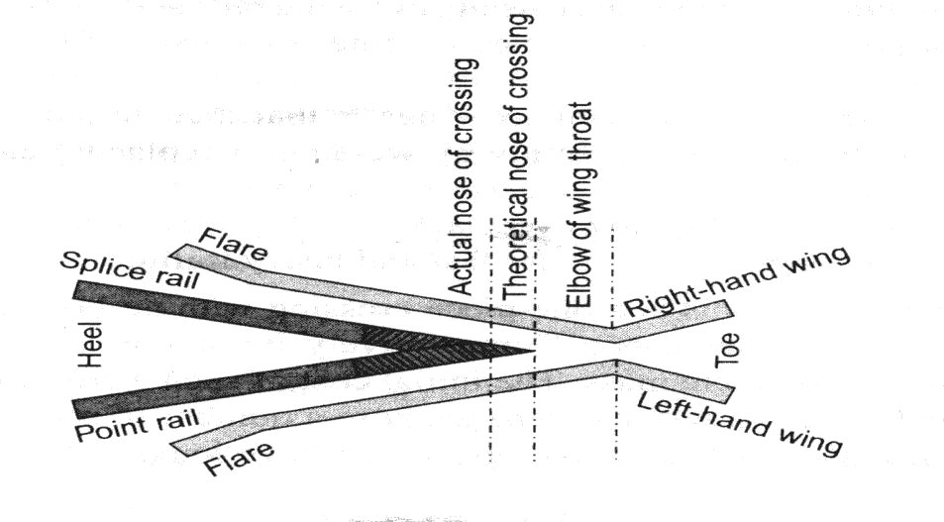

Figure:-PointRailandSpliceRail

  - Two wing rails consisting of a right hand and a left hand wing rail that converge to from a throat and diverge again on either side of the nose. Wing rails are flared at the ends to facilitate the entry and exit of the flanged wheel in thegap.

  - A pair of check rails to guide the wheel flanges preventing them from moving sideways which would otherwise may result in the wheel hitting the nose of the crossing as it movesin the facing direction.

TYPESOFCROSSING:

Acrossingmaybeofthefollowingtypes:-
    - An acute angle crossing or ‘V’ crossingin which the intersection of two gauge faces forms on acute angle, For example when a right rail crosses a left rail, it makes an acute crossing. So unlike rail crossing from an acute crossing.

    - Anobtuseordiamondcrossinginwhichthetwogaugefacesmeetatanobtuseangle.Whena right on left rail crosses a similar rail, it makes an obtusecrossing.
    - Asquarecrossinginwhichtwotrackscrossingatrightangles,suchcrossingsarerarelyused in actual practice. For manufacturing purposes, crossing is of followingtypes.

Accordingtomanufacture,thecrossingmaybeclassifiedasmentionedunder:-
      - Builtup crossing:-
Inabuilt-upcrossingtwowingrailsandaV-sectionconsistingofspliceandpointrails are assembled together by means of bolts and distance blocks to form a crossing.
Advantages:-
        - Initialcostislow.
        - Repaircanbecarriedoutbywelding.

Caststeelcrossing:-
Thisisonepiececrossingwithnoboltsandthereforerequiringverylittle maintenance.
Comparatively

Advantages:-
- Longerlife.

Disadvantages:-
  - Initialcostishigh.
  - Repairandmaintenancecausesanoofproblem.

Combinedrailandcastcrossing:-.
is a combination of a built-up and cast steel crossing and consists of a cast steel nose finished to ordinary rail faces to form the two legs of the crossing.
Through it allows the welding of worn-out wing rails, the nose is still liable to fracture suddenly.
CMS Crossing:- Due to increase in traffic and the use of heavier axle loads, the ordinary built-up crossing manufacturer from medium –manganese rails subjected to vary heavy wear and tear, especially in fast lines and suburban sections with electric traction. Past experience has shown that life of such crossings varies six months to two years, depending on their location and service conditions. CMS crossings possess higher strength, offer more resistance to wear and consequently have a longer life.

Advantages:-
- Lesswearand tear.
- Longerlife.
- Freefrombolts aswheelasothercomponentsthatnormallytogetlooseasaresultof movement of traffic.

SpringorMovable Crossing:-
In a springcrossing, one wingrailis movable andheldagainsttheVofthe crossingwith a strong helicalspringwhiletheotherwingrailiskeptfixed.Whenavehiclepassesonthemaintrack,the

movable wing rail is snug with crossing and the vehicle does not need to negotiate any gap at the crossing. In case the vehicle has to pass over a turnout track, the movable wing is forced out by the wheel flanges and the vehicle has to negotiate a gap as in normal turnout
This type of crossing is useful when there is high-speed traffic on the main track and slow-speed traffic on the turnout track

CHAPTER6

METHODSOFLAYING&MAINTENANCEOFTRACK

EssentialofTrackMaintenance:-
- Thegaugeshouldbecorrectorwithinthespecifiedlimits.
- Thereshouldbenodifferenceincrosslevelsexceptoncurves,wherecrosslevelsvaryin order to provide super elevation.
- Longitudinallevelsshouldbeuniform.
- Thealignmentshouldbestraightandkink-free.
- Theballastshouldbeadequateandsleepersshouldbewellpacked.
- Thetackdrainageshouldbegoodandformationshouldbewelltrained.

Railway track can be maintained either conventionally by manual labor or by the application of modern methods of track maintenance, such as mechanical tamping or measured shovel packing. The major maintenance operations performed in a calendar year (12-months) are as follows for achieving the above mentioned standards:-
- ThroughPacking-:
- SystematicOverhauling
- Pickingupslacks
  - Through Packing
ThroughPackingiscarriedoutinasystematicandsequentialmannerasdescribedas follows:

Openingofroad:-
Theballastisdugout oneither sideoftherail seatforadepthof50mm(2”)belowthe bottom of the sleeper with the help of a shovel with a wire claw .On the outside, the width of the opening should extend up to the end of the sleeper.
Ontheinsideitshouldextendfromtherailseattoadistanceof450mm(18”)incaseof BG, 350mm (14”) in case of MG, and 250mm (10”) in case of NG.

Examinationofrails,sleepersandfastening:-
Therails,sleepersandfasteningtobeusedarethoroughlyexamined.Defectivesleepersare removed and loose fastening are tightened. Any kinks in rails are removed.

Squaringof sleepers:-
- Todothisoneoftherailsistakenasthesightingrailandthecorrectsleeperspacingis marked on it.
- Thepositionof thesleeperischeckedwithreferencetothesecondrailwiththehelpofaT- square.

- Thesleeperattendedtoafterthisdefectshavebeenestablished,whichmayincludetheir being out of square or at incorrect spacing.

Aligningthetrack:-
- Thealignmentofthetrackisnormallycheckedvisually,whereintherailisvisually assessed form a distance of about four rail lengths orso.
- Smallerrorsinthealignmentarecorrectedbyslewingthetrackafterlooseningthecoresat the ends and drawing out sufficient ballast at the ends of thesleeper.
- Slewingiscarriedoutbyplantingcrowbardeepintotheballastatananglenotmorethan30 form the vertical.

AdvantagesofTrackMaintenance:-
- Ifthetrackissuitablymaintained,thelife ofthetrackaswellasthatoftherollingstockincreases since there is lesser wear and tear of their components.
- Regulartrackmaintenancehelpsinreducingoperatingcostsandfuelconsumption.
- Small maintenance jobs done at the appropriate time, such as tightening a bolt or key, hammeringthe dog spike, etc., help in avoiding loss of concerned fitting and thus saving on the associated expenditure.
- When track maintenance is neglected for along time, it may render the track beyond repair, calling for heavy track renewals that entail huge expenses

Gauging:-
Thegaugeshouldbecheckedandanattemptshouldbemadetoprovideauniformgauge within permissible tolerance limits.

Systematicoverhauling:-
Thesystematicoverhaulingofthetrackshouldnormallycommenceafterthecompletionof one cycle of through packing. It involves the following operations in sequence:-
- Shallowscreeningandmakingupofballastsection.
- Replacingdamagedorbrotherfittings.
- Includingallitemsinthroughpacking.
- Makingup thecess.

Pickingupstacks:-
Stacksarethosepointsinthetrackwheretherunningoftrainsisfaculty.Slacksgenerally occur in the following cases:-
- Stretchesofyieldingformation.
- Improperlyalignedcurves.
- Portionsoftrackwithpoordrainage.
- Approachestolevelcrossing,girderbridgesetc.
- Sectionwithaninadequateoruncleanballastcushion.
Nothroughpackingisdoneduringtherainingseasonandslacksareonlypickedupinorderto keep the track safe and in good running condition.

Dutiesof apermanentwayInspector(PWI)

ThePWIisgenerallyresponsibleforthefollowing:-

  - Maintenanceandinspectionofthetracktoensuresatisfactoryandsafeperformance.
  - Efficientexecutionofallworksincidentaltotrackmaintenance,includingtrackrelayingwork.
  - Accountsandperiodicalverificationofthestoresandtoolsinhisorhercharge.
  - Maintenanceoflandboundariesbetweenstationsandatimportantstationsasmaybespecifiedby the administration.
ThePWIalsocarriesoutinspectionofthefollowingfactsofatrack.

- Testingthetrack.
- Inspectionoftrackandgauge.
- Levelcrossinginspection.
- Pointandcrossinginspection.
- Curveinspection.
- Safetyof track.
Inadditiontotheinspections,aPWIalsocarriesoutfollowingduties:-
- Checktheproximityoftreesthatarelikelytodamagethetrackandgetthemremoved.
- Checknightpatrollingatlastonceamonthbytrainaswellasbytrolley.
- Takesthenecessarysafetymeasureswileexecutingmaintenanceworkthataffectsthesafetyofthe track.
- PeriodicallyinspectsandrespectiveLWRtackstoensuretheirsafety.
- Ensuresthecleanlinessofstationyards.
- Keepsproperrecordsofthetrainingoutofballast.
- Looksafterallestablishmentwork,includingthewelfareofthestaffworkingunderhischargeand maintenance their service records.
- Ensuresthesafetyofthetrackduringtheexecutionofworkthataffectsthetrack.

SECTION-B

DEFINATION
CHAPTER-7

BRIDGEENGINERRING

ThefollowingdefinitionsofcertainimportanttermsusedinBridgeEngineeringaregivenbelow:

- Bridge: - A structure is facilitating a communication route for carrying road traffic or other moving loads over a depression or obstruction such as river, stream, channel, road or railway. The communication route may be a railway track, a tramway, a roadway, footpath, a cycle track or a combination of them.
- High Level Bridge or Non-submersible Bridge: -The Bridge which does not allow the high flood waters to pass over them. All the flood water is allowed to pass through its vents. In other words it carries the roadway above the highest flood level of the channel.
- Submersible Bridge: - A submersible bridge is a structure which allows flood water to pass over bridge submerging the communication route. Its formation level should be so fixed as not to cause interruption to traffic during floods for more than three days at a time not more than six times in a year.
- Causeway: - It is a pucca submersible bridge which allows floods to pass over it. It is provided on less important routes in order to reduce the construction cost of cross drainage structures. It may have vents for low water flow.
- Foot Bridge: - The foot bridge is a bridge exclusively used for carrying pedestrians. Cycles and animals.
- Culvert: - When a small stream crosses a road with linear waterway less than about 6 meters. The cross drainage structure so provided is calledculvert.
- DeckBridge:-Thesearethebridgewhoseflooringsaresupportedattopofthesuperstructures.
- ThroughBridge:-Thesearethebridgeswhoseflooringsaresupportedorsuspendedatthebottom of the superstructures.
- Semi-ThroughBridges:-Thesearethebridgeswhoseflooringsaresupportedatsomeintermediate level of the superstructure.
- SimpleBridges:-Theyincludeallbeam,girderortrussbridgeswhoseflooringissupportedat some intermediate level of superstructure.
- CantileverBridges: -Bridgeswhicharemoreorlessfixedatoneendandfreeatother.Itcanbe used for spans varying from 8 meters to 20meters.
- ContinuousBridges:-Bridgeswhichcontinueovertwoormorespans.Theyareusedforlarge spans and where unyielding foundations are available.

- Arch Bridge: - These are the bridges which [produce inclined pressures on supports under vertical loads. These bridges can be economically used up to spans about 20 meters. The arches may be in the barrel form or in the form of ribs.
- Rigid Frame Bridges: - In these bridges the horizontal deck slab is made monolithic with the vertical abutments walls. These bridges can be used up to span about 20 meters. Generally this type of bridge is not found economical for spans less than 10meters.
- SquareBridge:-Thesearethebridgesatrightanglestoaxisoftheriver.
- SkewBridge:-Thesearethebridgesnotatrightanglestoaxisoftheriver.
- SuspensionBridges:-Thesearethebridgeswhicharesuspendedoncablesanchoredatends.
- Under-Bridges: - It is a bridge constructed to enable a road to pass under another work or obstruction.
- Over-Bridges:-itisabridgeconstructedtoenableoneformoflandcommunicationovertheother.
- Class AA Bridges: - These are bridges designed for I.R.C. class AA loading and checked for classA loading. They are provided within certain municipal limits, in certain existing or contemplated industrial area, in other specified areas, and along certain specifiedhighways.
- ClassABridges:-ThesearepermanentbridgesdesignedforI.R.C.classAloading.
- ClassBBridges:-ThesearepermanentbridgesdesignedforI.R.C.classBloading.
- Viaduct:-Itisalongcontinuousstructurewhichcarriesaroadorrailwayslike Bridgeoveradry valley composed of series of span over trestle bents instead of solidpiers.
- Apron:-Itisalayerofconcrete,masonrystoneetc.placedlikeflooringattheentranceoroutofa culvert to prevent scour.
- Piers:-Theyaretheintermediatesupportsofabridgesuperstructureandmaybesolidor opentype.
- Abutments:-Theyaretheendsupportsofthesuperstructure.
- CurtainWall:-Itisathinwallusedasaprotectionagainstscouringactionastream.
- Effective Span: - The centre to centre distance between any two adjacent supports is called as theeffective span of a bridge.
- ClearSpan:-ThecleardistancebetweenanytwoadjacentsupportsofabridgeiscalledclearSpan.
- Economic Span: - the span, for which the total cost of bridge structure is minimum is known as economic span.
- Afflux: - due to construction of the Bridge there is a contraction in waterway. This results in rise of water level above its normal level while passing under the Bridge. This rise is known asafflux.
- Free Board: - Free Board at any point is the difference between the highest flood level after allowing for afflux, if any, and the formation level of road embankment on the approaches or top level of guide bunds at that point.
- Headroom:-Headroomistheverticaldistancebetweenthehighestpointsofavehicleorvesseland the lowest points of any points of any projecting member of aBridge.
- Length of the Bridge: - The length of a Bridge structure will be taken as the overall length measured along the center line of the Bridge from the end to end of the Bridgedeck.

- Linear Waterway: - The linear waterway of a Bridge shall be the length available in the bridge between extreme edges of water surface at the highest flood level, measured at right angles to the abutment faces.
- Low Water Level (L.W.L.): - The low water level is the of water surface obtained generally in the dry season.
- Ordinary Flood Level (O.F.L.):- It is average level of a high flood which is expected to occur normally every year.
- Highest Flood Level (H.F.L.):- It is the level of highest flood, every recorded or the calculatedlevel for the highest possible flood.
- Effective Linear Waterway: - Effective linear waterway is the total width of waterway of a bridge minus theeffective widthof obstruction. For calculatingthe effectivelinear waterways, thewidthof mean obstruction due to each pier shall be taken as mean submerged width of the pier at its foundation up to maximum scour level. The obstruction at ends due to abutments or pitched slopes should be ignored.

COMPONENTSOFABRIDGE

Thebridgestructureisdividedmainlyintotwo components:

- Substructure
  - The function of substructure is similar to that of foundations, columns and walls etc. of a building. Thusthesubstructuresupportsthesuperstructureanddistributestheloadintothesoilbelowthrough foundation.
  - Thesubstructureconsistsoffoundationpiersandabutmentpiers,foundationforthepiers, abutments, wing walls, and approaches.
  - Theaboveallsupportsthesuperstructureofthebridge.

- Superstructure
  - Thesuperstructureofabridgeisanaloguestoasinglestoreybuildingroofand substructure to that of walls, columns and foundations supportingit.
  - Superstructureconsistsofstructuralmemberscarryingacommunicationroute
  - Itconsistsofhandrails,parapets,roadways,girders,arches,walltrussesoverwhichtheroad is supported.
  - Itisthatpartofthebridgeoverwhichthetrafficmovessafely.

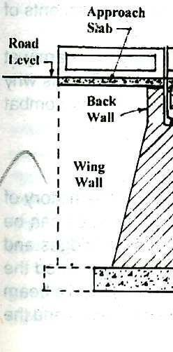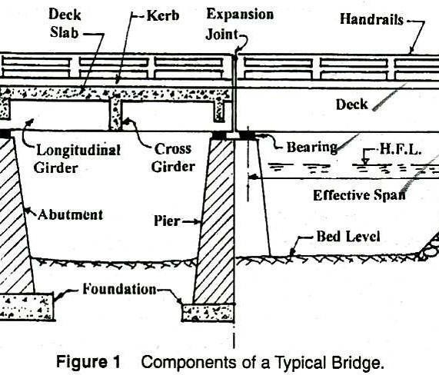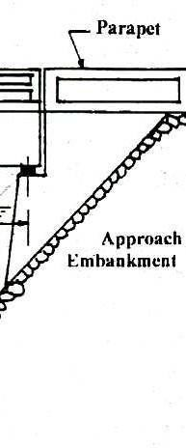

ClassificationofaBridge:-

Thebridgesmaybeclassifieddependinguponthefollowingfactors:-
- Theirfunctionsorpurposeasrailway,highway,FootBridge,aqueductetc.
- Theirmaterialofconstructionusedastimber,masonry,R.C.C.Steel,prestressconcreteetc.
- Natureorlifespansuchastemporary,permanentbridgeetc.
- TheirrelativepositionoffloorsuchasDeckBridge,throughbridge,semithroughetc.
- Typeofsuper-structuresuchasarchedgirder,truss,suspensionbridgeetc.
- Loadings: -RoadBridgesandculvertshavebeenclassifiedbyI.R.C.intoclass AA,ClassA,ClassB bridges according to the loadings they are designed tocarry.

- SpanLength:-Underthiscategorythebridgescanbeclassifiedas
  - Culverts(SpanLessthan8m)i.e.BOXType,HumePipeType,
  - MinorBridge(Spanlength=8to30m)i.e.BOXtype,GirderType
  - MajorBridge(SpanLength=abovethan30m)
- DegreeofRedundancy:-Underthisthebridgescanbeclassifiedasdeterminate&indeterminatebridges.
- TypesofConnection: -Underthiscategorythesteelbridgescanbeclassifiedaspinnedconnected, riveted or welded bridges.

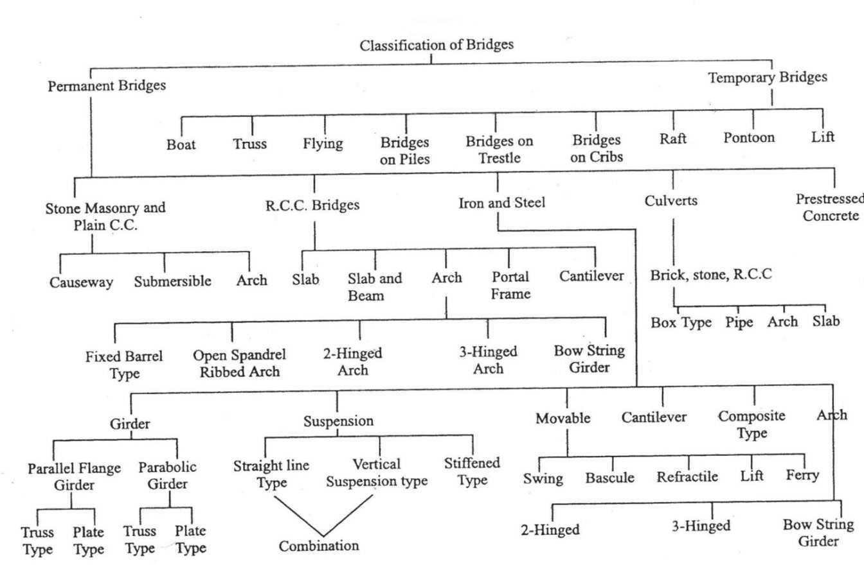
ClassificationofBridge

REQUIRMENTSOFANIDEALBRIDGE:-
Anidealbridgemeetsthefollowingrequirementstofulfillthethreecriteriaofefficiency,effectiveness and equity
- Itservestheintendedfunctionwithutmostsafetyandconvenience
- Itisaestheticallysound
- Itiseconomical
ThesitecharacteristicofanIdealBridgehasbeendiscussedbelow:
- Thestreamatthebridgesideshouldbewelldefinedandasnarrowaspossible.
- Thereshouldbeastraightreachofstreamatbridgesite
- Thesiteshouldhavefirm,permanent,straightandhighbanks.
- Theflowofwaterinthestreamatthebridgesiteshouldbeinsteadyregimecondition.Itshouldbe free from whirls and cross-current.
- Thereshouldbenoconfluenceoflargetributariesinthevicinityofbridgesite
- Itshouldbereliabletohavestraightapproachroadsandsquarealignment,i.e.right-angledcrossing
- Thereshouldbeminimumobstructionofanaturalwaterwaysoastohaveminimumafflux
- Inordertoachieveeconomythereshouldbeeasyavailabilityoflabour,constructionmaterialand transport facility in the vicinity of bridgesite.
- Inordertohaveminimumfoundationcost,thebridgesiteshouldbesuchthatnoexcessiveworkis to be carried inside the water
- Atbridgesiteitshouldbepossibletoprovidesecureandeconomicalapproaches.

- In case of curved alignment the bridge should not be on the curve, but preferably on the tangentsince otherwise there is a greater likelihood of accident as well as an added centrifugal force which increases the load effect on the structure and will require modification ofdesign.
- Thereshouldbenoadverseenvironmentalinput.
- Thebridgesiteshouldbesuchthatadequateverticalheightandwaterwayisavailable
- Underneaththebridge,rivershouldbeusedfornavigationalpurpose.
In actual practice the determination of best possible site for any proposed bridge is truly an economic problem. The various factors which should be carefully examined before setting final layout of a bridge are as follows:
  - Gradeonalignment,
  - GeographicalConditions,
  - Governmentrequirements,
  - Commercialinfluences,
  - Adjacentpropertyconsideration,
  - Generalfeaturesofthebridge structure,
  - Futuretrendsforenlargement,
  - TimeConsideration,
  - FoundationConsiderations,
  - Constructionfacilitiesavailable,
  - ErectionConsideration,
  - Aesthetics,
  - Maintenanceandrepairs,
  - EnvironmentalImpact

CHAPTER-8

BridgeAlignment:-
Dependingupontheanglewhichthebridgemakeswiththeaxisoftheriver,thealignmentcanbeoftwo types:
    - SquareAlignments:-Inthisthebridgeisatrightangletotheaxisoftheriver.

    - SkewAlignments: -Inthisthebridgeisatsomeangletotheaxisoftheriverwhichisnotaright angle.
Note: -As faras possible,it isalways desirable to provide thesquare alignment. Theskewalignment suffers from the following disadvantages:-
      - AgreatskillisrequiredfortheconstructionofskewBridges.Maintenanceofsuchtypeof Bridges is also difficult.
      - Thewater-pressureonpiersincaseofskewalignmentisalsoexcessivebecauseofnon-uniform flow of water underneath the bridge superstructure.
      - Thefoundationofskewbridgeismoresusceptibletoscouraction.

FloodDischarge:-

One of the essential data for the bridge design is fair assessment of the maximum flow which could be expected to occur at the bridges site during the design period of the bridge. The conventional practice in India for determination of flood discharge is to use a few convenient formulae or pastrecords.
Note:-Thisfaultydeterminationofflooddischargewhichledtofailureofmanyhydraulic structures.

As per I.R.C. recommendation the maximum discharge which a bridge on a natural stream should be designed to pass should be determined by the following methods:-
- Fromtherainfallandothercharacteristicsofthecatchment.

  - Byuseofanempiricalformulaappliedtothatregion,or

  - Byarationalmethod,provideditispossibletoevaluatefortheregionconcernedthevarious factors employed in the method.
- Fromthehydrauliccharacteristicsofthestreamsuchascross-sectional area,andslopeofthestream allowing for velocity of flow.
- Fromtherecordsavailable,ifany,ofdischargesobservedonthestreamatthesiteofthebridge,oratany other site in its vicinity.

EmpiricalMethodsforEstimationofFloodDischarge:-

Inthesemethodsareaofabasinoracatchmentisconsideredmainly.Allotherfactorswhich influence peak flow are merged in a constant.

Ageneralequationmaybefollowedintheform:-

Q =C.M^{n}

Here, Q=PeakFloworrateofmaximumdischarge C= a constant for the catchment
M=areaofcatchment,and‘n’isanindex
Theconstantforcatchmentisarrivedat,aftertakingthefollowingfactorsinto account:

- BasinCharacteristics
  - Area
  - Shape
  - Slope

- StromCharacteristics
  - Intensity
  - Duration
  - Distribution

Limitations:
- Thesemethodsdonottakefrequencyoffloodinto consideration.
- Thesemethodscannotbeapplieduniversally.
- Fixingofconstantisverydifficultandexacttheorycannotbeputforthforitsselection.

Dicken’sFormula

Q =C.M^{3/4}

Here, Q=Dischargeincum/sec C= a constant
M=areaofcatchmentinsq.km.
AccordingtotheareaofcatchmentandamountofrainfallCvariesfrom11.02to 22.04.

Ryve’sformula
Q =C.M^{2/3}
ThisformulaisusedonlyinSouthernIndia.

Here, Q=Dischargeincum/sec
C= 6.74 for areawithin24kmfromcoast, 8.45forareas within24-161 kmfromcoast,10.1for limited hilly areas
InworstcaseCgoesupto 40.5
M=areaofcatchment insq.km.

InglisFormula

ThisformulaisusedonlyinMaharashtrastateandherethreedifferentcasesaretakenintoconsideration.
  - Forsmallareasonly(Itisalsoapplicableforfan-shapedcatchment)

Q=123.2√M

  - Forareasbetween160to1000square km.
Q=123.2√M–2.62(M–259)
  - Foralltypeofcatchment
Q=123.2M/√(M +10.36)
Inallequations,M=areaofcatchmentinsq.km.

NawabJangBahadur’sFormula:-

Q =C(M/ 2.59)(a -b.log M)
Here,a,b,andCare constant.
a=0.993andb= 1/14
C=59.5forNorthIndiaor,
=48.1forSouth India

Creager’sFormula:-
q=C.M ^{n}

Here, q=thepeakflowpersq.kmofabasin M= area of catchment in sq. km. and ‘n’ is some index

BymultiplyingbothsidesoftheaboveequationareaofthebasinM,we get
Q=C.M ^{n+1}
WhereQispeakvalue

EquationgivenbyCreager,JustinandHindsis
Q=46.CM(0.894M-0.048)

Khosla’sFormula:-
Itisarationalformula;itisbasedonthe equation

P=R+Lor R=P-L
Here,Risrun off,PisrainfallandLis losses.
L=4.82Tm, whereLisinmmandTmisincentigrade {inC.G.S.System}
⸫R=P-4.82Tm.ThisformulaisforTm=40˚c,forlesservaluesofTmtheL value varies. It is useful for river valley project.

Besson’sFormula:-
Thisformulaisveryrationalandcanbeusedinanycase:
Qm=(PmXQr)/(Pr)
Here, Qm=Peakflowexpected
Qr=Someobservedpeakflow Pr = Observed rainfall
Pm=expectedrainfall

RationalMethodsforEstimationofFloodDischarge:-

This method is applicable for determination of flood discharge for small culverts only. In order to arrive at a rational approach, a relationship has been established between rainfall and runoff under various circumstances. The size of flood depends upon the following factors.
- ClimateorRainfallFactors.Thisincludes

(a) Intensity(b)Distributionand(c)DurationofRainfall

- CatchmentAreaFactors.This includes:

(a)CatchmentArea(b)itsslope(c)itsshape(d)porosityofsoil

(e)Vegetablecover(f)initialstateofwetness

WATERWAY

The area through which the water flows under a bridge superstructure is known as the waterway of thebridge.Thelinear measurement ofthis areaalongthe bridgeis known asthelinearwaterway.Thislinear waterway is equal to the sum of all the clear spans. This may be called as artificial linear waterway.

Due to the construction of a bridge the natural waterway gets contracted thereby increasing the velocity of flow under a bridge. This increased velocity results into heading up of water on the upstream of the river or stream, known as Afflux.
EconomicSpan:-theeconomicspanofabridgeistheonewhichreducestheoverallcostofabridgetobe minimum. The overall cost of a bridge depends upon the following factors
  - Costofmaterialanditsnature.
  - Availabilityofskilledlabour
  - Span Length.
  - Natureofstreamtobebridged.
  - Climaticandotherconditions.

Notes:-

It is not in the hand of engineers to bring down the cost of living index or price of the materials like cement, steel, timber, etc. but they can help in bringing down the cost of bridges by evolving economical designs.
Considering only variable items, the cost of superstructure increases and that of sub-structure decreases with an increase in the span length. Thus most economic span length is that which stultifies the following:-
ThecostofSuperStructure=ThecostoftheSub-Structure

AFFLUX
When a bridge is constructed, the structure such as abutments and piers cause the reduction ofnatural waterway area. The contraction of stream is desirable because it leads to tangible saving in the cost especially for alluvial stream whose natural surface width is too large than required for stability. Therefore, to carry the maximum flood discharge, the velocity under a bridge increases. This increased velocity gives rise to sudden heading up of water on the upstream side of the stream. The phenomenon of heading up of water on the upstream side of the stream is known as“AFFLUX”
Greater the afflux greater will be the velocity under the downstream side of the bridge and greater will be the depth of scour and consequently greater will be depth of foundations required.

Affluxiscalculatedbyoneofthefollowingformula
- Marriman’sFormula
ha=(V²/2g){(A/C.a) ²-(A/A1)}
Here,ha=Affluxinmeters
V=Velocityofapproachinmeterspersecond A= Natural Waterway area at the site a=Contracted area in square meters
A1=Theenlargedareaatupstreamofthebridgeinsquare meters

C=CoefficientofDischarge=0.75+0.35(a/A) -0.1(a/A)²approximately

(A)Molesworth’sFormula

V2
ha =
+ 0.015 {(A/a)²-1}
17.9

Here,V,Aandahavethesame meaningasintheMarriman’sFormula

CLEARANCE

To avoid any possibility of traffic striking any structural part clearance diagram are specified. The horizontal clearance should be the clear width and vertical clearance of the clear height, available for the passage of vehicular traffic as shown in the clearance diagram in the figure below.
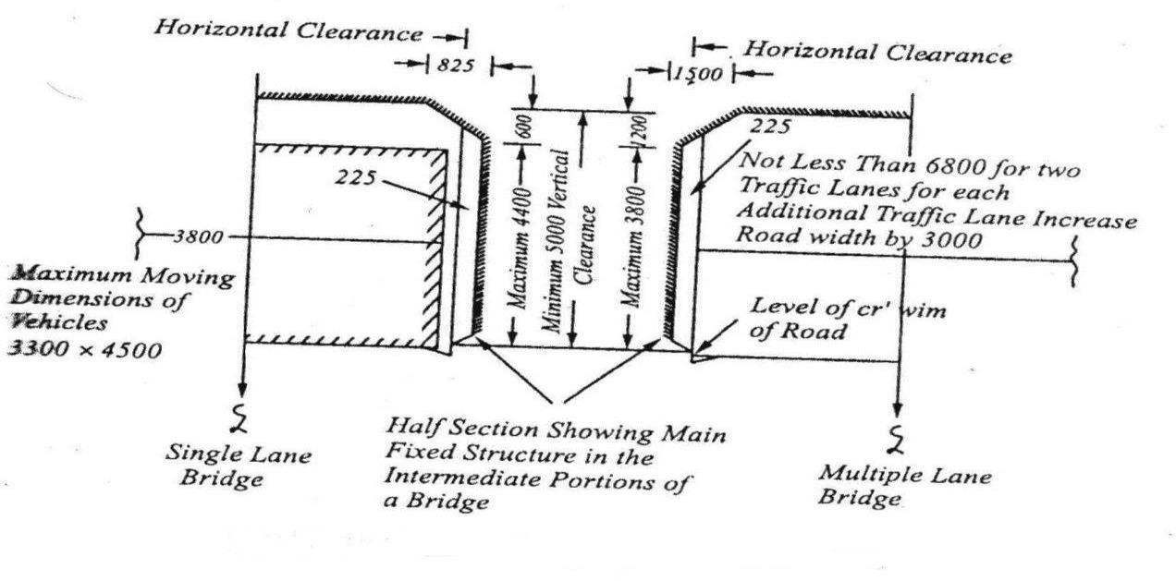

ClearanceDiagramforRoadBridges

Note: - For a bridge constructed on a horizontal curve with super elevated road surfaces, the horizontal clearance should be increased on the side of inner kerb by an amount equal to 5m multiplied by the super elevation. The minimum vertical clearance should be measured from the super elevated level of roadway.

FREEBOARD

Freeboardistheverticaldistancebetweenthedesignedhighfloodlevel,allowingforthe afflux,if any, and level of the crown of the bridge at its lowest point.
Itisessentialtoprovidethefreeboardinalltypesofbridgesforthefollowingreasons:-

- FreeBoardisrequiredtoallowfloatingdebris,fallentreetrunksandapproacheswavesto pass under the bridge.
- Freeboardisalsorequiredtoallowfortheaffluxduringthemaximumflooddischargedue to contraction of waterway.
- Freeboardisrequiredtoallowthevesselstocrossthebridgesincaseofnavigablerivers. The value of free-broad depends upon the types of thebridge.

CollectionofBridgeDesignData:-

For a complete and proper appreciation of the bridge project the engineer in charge of the investigation should carry out studies regarding its financial, economic, social and physical feasibility. The detailed information to be collected may cover loading to be used for design based on the present and anticipated future traffic, hydraulic data based on stream characteristics, geological data, subsoil data, climatic data, alternative sites, aesthetics, cost etc.
Thefollowingdrawingscontaininginformationasindicatedshouldbeprepared
- INDEXMAP
- CONTURESURVEYPLAN
- SITEPLAN
- CROSS-SECTION
- LONGITUDINALSECTION
- CATCHEMENTAREAMAP
- SOILPROFILE

Designdataformajorbridge:- A- General data:-
  - Nameoftheroadanditsclassification.
  - Nameofthe stream.
  - LocationofnearestG.T.S.benchmarkanditsreducedlevel.
  - Chainageatcentrelineofthestream.
  - Existingarrangementforcrossingthestream.
- DuringMonsoon b)Duringdryseason
  - Liabilityofthesitetoearthquakedisturbance

B-CatchmentAreaandRunoff Data:-
  - CatchmentArea
    - HillyArea b)In plains
  - Maximumrecordedintensityandfrequencyofrainfallincatchment.
  - Rainfallincentimetersperyearinaregion.
  - Lengthofcatchmentinkilometres.
  - Widthofcatchmentinkilometres.
  - Longitudinalslopeofcatchment.
  - Crossslopeofcatchment.
  - Thenatureofcatchmentanditsshape.
C-DataRegardingNatureof Stream
D-DataregardingAlignment&Approaches
E-SuperstructureData
F-Foundation Data
G-Dataofexistingstructure
H-MiscellaneousData

Sub-SurfaceInvestigation:-

Sub-Surfaceinvestigationisessentialfortoknowthepropertiesofthebridgesitesoil.Thefieldand laboratory investigations required to obtain the necessarysoil data for the design are called soil exploration.
Theprincipalrequirementsofacompleteinvestigationcanbesummarizedasfollows:-

- Natureofthesoildepositsuptosufficientdepth.
- Depth,thicknessandcompositionofeachsoilstratum.
- Thelocationofgroundwater.
- Depthtorockandcompositionofrock.
- Theengineeringpropertiesofsoilandrockstratathataffectthedesignof thestructure.

Inexplorationprogramme,theextentof distributionofdifferentsoilsbothinthehorizontal and vertical directions can be determined by the following methods:
- Byuse of openpits.
- Bymakingboreholesandtakingoutsamples.
- BySoundings.
- Byuseofgeophysicalmethods.

EquipmentsforlaboratoryWork:-

Thedisturbedsoilsampleastakenfrombedleveltoscourlevelateveryonemeterintervalorat depths wherever strata changes are tested to determine the following properties:-
- LiquidLimit,PlasticLimitandPlasticityIndex,
- OrganicContent,
- HarmfulSalts,
- SieveAnalysis,
- Silt Factor.

Theundisturbedsoilsamplesastakenbelowthescourleveltoalevelwherethepressureisabout 5% of the pressure at the base are tested to determine
- Particlesizeanalysis,
- Valuesofcohesionandangleofinternalfrictionbysheartest,
- Compressionindexandpre-consolidationpressurebyconsolidationtest,
- Densityspecificgravityandmoisturecontent.
TheequipmentusedfortheabovetestsareasperrelevantISspecifications.

AdvantageofSub-SurfaceInvestigation:-

Therearemanifoldadvantagesofcarefullyplannedinvestigationprogramme.Thesecanbesummarizedas below:-
- Asuitableandeconomicalsolutioncanbeworkedout.
- Theconstructionschedulecanbeproperlyplanned.
- Theextentandnatureofdifficultieslikelytobemetwithcanbedetermined.
- Therateandamountofsettlementscanbedetermined.
- Thevariationinthewater –table,ofthepresenceofartesianpressurescanbefoundout.

CHAPTER9

DepthofScour:-
DEPTH OF SCOUR (D) is the depth of the eroded bed of the river, measured from the water level for the discharge considered. Well-laid foundation is mostly provided in road and railway bridges in India over large and medium-sized rivers. The age-old Lacey–Inglis method issued for estimation of the design scour depth around bridge elements such as pier, abutment, guide bank, spur and groyene. Codal provisions are seen to produce too large a scour depth around bridge elements resulting in bridge sub-structures thatleadtoincreasedconstruction costs. Limitationsthat exist inthecodesofpracticeareillustratedinthis paper using examples.The methods recently developed for estimation of the scour are described. Newrailway and road bridges are required to be built in large numbers in the near future across several rivers to strengthen such infrastructure in the country. It is strongly felt that provisions in the existing codes of practice for determination of design scour depth require immediate review. The present paper provides a critical note on the practices followed in India for estimating the design scourdepth.
Indianpracticesonestimationofdesignscourdepth
    - Lacey–Inglismethod
    - CommentsonLacey’smethod
      - The probable maximum depth of scour for design of foundations and training and protection works shall be estimated considering local conditions.
      - Wherever possible and especially for flashy rivers and those with beds of gravel or boulders, sounding for purpose of determining the depth of scour shall be taken in the vicinity of the site proposed for the bridge. Such soundings are best taken during or immediately after a flood beforethe scour holes have had time to silt up appreciably. In calculating design depth of scour, allowance shall be made in the observed depth for increased scour resultingfrom:
- Thedesigndischargebeinggreaterthantheflooddischargeobserved.
- Theincreaseinvelocityduetotheconstrictionofwaterwaycausedbyconstructionof thebridge.
- Theincreaseinscourintheproximityofpiersandabutments.
  - 4.6.3 In the case of natural channels flowing in alluvial beds where the width of waterway provided is not less than Lacey’s regime width, the normal depth or Scour (D) below the foundation design discharge (Qf) level may be estimated from Lacey’s formula as indicatedbelow

D=0.473 (Q^{f}/f)^{1/3}

Where D is depth in metres Qf is in cumecs and ‘f‘ is Lacey’s silt factor for representative sample of bed material obtained from scour zone.
  - Where due to constriction of waterway, the width is less than Lacey’s regime width for Qf or where it is narrow and deep as in the case of incised rivers and has sandy bed, the normal depth of scour may be estimated by the followingformula:

D=1.338 (Qf 2/f)^{½}

Where ‘Qf ’ is the discharge intensity in cubic metre per second per metre width and f is silt factor The silt factor ‘f’ shall be determined for representative samples of bed material collected from scour zone using the formula : f = 1.76 √m where m is weighted mean diameter of the bed material particles in mm. Values of ‘f’ for different types of bed material commonly met with are given below :
Typeofbed | MaterialWeighted mean  diaofparticle(mm) | Valueof‘f’
(i)Coarsesilt | 0.04 | 0.35
(ii)Fine sand | 0.08 | 0.50
 | 0.15 | 0.68
(iii)Mediumsand | 0.3 | 0.96
 | 0.5 | 1.24
(iv)Coarse sand | 0.7 | 1.47
 | 1.0 | 1.76
 | 2.0 | 2.49
Thedepthcalculated(videclause4.6.3and4.6.4above)shallbeincreasedasindicatedbelow,toobtain maximum depth of scour for design of foundations, protection works and training works:-

Natureofthe river | Depthof scour
Inastraightreach | 1.25D
Atthemoderatebendconditionse.g.alongapronofguidebund | 1.5D
Ataseverebend | 1.75D
Atarightanglebendoratnoseofpiers | 2.0D
Insevereswirlse.g.againstmoleheadofaguidebund. | 2.5 to 2.75D

Incaseofclayeybeds,wherever possible,maximumdepthofscourshallbeassessedfromactual observations.

TypesofBridge
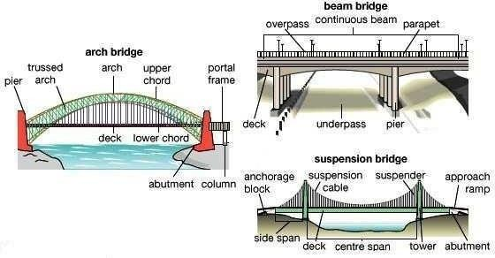
Typesof Bridge

Archbridge | 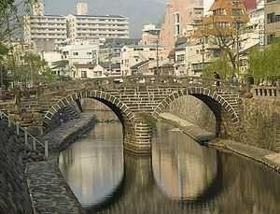
Archbridge(concrete) | 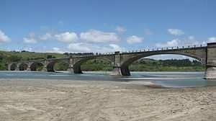
Througharchbridge | 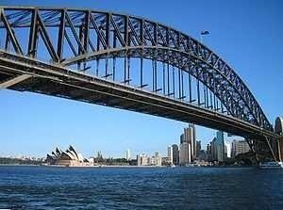
Beambridge | 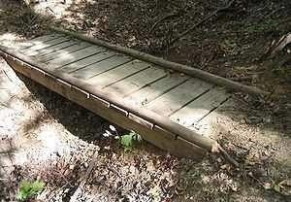
Logbridge(beambridge) | 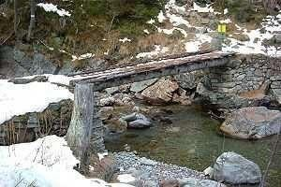
CavitywallViaduct | 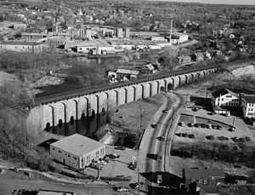
Bowstringarch | 
Boxgirderbridge | 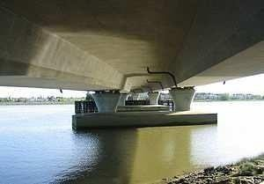

Cable-stayedbridge | 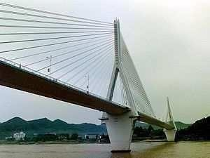
Cantileverbridge | 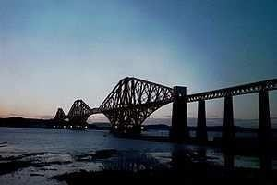
Cantileversparcable-stayed bridge | 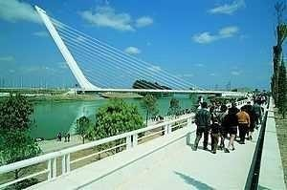
Clapperbridge | 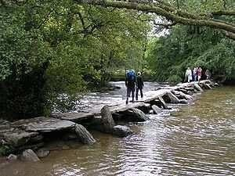
Coveredbridge | 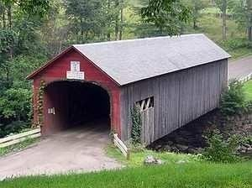
Girderbridge | 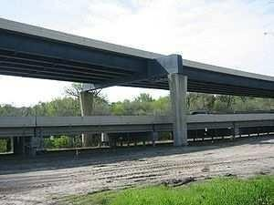
Continuousspangirderbridge | 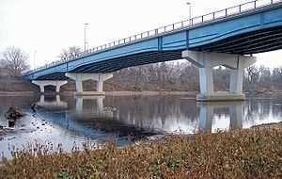
Moon bridge | 
Movablebridge | 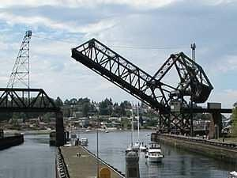

Pigtailbridge | 
Plategirderbridge | 
Pontoonbridge | 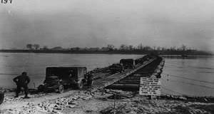
Rovingbridge | 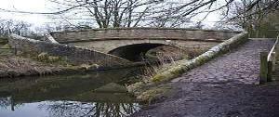
Segmental bridge | 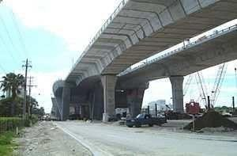
Self-anchoredsuspensionbridge | 
Side-sparcable-stayedbridge | 
Simple suspensionbridge(Incaropebridge)) | 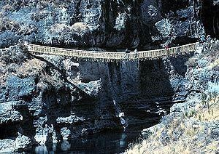
Step-stonebridge | 
Stressedribbonbridge | 
Suspensionbridge | 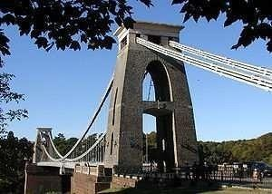

Transporterbridge | 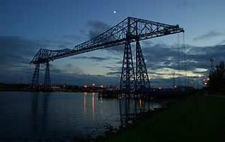
Trestle | 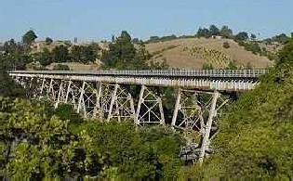
Trussarchbridge | 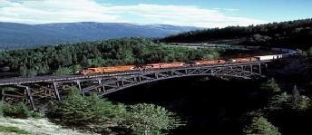
Trussbridge | 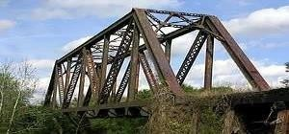
Vierendeelbridge | 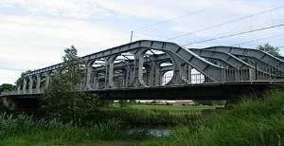
Browntruss | 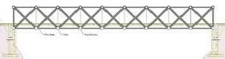
Coveredbridge | 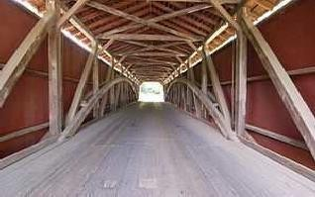
Latticetrussbridge(Townlattice truss | 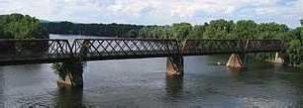
Tubularbridge | 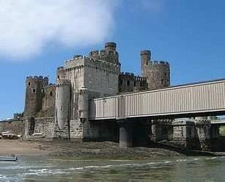

BridgeFoundation:-
Definition:-Afoundationisthepartofthestructurewhichisindirectcontactwiththeground.Ittransfers the load of the structure to the soil below. Before deciding upon its size, we must ensure that:
- Thebearingpressureatthebasedoesnotexceedtheallowablesoilpressure.
- Thesettlementoffoundationiswithinreasonablelimits
- Differentialsettlementistolimitedasnottocauseanydamagetothestructure.

Broadly,foundationmaybeclassifiedundertwocategoriesi.e.
  - Shallowfoundation
  - Deep Foundation
ShallowFoundation:-AccordingtoTrezaghi,afoundationissaidtobeshallowifitsdepthisequal orless than its width.
DeepFoundation:-AccordingtoTrezaghi,afoundationissaidtobedeep,thedepthisgreaterthanitswidth and it cannot be prepared by open excavation.
TypesofBridgeFoundation:-
Theselectionoffoundationtypesuitableforaparticularsitedependsonthefollowingconsiderations:-
- Natureof Subsoil
- Natureandextentofdifficulties,e.g.presenceofboulder,buriedtreetrunks,etc.Likelytobemetwith,and
- Availabilityofexpertiseandequipment.
Dependingupontheirnatureanddepth,bridgefoundationcanbecategoriesasfollows:
  - OpenFoundation,
  - RaftFoundation,
  - PileFoundation,
  - WellFoundation,

1(i)OpenFoundationinBridges:-
    - Anopenfoundationorspreadfoundationisatypeoffoundationandcanbelaidusingopen excavation by allowing natural slopes on all sides.
    - Thistypeoffoundationispracticableforadepthofabout5mandisnormallyconvenientabovethe water table.
    - Thebaseofthepierorabutmentisenlargedorspreadtoprovideindividualsupport.
    - Since spread foundations are constructed in open excavation, therefore, they are termed as open foundation.
    - This type of foundation is provided for bridges of moderate height built on sufficiently form day ground.
    - The piers in such cases are usually made with slight batter and provided with footings widened at bottom. Where the ground is not stiff the bearing surface is further extended by a wide layer of concreter at bottom (see the figure).

RaftFoundation:-
  - Araftfoundationormatisacombinedfootingthatcoverstheentireareabeneathabridgeand supports all the piers and abutments.
  - Whentheallowablesoilpressureislow,orbridgeloadsareheavy,theuseofspreadfootingwould cover more one-half of the area, and it may prove more economical to use raftfoundation
  - Theyarealsousedwherethesoilmasscontainscompressiblelensessothatthedifferential settlement would be difficult to control.
  - Therafttendstobridgeovertheerraticdepositsand eliminatesthedifferentialsettlement.

  - Raft foundation is also used to reduce the settlement above highly compressible soils by making the weight of bridge and raft may undergo large settlement without causing harmful differential settlement. For this reason, almost double settlement of that permitted for footings is acceptable for rafts.
  - Usuallywhenhardsoilisnotavailablewithin1.5to2.5maraftfoundationisadopted.
  - Theraftiscomposedofreinforcedconcretebeamsarelativelythinslabunderneath,figure

PilefoundationinBridges:
  - Thepilefoundationisconstructionsforthefoundationofabridgepierorabutmentsupportedon piers.
  - Apileisanelementofconstructioncomposedoftimber,concreteorsteelorcombinationofthem.
  - Pilefoundationmaybedefinedasacolumnsupporttypeoffoundationwhichmaybecast-in-situor precast.
  - Thepilesmaybeplaceseparatelyortheymaybeplacedinformofaclusterthroughout thelengthof the pier or abutment.
  - Thistypeofconstructionisadoptedwhentheloosesoilextendstogreatdepth.
  - Theloadofthebridgeistransmittedbythepilestohardstratumbeloworitisresistedbythefriction developed on the sides of piles.

Classificationof piles:-
Pilesarebroadlyclassifiedintotwocategories:-.
    - Classificationbasedonthefunction
    - Classificationbasedonthematerialsandcomposition

Classificationbasedonthefunction
      - BearingPile.
      - FrictionPile.
      - ScrewPile.
      - CompactionPile.
      - UpliftPile.
      - BatterPile.
      - SheetPile.

Classificationbasedonthefunction
      - Cementconcretepiles.
      - TimberPiles.
      - SteelPiles.
      - SandPiles.
      - CompositePiles.

WellFoundationinbridges
- Well foundationsarecommonlyusedfortransferringheavyloadstodeepstratainriver orseabed for bridges, transmission towers and harbour structures. The situation where well foundations are resorted are as below as) Wherever consideration of scour or bearing capacity require foundation to be taken to depth of more than 5 M below ground level open foundation becomes uneconomical. Heavy excavation and dewatering problem coupled with effort involve in retaining the soil makesthe open foundation costlier in comparison to other type offoundation.
- Soil becomes loose due to excavation around the open foundation and hence susceptible to scouring. This is avoided in well foundation which is sunk by dredging inside of thewell.

- From bearing pressure considerations, a well foundation can always be left hollow thereby considerablyreducingbearingpressure transmittedtothe foundation material.This is veryimportant in soils of poor bearing capacity, particularly in clayey soils. In other type of foundation, the soil displaced is occupied by solid masonry/concrete which are heavier than the soil displaced and hence this does not give any relief in respect of adjusting bearing capacity. However in case of well foundation this is easily achieved because of cellular space left inside thewell.

Caisson:-
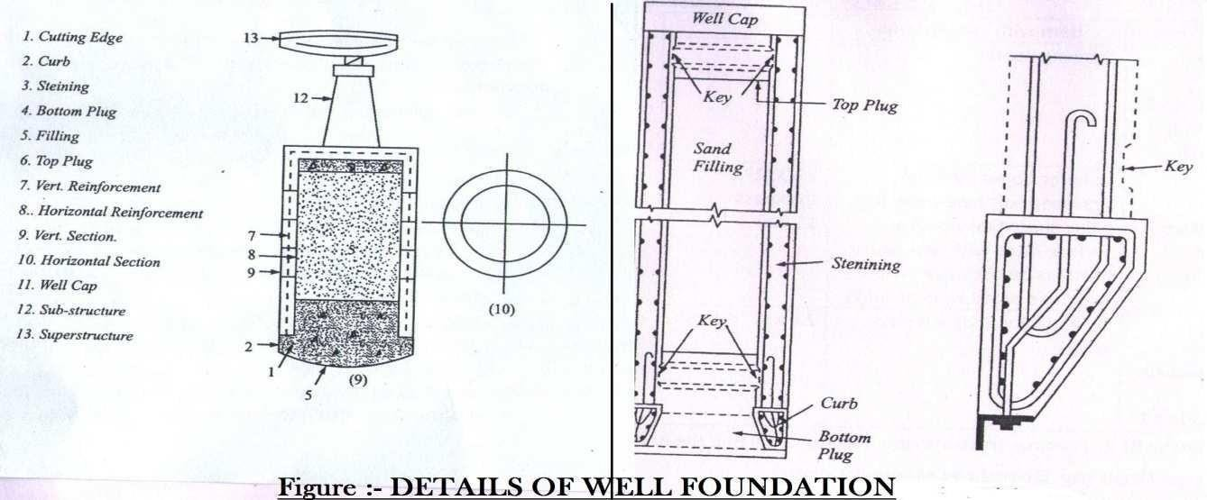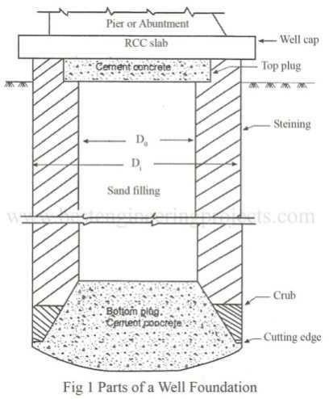

Caisson: - The caisson is astructure used forthe purpose of placing as foundationin correct position under water. The term caisson is derived from the French word ‘caisse’ meaning a box. It is a member with hollow portion, which after installing in palace by any means is filled with concrete or other material. Caissons are prepared in sandy soils the caissons can be divided in the followingthree groups
  - BoxCaissons
  - OpenCaissonsorWells
  - PneumaticCaissons

Wellcomponentsandtheirfunctions:

- Cutting edge:- It provides a comparatively sharp edge to cut the soil below during sinking operation. It is usually consists of a mild steel equal angle of side150mm.
- Curb: -It has a two-fold purpose. During sinking it acts as an extension of cutting edge and also provided support to the well steiningand bottomplugwhile after sinkingit transfers the load to the soil below. It is made up of reinforced concrete using controlled concrete ofgrade M200.
- Steining:- It is the main body of the well. It is serves dual purpose. It acts as a cofferdam during sinking and structural member to transfer the load to the soil below afterwards. The steining may consist of brick masonry or reinforced concrete. The thickness of steining should not be less than 4.5 cm not less than that given byequation.

t=K {(H/100)+(D/10)}
Here, t=minimumconcretesteiningthickness.
H=welldepthbelowbed
D=ExternaldiameterofWell
K=aconstant whichis1.0forsandystrata.

  - BottomPlug:-Its mainfunctionistotransfersloadfromthe steiningtothesoil below.
  - SandPlug:-Itsutilityisdoubtful.Itissupposedtoaffordsomerelieftothesteining by transforming directly a portion of load from well cap to bottomplug.
  - TopPlug:-Theopinionisdividedaboutthetopplug.It,atleast,servesasa shuttering for laying well cap.
  - Reinforcement:–Itprovidesrequisitestrengthtothestructureduringsinkingand service.

  - Well Cap: - It is needed to transfer the loads and moments from the pier to the well or wells below. The shape of well cap is similar to that of the well with a cantilevering of about 15cm. Whenever 2 or 3 wells of small diameter are needed to support the sub-structure , the well cap designed as a slab resting over the well or wells with partial fixity at the edges of the wells.
  - Depth of Well Foundation:- As per I.R.C. Bridge Code (Part-III), the depth of well foundation is to be decided on the followingconsideration
    - The minimum depth of foundation below the H.F.L. should be 1.33D,Where D is the anticipated max. Depth of scour below H.F.L. Depth should provided proper grip according to some rational formula.
    - The max bearing pressure on the subsoil under the foundationresulting form any combination of the loads and forces except wind and seismicforces should not exceed the safe bearing capacity of the subsoil, aftertaking into account the effect of scour.
Withwindandseismicforcesinaddition,themax.Bearingpressure should not exceed the safe bearing capacity of the subsoil by more than25%.
    - While calculating max. Baring pressure on the foundation bearing layer resulting from the worst combination of direct forces and overturning moments, the effect of a passive resistance of the earth on sides of the foundation structure may be taken into account below the max, depth of the scour only.
    - The effect of skin friction may be allowed on the portions below the max, depth of scour. Accordingly for deciding the depth of well foundation, we require correct estimation of the following.
      - Max.Sourdepth.
      - Safebearingcapacity.
      - Skinfriction.
      - Lateralearthsupportbelowmax.Scourlevel.
It is always desirable to fix the level of a well foundation on a sandy strata with adequate bearing capacity. Whenever a thin stratum of clay occurring between two layers of sand is met with, in that case well must be pierced through the clayey strata. If at all foundation has to be laid on clayey layer it should be ensured that the clay is stiff.
Design loads and Forces. The forces acting o n a bridge structure, to be consideredfo the design of a well foundation, are as follows:
Vertical
- Deadload,
- Liveload,
- Buoyancy.

Horizontal
- Windforce.
- Forceduetowatercurrents.
- Longitudinalforcescausedbythetractiveeffortofvehicleorbybrakingeffectof vehicles.
- Longitudinalforceonaccountofresistanceofthebearingagainstmovementdueto variations of temperature.
- Seismicforce.
- Earthpressure.
- Centrifugalforce.
The I.R.C. Bridge code II stipulates the magnitude of above loads and forces. The magnitude,directionandpointofapplicationofalltheaboveforcescanberesolvedintotwo horizontal forces, P and Q and a single vertical force W under the worst possible combinations.

Chapter10
Piers:-
Piers provide vertical supports for spans at intermediate points and perform two main functions: transferring superstructure vertical loads to the foundations and resisting horizontal forces acting on the bridge. Although piers are traditionally designed to resist vertical loads, it is becoming more and more common to design piers to resist high lateral loads caused by seismic events. Even in some low seismicareas, designers are paying more attention to the ductility aspect of the design. Piers are predominantly constructed using reinforced concrete. Steel, to a lesser degree, is also used for piers. Steel tubes filled with concrete (composite) columns have gained more attention recently.


FIGURE:1:Typicalcross-sectionshapesofpiersforovercrossingsorviaductsonland.

Pier is usually used as a general term for any type of substructure located between horizontal spans and foundations. However, from time to time, it is also used particularly for a solid wall in order to distinguish it from columns or bents. From a structural point of view, a column is a member that resists the lateral force mainly by flexure action whereas a pier is a member that resists the lateral force mainly by a shear mechanism. A pier that consists of multiple columns is often called a bent.
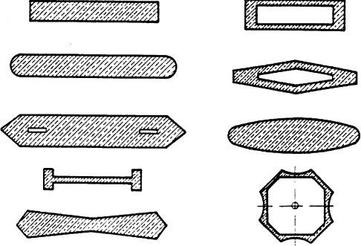

FIGURE:-2Typicalcross-sectionshapesofpiersforriverandwaterwaycrossings.

There are several ways of defining pier types. One is by its structural connectivity to the superstructure: monolithic or cantilevered. Another is by its sectional shape: solid or hollow; round, octagonal, hexagonal, or rectangular. It can also be distinguished by its framing configuration: single or multiple columns bent; hammerhead or pier wall. Selection of the type of piers for a bridge should be based on functional, structural, and geometric requirements. Aesthetics is also a very important factor of selection since modern highway bridges are part of a city’s landscape. Figure-1 shows a collection of typical cross section shapes for overcrossings and viaducts on land and Figure-2 shows some typical cross section shapes forpiersofriverandwaterwaycrossings.Often,piertypesaremandatedbygovernmentagenciesorowners. Many state departments of transportation in the United States have their own standard column shapes.

Broadlypiersareclassifiedunderfollowingtwocategories:-
    - SolidPiers.
    - Open Piers.
Solid wall piers, as shown in Figures 3-a and 4, are often used at water crossings since they can be constructed to proportions that are both slender and streamlined. These features lend themselves well for providing minimal resistance to flood flows.
Hammerhead piers, as shown in Figure 3-b, are often found in urban areas where space limitationis a concern. They are used to support steel girder or precast prestressed concrete superstructures. They are aesthetically appealing. They generally occupy less space, thereby providing more room for the traffic underneath. Standards for the use of hammerhead piers are often maintained by individual transportation departments. A column bent pier consists of a cap beam and supporting columns forming aframe.
Column bent piers,as shown in Figure 3-c and Figure 27.5, can either be used to support a steel girder superstructure or be used as an integral pier where the cast-in-place construction technique is used. The columns can be either circular or rectangular in cross section. They are by far the most popular forms of piers in the modern highway system.
A pile extension pierconsists of a drilled shaft as the foundation and the circular column extended fromthe shaft to formthe substructure. An obvious advantage of this type of pier is that it occupies minimal amount of space. Wideningan existingbridge in some instances mayrequire pile extensions because limited space precludes the use of other types of foundations.
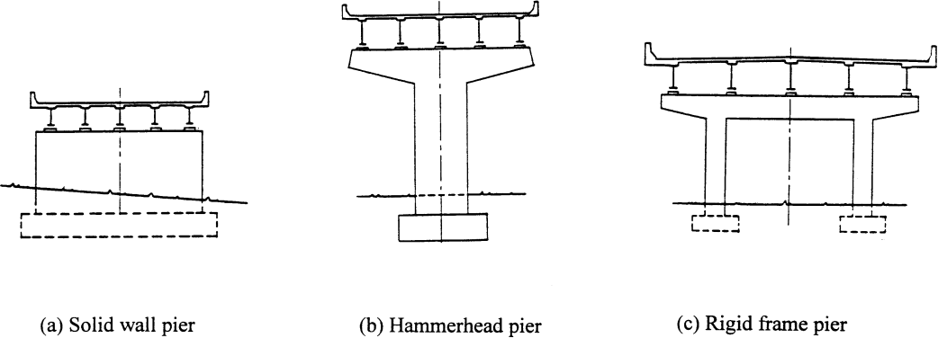

FIGURE-3
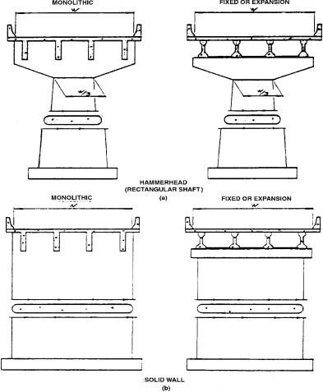
FIGURE-4

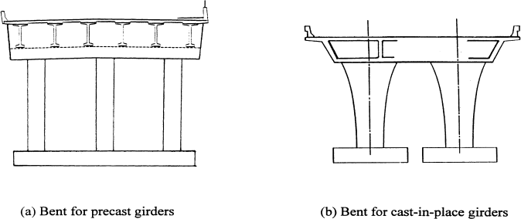

Abutments:-
They are the end supports of the superstructure, retaining earth on their back. They are built either with masonry, stone or brick work or ordinary mass concrete or reinforced concrete. The top surface of the abutment is made flat when the superstructure is of trusses or girders or semi-circular arch. In case of segmental or elliptical arch type of superstructure, the abutment top is made skew. Weep holes are provided at different levels through the body of the abutment to drain of the retained earth.
Thesalientfeaturesofbridgeabutmentsarelistedbelow.
- Height.Theheightoftheabutmentsiskeptequaltothatofthe piers.
- Abutment batter.Thewaterfaceofthe abutmentisusuallykeptverticalorcouldbe given abatterof 1 in 12 to 1 in 24 as of piers. The face retaining earth is given a batter of 1 in 6 or may be stepped down.
- Abutment Width. The top width of the abutment should provide enough space for the bridge seatand for the construction of a dwarf wall to retain earth up to the approachlevel.
- LengthofAbutment.Thelengthofabutmentiskeptatleastequaltothewidthofthebridge.
- Abutmentcap.Thedesignissimilartothatofpiercap.
Abutments can be spill-through or closed. The spill through abutment generally has a substantial berm to help restrain embankment settlement at the approach of the structure.
Approach embankment settlement can also be accommodated by approach slabs to eliminate bumps at the bridge ends, closed abutments partially or completely retain the approach embankments from spilling under the span, and Bridges of several spans require expansion at the abutments. Therefore they are no usually required to resist the longitudinal forces that develop.
Broadly,abutmentsareclassifiedunderthefollowingcategories.
  - Abutmentswithwingwalls
  - Abutmentswithoutwingwalls Abutments with wing walls
    - StraightWingwalls
    - SplayedWingwalls
    - Return Wing Walls Abutmentswithoutwingwalls
- BuriedAbutments
- BoxAbutments
- TeeAbutments
- Arch Abutments

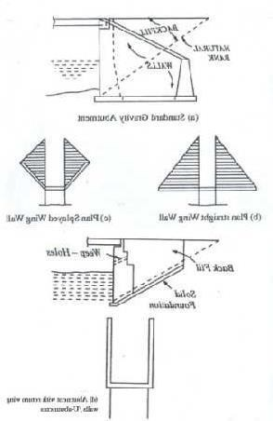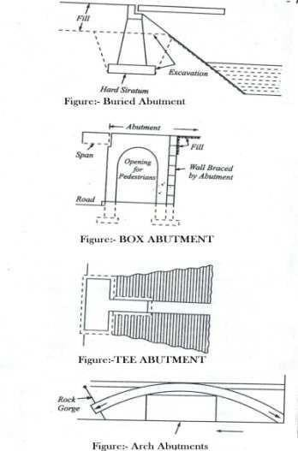

FIGURES:-ABUTMENTS
BuriedAbutments: -Thistype of abutmentsis generallybuilt priortothe placingofthefill. Sinceit isfilled on both sides the earth pressure is low. Superstructure erection can be begin before placement of fill .
Box Abutments: -This employs a short span of bridge built integral with columns to act as a frame andresist earth pressure of the approaches. It is most often used overpass work where the short span may be employed for pedestrian passage (see figure).
TeeAbutments:-ThistypelookslikeTinplanandhasnowbecomeabsolute(seefigure)
Arch Abutments: - This type of abutment is used where arches are employed because of their economy in certain conditions. The high inclined skewback thrusts are difficult to handle unless the abutment can be seated in rock. Therefore, they are often used for span over gorges. (see figure)

WINGWALLS:
In a bridge, the wing walls are adjacent to the abutments and act as retainingwalls. They are generally constructed of the same material as those of abutments. The wing walls can either be attached to the abutment or be independent of it. Wing walls are provided at both ends of the abutments to retain the earthfillingoftheapproaches.Theirdesign perioddependsuponthenatureofthe embankment and doesnot depend upon the type or parts of the bridge.
Thesoilandfillsupportingtheroadwayandapproachembankmentareretainedbythewingwalls,which
canbeatarightangletotheabutmentorsplayedatdifferentangles.Thewingwallsaregenerally constructed at the same time and of the same materials as the abutments.

Classificationofwingwalls
Wingwallscanbeclassifiedaccordingtotheirpositioninplanwithrespecttobanksandabutments.The classificationis as follows:
- Straight Wing walls: They are used for small bridges, on drains with low banks and for railway bridges in cities (weep holes are provided).
- Splayed Wing walls: These are used for bridges across rivers. They provide smooth entry and exit to the water. The splay is usually 45°. Their top width is 0.5 m, face batter 1 in 12 and back batter 1 in 6, weep holes are provided.
- Return Wing walls: They are used where banks are high and hard or firm. Their top width is 1.5 m and face is vertical and back battered 1 in 4. Scourcan be a problem for wing walls and abutments both, as the water in the stream erodes the supporting soil.

CHAPTER-11

PERMANENTBRIDGES

MasonryBridges:-

Bridge unit the spandrel, which supports the bridge roadway. The spandrel is made fromgravel or crushed stone backing held in by lateral (side) walls made of concrete masonry or stonework or in theformof anopenmain load-bearingstructures aremade of natural stone, brick, or concrete blocks. Sucha bridge is always arched, with massive supports. The main load-bearing element of a masonry bridge is the arch, over which is structure of small arches resting on crosswalk. The advantages of a masonry bridge areits architectural attractiveness and its durability. Masonry bridges are known that have been in use for more than 1,000 years. The basic short comings that limit the use of masonry bridges are their complexity and labor intensiveness of construction..Theirsimplicity,economyandease withwhichpleasingappearance can be obtained make them suitable for this purpose.
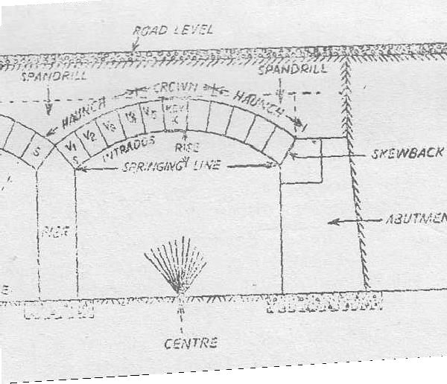

Classificationofsteelbridges
Steelbridgesareclassifiedaccordingto
- thetypeoftrafficcarried
- thetypeofmainstructuralsystem
- thepositionofthecarriagewayrelativetothemainstructuralsystem These are briefly discussed in thissection.
Classificationbasedontypeoftrafficcarried

Bridgesareclassifiedas
- Highwayorroadbridges
- Railwayorrailbridges
- Road -cum -railbridges

Classificationbasedonthemainstructuralsystem
Manydifferent typesofstructuralsystemsareusedinbridgesdependinguponthespan,carriagewaywidth and types of traffic. Classification, according to makeup of main load carrying system, is as follows:

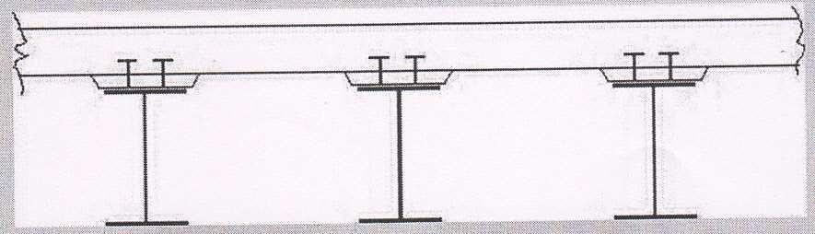
  - Girder bridges - Flexure or bending between vertical supports is the main structural action in this type. Girder bridges may be either solid web girders or truss girders or box girders. Plate girder bridges are adopted for simply supported spans less than 50 m and box girders for continuous spans up to 250 m. Cross sections of a typical plate girder and box girder bridges are shown in Fig.7.2 (a) and Fig. 7.2(b) respectively. Truss bridges [See Fig.7. 2(c)] are suitable for the span range of 30 m to 375 m. Cantilever bridges havebeen built with success with main spans of 300 m to 550 m. . They may be further, sub-divided into simple spans, continuous spans and suspended-and-cantilevered spans, as illustrated in Fig.7.3.
Fig.7.2(a)Plategirderbridgesection

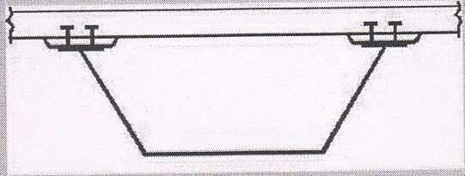
Fig.7.2(b)Boxgirderbridgesection
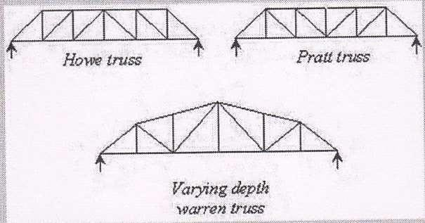
Fig.7.2(c)Someofthetrussesusedinsteelbridges

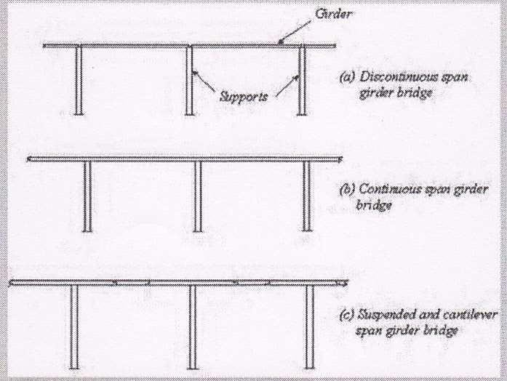
Fig.7.3Typicalgirderbridges
  - Rigid frame bridges - In this type, the longitudinal girders are made structurally continuous with the vertical or inclined supporting member by means of moment carrying joints [Fig.7.4]. Flexure with some axial force is the main forces in the members in this type. Rigid frame bridges are suitable in the span range of 25 m to 200 m.

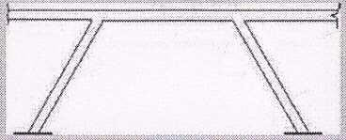
Fig.7.4Typicalrigidframebridge

Archbridges
The loads are transferred to the foundations by arches acting as the main structural element. Axial compression in arch rib is the main force, combined with some bending. Arch bridges are competitive in span range of 200 m to 500m.
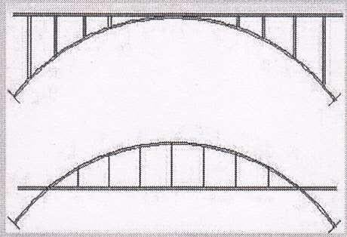

  - Cable stayed bridges - Cables in the vertical or near vertical planes support the main longitudinal girders. These cablesarehung from oneormoretall towers,andareusually anchored atthebottom to the

girders.Cablestayedbridges areeconomicalwhenthespanisabout150mto700m.Layoutofcablestayed bridges are shown in Fig. 7.6.

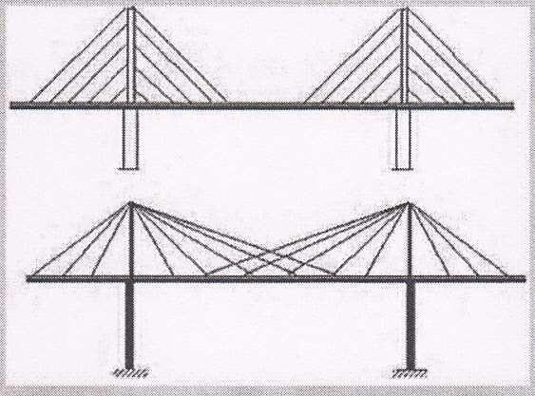
Fig.7.6Layoutofcablestayedbridges
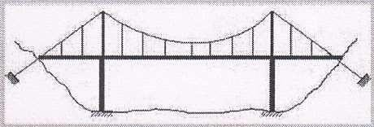
  - Suspension bridges - The bridge deck is suspended from cables stretched over the gap to be bridged, anchored to the ground at two ends and passing over tall towers erected at or near the two edges of the gap. Currently, the suspension bridge is best solution for long span bridges. Fig. shows a typical suspension bridge. Fig. 7.8 shows normal span range of different bridge types.
Fig.7.7Suspensionbridge

Classificationbasedonthepositionofcarriageway
Thebridgesmaybeofthe"decktype","throughtype"or"semi-throughtype".Thesearedescribedbelow with respect to truss bridges:
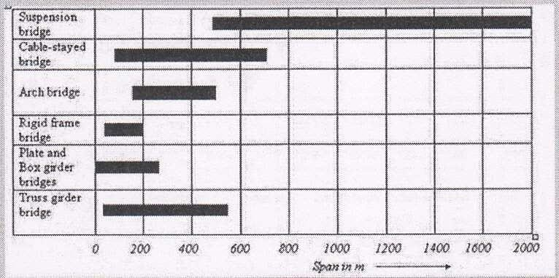
    - Deck type bridge -The carriageway rests on the top of the main load carrying members. In the deck type plate girder bridge, the roadway or railway is placed on the top flanges. In the deck type truss girder bridge, the roadway or railway is placed at the top chord level as shown in Fig.7.9(a).
Fig.7.8Normalspanrangesofbridge system

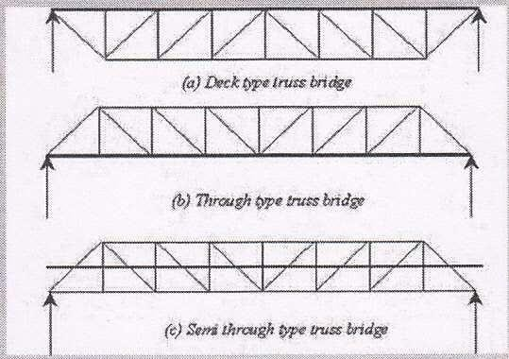

TYPESOFCONCRETEBRIDGES

ArchBridges
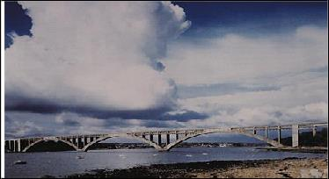
Arch bridges derive their strength fromthe fact that vertical loads on the arch generate compressive forces in the arch ring, which is constructed of materials well able to withstand these forces. The compressive forces in the arch ring result in inclined thrusts at the abutments, and it is essential that arch abutments are well founded or buttressed toresist the vertical and horizontal components of these thrusts. If the supports spread apart the arch falls down. Traditionally, arch bridges were constructed of stone, brick or mass concrete since these materials are very strong in compression and the arch could be configured so that tensile stresses did not develop. Modern concrete arch bridges utilize prestressing or reinforcing to resist the tensile stresses which can develop in slender archrings.

ReinforcedSlabBridges
For short spans, a solid reinforced concrete slab, generally cast in-situ rather than precast, is the simplest design. It is also cost-effective, since the flat, level soffit means that false work and formwork are also simple. Reinforcement, too, is uncomplicated. With larger spans, the reinforced slab has to be thicker to carry the extra stresses under load. This extra weight of the slab itself then becomes a problem, which can be solved in one of two ways. The first is to use prestressing techniques and the second is to reduce the deadweight of the slab by including 'voids', often expanded polystyrene cylinders. Up to about 25m span, such voided slabs are more economical than prestressed slabs.

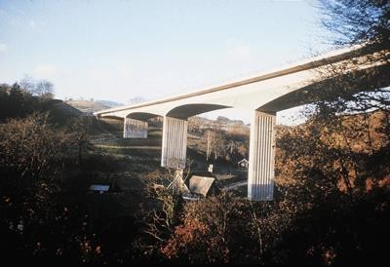

BeamandSlabBridge
Beamandslabbridgesareprobablythemost common formofconcretebridgeintheUKtoday,thankstothe success of standard precast prestressed concrete beams developed originally by the Prestressed Concrete Development Group (Cement & Concrete Association) supplemented later by alternative designs by others, culminating in the Y-beam introduced by the Prestressed Concrete Association in the late 1980s.
They have the virtue of simplicity, economy, wide availability of the standard sections, and speedof erection.The precast beams are placed on the supporting piers or abutments, usually on rubber bearings which are maintenance free. An in-situ reinforced concrete deck slab is then cast on permanent shuttering which spans between the beams.
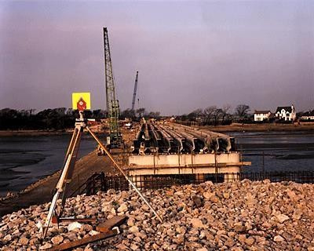
The precast beams can be joined together at the supports to form continuous beams which are structurally more efficient. However, this is not normally done because the costs involved are not justified by the increased efficiency.

Simplysupportedconcretebeamsandslabbridgesarenowgivingwaytointegralbridgeswhich offertheadvantages of less cost and lower maintenance due to the elimination of expansion joints and bearings.

Techniquesofconstructionvaryaccordingtotheactualdesignandsituationofthebridge,therebeingthreemain types:

- Incrementallylaunched
- Span-by-span
- Balancedcantilever

Incrementallylaunched

As the name suggests, the incrementally launched technique creates the bridge section by section, pushing the structureoutwardsfromtheabutmenttowardsthepier.Thepracticallimit onspanforthetechniqueisaround75m.

Span-by-span

Thespan-by-spanmethodisusedformulti-spanviaducts,wheretheindividualspancanbeupto60m.

Thesebridgesareusuallyconstructedin-situwiththefalseworkmovedforwardspanbyspan,but canbebuilt of precast sections, put together as single spans and dropped into place, span by span.

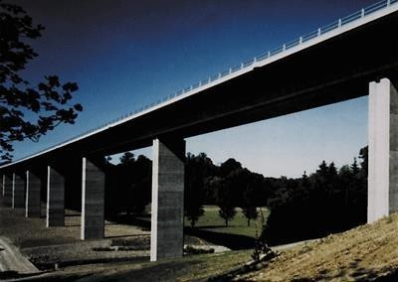

Balancedcantilever

In the early 1950's, the German engineer Ulrich Finsterwalder developed a way of erecting prestressed concrete cantilevers segment by segment with each additional unit being prestressed to those already in position. This avoids the need for false work and the system has since been developed.
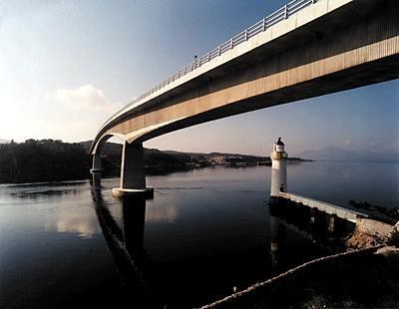
Whether created in-situ or using precast segments, the balanced cantilever is one of the most dramatic ways of buildingabridge.Workstartswiththeconstructionoftheabutmentsandpiers.Then,fromeachpier,thebridgeis constructed in both directions simultaneously. In this way, each pier remains stable - hence 'balanced' - until finally the individual structural elements meet and is connected together. In every case, the segments are progressively tied back to the piers by means of prestressing tendons or bars threaded through eachunit.

IntegralBridges
One of the difficulties in designing any structure is deciding where to put the joints. These are necessary to allow movement as the structure expands under the heat of the summer sun and contracts during the cold of winter. Expansion joints in bridges are notoriously prone to leakage. Water laden with road salts can then reach the topsof the piers and the abutments, and this can result in corrosion of all reinforcement. The expansive effects of rust cansplitconcreteapart. In addition, expansionjointsand bearings areanadditionalcost so moreand morebridges are being built without either. Such structures, called 'integral bridges', can be constructed with all types of concrete deck. They are constructed with their decks connected directly to the supporting piers and abutments and with no provision in the form of bearings or expansion joints for thermal movement. Thermal movement of the deck is accommodated by flexure of the supporting piers and horizontal movements of the abutments, with elastic compression of the surrounding soil.

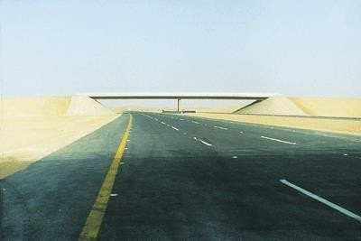

Already used for lengths up to 60m, the integral bridge is becoming increasingly popular as engineers and designers find other ways of dealing with thermal movement.

Cable-StayedBridges

For really large spans, one solution is the cable-stayed bridge. These types of bridges first developed in west Germany. They consists of cables provided above the deck and are connected to the towers. The deck is either supported by a number cables meeting in a bunch at the tower or by joining at different levels on the tower. The multiple cables would facilitate smaller distance between points of supports for the deck girders. This results in reduction of structure depth. The cables can arrange in one plane or two planes. The two plane system requires additional widths to accommodate the towers and deck anchorages. Singly plane system requires less width of deck.Where all elements are concrete, the design consists of supporting towers carrying cables whichsupport thebridgefrombothsidesofthetower.Most cable-stayedbridgesarebuilt usingaformofcantilever construction which can be either in-situ or precast.


The cable stayed bridges are similar to suspension bridges except that there are no suspenders in the cable stayed bridges and the cables are directly stretched from the towers to connect with decking. No special anchorage is required for the cables as incase of suspension bridges because the anchorage at one end is done in the girder and at the other on top of tower. The cable-stayed bridges have been found economical for up to span 300m. However due to cantilever effect their deflection is rather high and hence theyare not preferred for very long span inrailways.

SuspensionBridges
Concrete plays an important part in the construction of a suspension bridge suspension bridgs are ideal solutionfor bridging gaps in hilly areas because of their construction technology and capacity of spanning large gaps. There will be massive foundations,usuallyembeddedin the ground, thatsupportthe weight and cableanchorages
.The cable takes shape of catenary between two points of suspension. The flooring of bridge supported by thecable by virtue of tension developed in its cross section. The vertical members are known as suspenders are provided to transfer load from bridge floor to suspension cable. There will also be the abutments, again probably

inmassconcrete,providingthevitalstrengthand abilitytoresist theenormousforces,andinaddition,theslender superstructurescarryingtheupperendsofthesupportingcablesarealsogenerallymadefromreinforced concrete.
Typicaldeck,throughandsemi-throughtypetrussbridges

    - Through Type Bridge - The carriageway rests at the bottom level of the main load carrying members. In the through type plate girder bridge, the roadway or railway is placed at the level ofbottom flanges. In the through type truss girder bridge, the roadway or railway is placed at the bottom chord level. The bracing of the top flange or lateral support of the top chord under compression is also required.
    - Semi through Type Bridge - The deck lies in between the top and the bottom of the main load carrying members.Thebracingofthetopflange or top chord under compressionis not done andpart of the load carrying system project above the floor level The lateral restraint in the system is obtained usually by the U-frame action of the verticals and cross beam actingtogether.

Concretebridges-

Theycanbedividedintothefollowingmainclasses (1)Unstiffened suspension Bridges.
(2)StiffenedsuspensionBridges.

Un-stiffened suspension Bridges:-Incase of Un-stiffened suspension Bridges the moving load is transferred direct to the cables by each suspender. These are used for light construction such as foot bridges forest train structures, etc where the moving load is negligible and deflection requirements are not controlling. Alsotheplaceswherespanis verylongand theratiodeadto movingloadintensityis so great to render stiffening unnecessary.
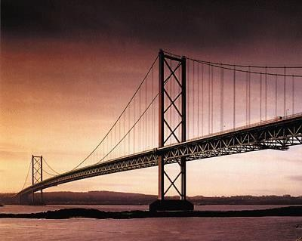

Stiffened suspension Bridges:-In stiffened type suspension Bridges moving loads are transformed to the cables through mediumof trusses called stiffeninggirders .The stiffeninggirder assists the cable to become more rigid and prevent change in shape and gradient of roadway platform. It is therefore adopted for heavy traffic .

IRCBridgeloading:-
The public roads in India are managed and controlled by the Government and hence bridges to be constructed for roads to be designed as per standards set up by standard authorities. For

highwaybridgesstandardspecificationsarecontainedintheIndianRoadCongress(I.R.C) Bridgecode. In India, highway bridges are designed in accordance with IRC bridge code. IRC: 6 - 1966 – Section II gives the specifications for the various loads and stresses to be considered in bridge design. There are three types of standard loadings for which the bridges are designed namely,

- IRCclassAAloading,
- IRCclassAloading
- IRCclassBloading.

IRCclass AA loading:-
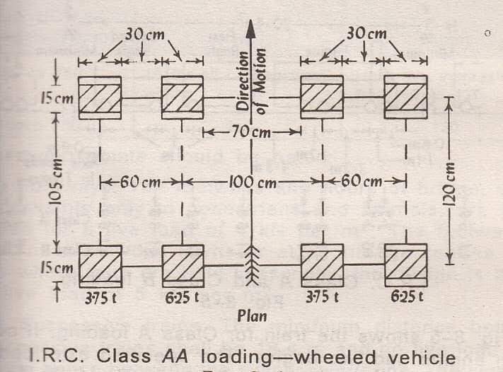
IRC class AA loading consists of either a tracked vehicle of 70 tonnes or a wheeled vehicle of 40 tonnes with dimensions as shown in Fig. The units in the figure are mm for length and tonnes for load. Normally, bridges on national highways and state highways are designed for these loadings. Bridges designed for class AA should be checked for IRC class A loading also, since under certain conditions, larger stresses may be obtained under class A loading. Sometimes class 70 R loading given in the Appendix - I of IRC: 6 - 1966 - Section II can be used for IRC class AA loading. Class 70 Rloading is not discussed further here.

IRC class A loading:-Class A loading is based on heaviest type commercial vehicle consists of awheel load train composed of a driving vehicle and two trailers of specified axle spacings. This loading is normally adopted on all roads on which permanent bridges areconstructed.

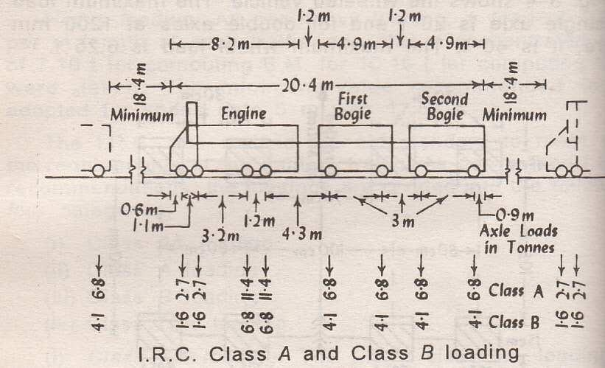
.IRCclassBloading:-ClassBloadingisadoptedfortemporarystructuresandforbridgesinspecified areas. For class A and class B loadings, reader is
referredtoIRC:6-1966–SectionII.

CHAPTER-12

CULVERTSANDCAUSEWAYS

Culvert- A culvert is defined as a small bridge constructed over a stream which remains dry most part of the year. It is across drainage work havingtotal length not exceeding6mbetween faces of abutment.

Typesof Culverts;-
Thefollowingaresixdifferenttype culvert.
  - Archculvert
  - Boxculvert
  - PipeCulvert
  - SlabCulvert

Arch culvert:-
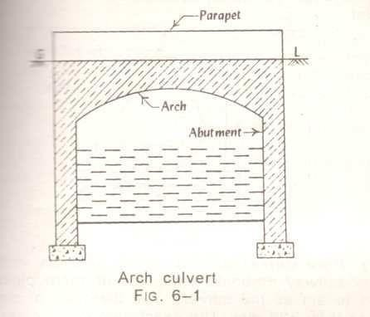
Anarchculvertconsistsofabutmentswingwalls,arch,parapetsandthefoundation.Theconstruction materials commonly used are brick work or concrete. Floor and curtain wall may or may notbe provided depending upon the nature of foundation soil and velocity of flow. A typical arch culvert is shown in figure.

Box culvert:-
Incaseofboxculverttherectangularboxesareformedofmasonry,R.C.Corsteel.TheR.C.Cbox culverts are very common and they consist of the following two component
- ThebarrelorboxsectionofsufficientlengthtoaccommodatetheroadwayandtheKrebs.
- Thewingwallssplayedat45forretainingtheembankmentandalsoguidingtheflowofwaterinto and out of the barrel.
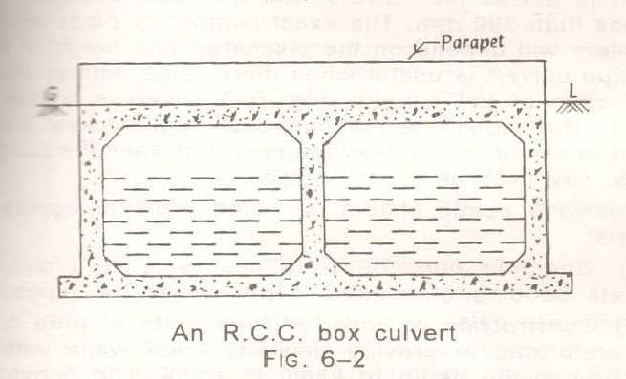

Fig.6-2showsanR.C.Cboxculvertwithtwoopenings.Followingpointsshouldbe noted.

(i)Foundation: The box culverts prove to be safe where good foundations are easily available. (ii)Height: The clear vent height i.e. the vertical distance between top and bottom of the culvert rarely exceeds 3 meters.
- Sap: The box culverts are provided singly or in multiple units with individual span exceed about 6 m or so, it requires thick section which will make the constructionuneconomical.
- Top: Dependingupon the siteconditions, the top level of box maybe at theroadlevel orit can even be at a depth below road level with filling of suitablematerial.

Pipe Culvert:
They are provided when discharge of stream is small or when sufficient headway is not available. Usually one or more pipes of diameter not less than 60cm are placed side by side. Their exact number and diameter depend upon the discharge and height of bank. For easy approach of water splayed type wing walls are provided infig. 6.3 shows a Hume pipes culvert of single pipe. The pipes can be built of masonry. Stone ware, cement concrete, cast iron or steel. Concrete bedding should also be given below the pipes and earth cushion of sufficient thickness on the top to protect the pipes and their joints. For Economic reason road culverts should have non-pressure heavy duty pipes of type ISI class NP3 conforming to IS:458-1961. As far possible the gradient of the pipe should not be less than 1000.
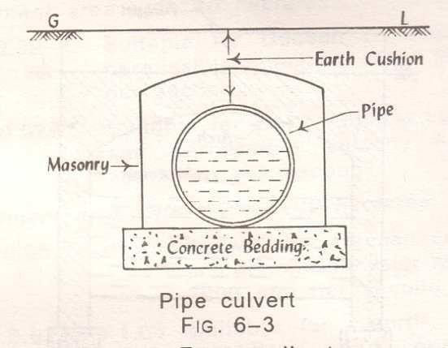

Slab Culvert:
A slab culvert consists of stone slabs or R.C.C slab, suitably support on masonry walls on either side.As shown in fig 6-4. The slab culverts of simply type are suitable up to a maximum span of 2.50 m or so. Howeverthe R.C.C culvertsofdeck slab typecan economically be adopted up to spans ofabout8
m. However, the thickness of slab and dead weight may sometimes prove to be the limiting factors for deciding the economical span of this type of culverts.


The construction of slab culverts is relatively simple as the frame work can easily be arranged, reinforcement can be suitably placed and concreting can be done easily. This type of culvert can beusedforhighwayaswellasRailwayBridge.Dependinguponthespanofculvertandsiteconditionsthe abutment and wing walls of suitable dimensions may be provided. The parapet or hand rail of at least 750 mm height should be provided on the slab to define the width ofculvert.

CAUSEWAYS:
A road causeway is a pucca dip which allows floods to pass over it. It may or may not have opening or ventsforlowwater toflow.If it hasventsforlowwatertoflowthenit isknown as high level causeway or submersible bridge ; otherwise a low level causeway.

TYPESOFCAUSEWAY:

Lowlevel causeway:
It is also known as Irish Bridge. The beds of small rivers or streams, which remain dry for most part of the year, are generally passable without a bridge. This involves heavy earth works in cutting for bridge approaches .Banks of such types of streams are cut down at an easy slope. Forstreams of rivers in plains having sandy beds, it is often sufficient to lay bundles of grass over and across the sandy track. The bundles may be of 20 to 25cm in diameter whose ends are secured by longitudinal fascines pegged down by stakes.
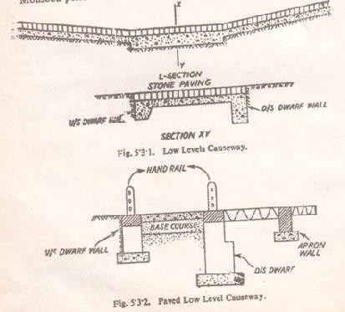

For crossings important from traffic point of view it is essential to lay a metal or pucca paving of stone or brick set in lime mortar on a substantial bed of concrete. To prevent against possible scour and undermining a cut off or dwarf wall usually 60cm deep on the upstream side and 120 to 150cm on downstream side is provided. Fig. 5.3.1 below shows the details of a typical Irish bridge.

ThelowlevelcausewaycouldbeprovidedwithopeningsformedbyconcreteHumepipesifthereisa continuous flow stream during the monsoon periods.

HighlevelCauseway:
A high level causeway is submersible road bridge designed to be overtopped in floods. Its formation level is fixed in such a way as not to cause interruption to traffic during floods for more than threedaysat atimenotformorethansixtimesinayear.Asufficient numbersofopeningsareprovided to allow the normal flood discharge to pass through them with the required clearance. They areprovided with abutments and piers, floors and slabs or arches to form the required number of openings. The slope of the approaches is kept as 1 in 20.When the velocity is high and stream bed is soft the aprons could be of concrete or harder masonry upto a certain distance. Similarly, the road can beformed of a cement concrete slab or stone blocks set in cement mortar. A typical type of high level causeway is shown in Fig.5.3.3.If railing are provided in the bridge, they should be of collapsible type.Temporary causewaysused for an emergency military operations are formed either by using timber stringers and planking over cribs used as piers or by constructing a culvert usingpipes.

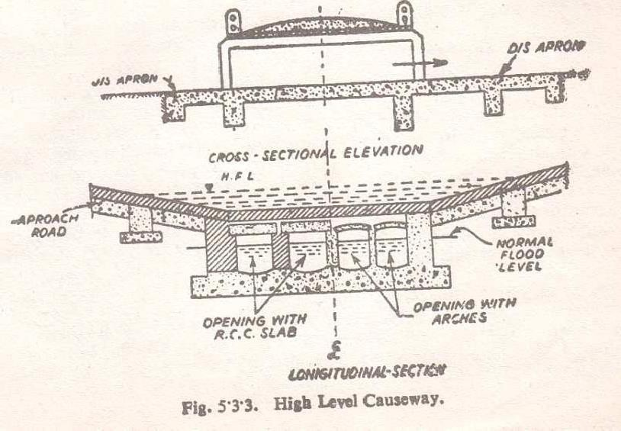

Referencebook:
RailwayEngineering
By: Chandra & Agrawal Atextbookofrailwayengineering
By:S.C.Sexena&S.P.Arora Railway Engineering
By:S.C.Rangawala

LECTURE NOTES
ON

CONSTRUCTION MANAGEMENT
Compiled by
Ms. SASMITA KUMARI DAS

Lecturer in Department of Civil Engineering
GANDHI ACADEMY OF TECHNOLOGY AND ENGINEERING

CONTENTS

Chapter No. | Topic Name | Page No.
01. | Introduction to Construction Management | 3-6
02. | Construction Planning | 7-21
03. | Materials and Stores Management | 22-34
04. | Construction Site Management | 35-40
05. | Construction Organization | 41-46
06. | Construction Labour and Labour Management | 47-76
07. | Equipment Management | 77-98
08. | Quality Control | 99-118
09. | Monitoring Progress | 119-148
10. | Safety Management In Construction | 149-168
11. | Role of Vulnerability Atlas of India in construction projects

INTRODUCTION

CHAPTER-1

AIMSANDOBJECTIVESOFCONSTRUCTIONMANAGEMENT:
Construction management is a managerial process involved in construction industries like management of labour, material and equipment to minimize the project cost and project duration and also to optimize the quality of works.
Objectives:
Themainobjectivesofconstructionmanagementare:
    - Completingtheworkwithinestimatedbudgetandspecifiedtime.
    - Evolvingareputationforhighqualityworkmanship.
    - Providingsafeandsatisfactoryworkingconditionsforallpersonnelandworkers.
    - Takingsounddecisionsatthelowestpracticalmanagementlevelthrough delegation of authority.
    - Motivatingthepeopletogiveoftheirbestwithintheircapacities.
    - Creatinganorganizationthatworksasateam.

FUNCTIONSOFCONSTRUCTIONMANAGEMENT:
Thefunctionsofconstructionmanagementare:

- Planning and scheduling: Planning involves formulation of a number of alternativerealisticworkplansforachievingspecifiedobjectivesandfinally selecting plan which is best suited from the stand point of available resources and constraints imposed upon the project. It essentially covers the aspect of ‘What to do’ and ‘How to do it’.
Schedulingisthefittingdurationofthefinalworkplanto a time scale. It shows the order of various construction activities. It deals with aspect of ‘When to do it’.
- Organizing: Organizing is concerned with division of the total construction work into manageable departments/sections and systematically arranging various operations by delegating specific task to the individuals. The relationships between various personnel are established and the organizational structure of the project is depicted by simple flow chart.
- Staffing: Organizing involves the division of the project work into sections and staffing is the provision of people to fill the positions so created. Recruitingtherightpeople,arrangingstafftrainingcoursesandcarryingout proper staff assessment are all part of the staffing function.
- Directing:Thedirectingfunctionisconcernedwithtrainingsub-ordinatesto carry out assigned task, supervising their work and guiding their efforts. The

essenceofdirectingliesintheabilitytomotivatepeopleindividuallyandas
groupstoutilizetheircreativeeffortinachievingspecifiedobjectives.
- Controlling: Controlling is necessary for ensuring effective and efficient working. It involves a constant review of the work plan to check on actual achievement and to discover and to rectify deviations through appropriate corrective measures. The essential steps in management control are:
  - Measurement of actual performance in terms of progress, quality and cost incurred;
  - Comparisonofactualandplannedperformance

- Co-coordinating:Sinceauthorityconvergestothetopoftheorganizational pyramid, itis necessaryto bringtogether andco-ordinate the work various departments and sections. This requires and efficient system of communications that each department and section is aware of its role and the assistant to be expected from others. Regular meetings of departmental/sections head with top management are fundamental to proper coordination ,so that plans, problems and remedies are discussed for determining the best solution.

THECONSTRUCTIONTEAMCOMPONENT:
    - Forcivilengineeringprojectaconstructionteamiscomposedofowner, engineer/architects and contractor.
    - Theobjectoftheteamisconvertownersconceptualintoareality.
    - Theownerformstheconstructionteamtosurveyhisintereststhroughthe services of both the contractor and the team of engineer.
    - Thefunctionoftheconstituentsofanyteamdependsuponthescopeand nature of the project.

Owner:
The owner may be an individuals or group of individuals, private or public sector company. The owner is the ultimate authority over the project. All the power of decision makingregardingmanagerial financialandadministrative aspects is invested inhim. He is responsible for the fund and other resource of the project.
Engineer:

It includes the empowered construction engineers who are sociallyresponsible for the project management, store control inspection and quality assurance, construction supervision, cost control and such similar assets. It also includes architect, structural engineer, quantity surveyor, mechanical and electrical engineer, specialists such as structural constant, safety and maintenance planner, soil investigator.
- Architects-The dutyofarchitects isto assessthe owner’sfunctional requirements and prepare plans and specification for the purpose.
- Structural engineer-The structural engineer is to prepare structural design as for requisite loads through technical design and to prepare working drawing which is handed over to construction engineer.
- MechanicalEngineer-Heisresponsibleformechanicalservicesassociatewiththe project during and after construction.
- Electrical Engineer-He is concerned with the preparation of working drawing for electrical power and distribution system during and after construction.
- QuantitySurveyor-Hisdutyisto,
  - Estimatethecostof work.
  - Preparebillofquantitiesandtenderdocument.
  - Assestheextracostduetospecialfeatures.
  - Preparethecashflowstatementduringconstruction.
  - Preparethefinalaccountsoncompletionoftheproject.
- Specialist-Theyhavetoperformspecializedworkentrustedtothem.suchassoil investigatorcollectinformationregardingsoilfortheproperdesignoffoundation.
Contractor:
- The contractor may be an individual undertaking small contracts or a large construction company undertaking turn –key projects.
- Contractor whether small or big needs the services of qualified engineers. Some of the engineers employed by the contractor deal with office work such as designing, tendering, scheduling etc. and others known as site engineers are concerned with the actual execution of work such as surveying, leveling, construction & billing.
- Hehastocollectratesofmaterialsandlabourtodeterminethetimerate.
- Itisdutyandliabilityofacontractortofollowthelabouract.
- Itisdutyofcontractortosafeguardhisownmenandmaterial.
- Heshouldfinallyhandoverthecompletedworktotheownerandgetthefinal payment, adjusting the running bill accounts.

RESOURCESFORCONSTRUCTIONMANAGEMENT:
Constitutional i.e. creation in the form of finished product is the direct resultofusingvariousresourcesinthemosteffectiveways.Thevariousresources being used in the construction project can be enumerated as,
- MANPOWER
- MATERIAL

- MACHINARY
- MONEY
- SPACE
- Manpower:
  - Manpower in the form of technical and managerial personnel and work force in various trades is essential to carry out project activities.
  - Technical managerial personnel are essential for efficient use of human resources and to achieve project completion within estimated time and budget.
  - Technical personnel include engineers, architects, quantity surveyors, supervisors, technicians etc.
  - Theworkforceconsistsofskilledandunskilledworkers.
- Materials:
Materials such as bricks, stones, cement, aggregate, steel, shuttering, scaffolding,timber,watersupply,sanitaryandelectricalfittings,petrol,oil, lubricant, etc. are required for construction.
- Machinery:
Foranyconstructionwork,variousplant/equipmentsandtoolsarerequired. Depending on the type and nature of the construction job, machinery required at site includes batching plant , mixer, tractor, excavators, dumpers, cranes, pumps, generator, workshop equipments etc .Power isan essential resource required for lighting, running the plant equipments and for other facilities.
- Funds:
Adequate funds should be available for smooth implementation of the project.Financialplanningisessentialforsmoothcashinflowandoutflowto avoid delays in project activities.
- Space:
Foranyconstructionactivitytoproceedefficientlyitisessentialtoplanthe available space at site for:
  - Storingmaterials.
  - Providingyardsforbarbenders,carpenters,installationof equipmentandplant,repairworkshops,castingyardsetc.
  - Siteoffice,labourcampetc.

CHAPTER-2
CONSTRUCTIONALPLANNING
IMPORTANTSOFCONSTRUCTIONALPLANNING:
The need for better construction practice, systematized planning and programming of works and effective management in the industry is therefore the demand of the day.
Constructional planning is the first step of the construction management. The constructionplanningofacivilengineeringprojectmustconsiderthewiderangeofaspect involved, site investigation, market survey, bidding of the works, post tender negotiation and agreement planning for the works monitoring and controlling the progress of work during the execution up to the completion of the work, even its maintenance during the stipulatedperiod.
DEVELOPINGWORKBREAKDOWNSTRUCTUREFORCONSTRUCTIONWORK:
For effective planning, it is necessary to break down the total project into sub- sections and activities. Each activity or job may further be sub-divided into smaller jobs for planning at various levels.
The functional elements of project and their inter-relationship are determined by a technique known as work breakdown structure. Such a technique establishes the hierarchical order in a system by breaking the project into recognizable systems, sub- systems, and discrete activities. For example, construction of a compound wall may be broken down as shown in figure,

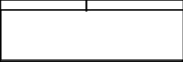
COMPOUNDWALL
EXCAVATION
MASONRY IN FOUNDATION
MASONRYINSUPER STRUCTURE
COPING
LEAN
CONCRETEIN FOUNDATION
DPC
POINTING

(Workbreakdownstructure)
ofacompoundwall)

CONSTRUCTIONPLANNINGSTAGES:
For efficient implementation of project activities, planning is essential at various stages. Planning for construction may be done in the following two stages. Planning for construction may be done in the following two stages:
- Pre-tenderStage
- PosttenderStage
Pre-TenderStage:

Pre-tender planning is broad based and is carried out by the contractor. It is the stage in which a contractor has the best opportunity of planning his likely method of construction for the future contract and prepares a realistic programme for carrying out the work. This stage enables the contractor to make a proper bid and prepare him for completingtheworkinthestipulatedtime.Duringthisstage,thecontractor’smainaimis to see whether the contract under consideration is profitable or not. Before a contract is undertaken, the contractor is required to visit the site of construction work.
Pre–tenderplanningincludesthefollowingsteps:
- Examiningdrawingsandspecificationstoidentifyvariousitemsofwork.
- Carrying out site investigation and market survey to assess the availability andrates of materials, manpower, machinery and other facilities.
- Identifyingalternativemethodsofexecutingtheworkforselectingthemost suitable4 and economical method.
- Estimatingthequantitiesof differentitemsofworkandthetimerequiredfortheir completion.
- Preparingthetentativeconstructionschedulewithreferencetothestipulated time of completion.
- Decidingtheoverheadsandmarginofprofitandfinalizingthetenderpricefor completing the work within the stipulated time.
Post-tenderstage:
Post-tenderstageisalsocalledContractstageorconstructionstage.Thisstage commenceswiththeacceptanceofthetenderandextendstillcompletionofthecontract. Afterthepre-tenderstage, thecontractorhastoundertakedetailedplanningto organize various activities of construction work so that the project may be completed within the scheduledtime.Post-tenderplanningisusedinchalkingoutspecificdetailsforexecution of the project. Inadequate planning at this stage inevitably results in delays leading to heavier expenditure than originally estimated.

Post-tenderstageplanninginvolvesthefollowingsteps:
- Establishingagoodcommunicationsystembetweenmembersofthe construction team for the smooth running of project work.
- Evaluatingalternativeconstructionmethodsidentifiedduringthepre-tenderstage in order to select the most economical and efficient method.
- Studyinginter-relationshipsofvariousitemsofworkandfinalizationofproper sequence of operations.
- Calculatingthephasedrequirementofconstructionmaterialssuchascement, aggregate, bricks, steel etc.
- Determiningthephasedrequirementofplantandmachineryincludingrepairand maintenance facilities.
- Preparingdetailsofmanpowerrequirementincludinglabour,supervisorsand managerial staff for various stages of the work.
Good communicationbetween various members of the construction team isessential to complete the project within scheduled time. Proper co-ordination between members of theconstructionteamvoidsthepossibilityofdelaysatvariousstagesofthework.Various alternatives have to be considered in derail to ensure proper utilization of project resources,leadingtothe greatesteconomyincost.Constructionprogrammeisdepicted in the form of charts which can be readily understood by workers, supervisors and constructionmanagers.Theprogrammeprovidesinformationregardingthedateandtime of starting and completing different items and activities of work including working drawings, staff recruitment, supply orders, delivery of materials etc.

CONSTRUCTIONSCHEDULINGBYBARCHARTS:
Schedulingistheprocessoffittingtheworkplantoatimeframeindicatingthestart and completion each activity. It also shows sequential relationships among various activities.
The construction schedule is a tool that a contractor uses to manage time and execute activities in aproper sequence. Topreparea construction schedule, the project is divided into different activities or operations. The sequence of operations can be decided after knowing their inter-relationship as per the construction method adopted.
Theconventionalmethodofschedulingusedintheconstructionindustryisthebar chart. It is also known as Gantt Chart after Henry Gantt. Who developed this technique around1900.Abarchartconsistsoftwoco-ordinateaxes,oneshowingthetimeandthe other showing jobs or activities to be performed. Each job is depicted in the form of a horizontal line or bar and the lengthof a bar indicates duration of the job oractivity. In a project, some jobs are taken up concurrently and some are required to be completed before other can begin. Thus, in a bar chart, some of the bars run parallel to each other and some runseriallywithonebarbeginningaftertheotherbarends.Thelevelof detail of the activities and the unit of time is determined by the intended use of the bar chart.

Activities Time(Days)

Layoutandexcavate(foundation)
5
Placeleanconcrete 1
Fabricateshuttering 3
Cutandbendreinforcement 4
Fixreinforcement 2
Fixshuttering 1
Pourconcrete 1
The activities of ‘layout and excavate foundation’, ‘fabricate shuttering’ and ‘cut and bendreinforcement’cantart simultaneously as these activities areindependentof
each other. These activities being concurrent are shown by parallel lines or bars in the chart(Fig.33).Activity‘peacemud-mat(leanconcrete)’canonlystartaftercompletingthe activity‘layoutandexcavatefoundation’.Thesetwoactivitiesbeinginseriesaredepicted inthebarchartoneaftertheother.Likewise,‘fixreinforcement’canonlybetakenupafter placingmud-mat(leanconcrete).‘fixshuttering’followsthefixingofreinforcement.These activities,beinginseries,areshownoneaftertheother.‘pourconcrete’isthelastactivity which follows the fixing of
shutteringandbeinginseries,isshownassuchinthebarchart.
Bar charts are easy to prepare and to understand. The progress achieved at site inrespectofanyactivitymaybeshownonthebarchartbydrawingacolouredlineunder the planned bar or line of that activity. The progress achieved is generally indicated on the coloured lined as a percentage. Bar chart may,therefore, beused formonitoring theprogressof work.
Barchartsmayalsobeusedfordepictingtheresourcerequirementsofaconstruction
job.

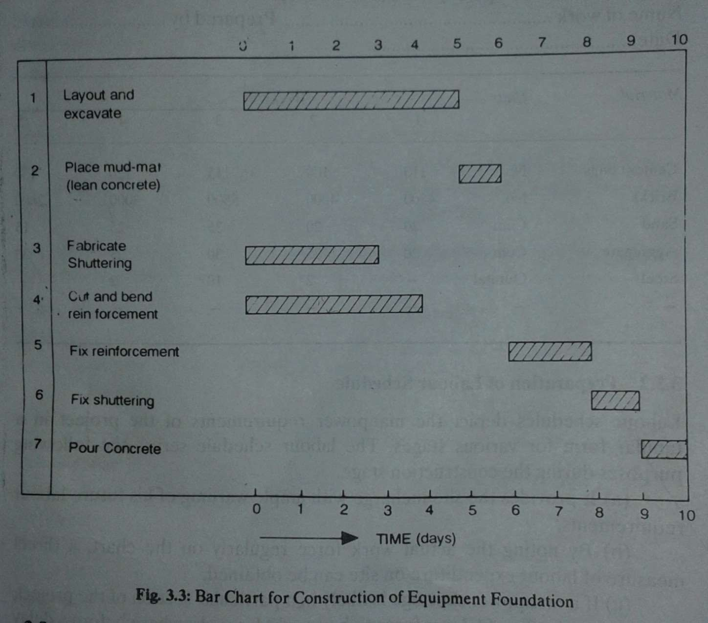

PREPARATION OF MATERIAL, EQUIPMENT, LABOUR AND FINANCESCHEDULES:

For any given work, the resources required are materials, manpower, machinery and money.Theseresourceshavetobeutilizedinaplannedandefficientmannerinorderto derive the maximum benefit. Further,theremaybe manyuncertainties in the availability of resources. The right type of labour or equipment may not e available at the required time due to labour unrest or breakdownof machinery. Thus, to execute the construction work in an efficient manner and without wastage of any of the inputs, schedules for various project resources need to be prepared.

PreparationofMaterialSchedule

Material schedules showing weekly requirements of commodities are preparedfrom the construction programme. A material schedule enables storage space to be adequately planned and necessary arrangements to be made for timely delivery of materials. Disruption of work due to shortage of materials can be avoided by using a material schedule. The material schedule may be prepared either month wise or week wise depending on the extent of the project and storage space.
Letusconsideratypicalmaterialschedulepreparedweekwisefortheconstruction of a temporary shed(8m x 20m).

Name of work Prepared
by……………….................................
Date…………………………………………….

Material Unit
Week s

5 |  | 1 |  | 2 | 3 | 4
Cementbags No. |  | 110 |  | 100 | 115 |  | 120
130  Bricks | No. |  | 4500 | 4000 | 5500 | 3000
2600
Sand | Cum | 20 | 20 | 35 | 25 | 15
Aggregate | Cum | 20 | 35 | 30 | 25 | 30
Steel | Quintal | _ | 2 | 10 | 2 | -
- | - | - | - | - | - | -
PreparationofLabourSchedule
Labourschedulesdepictthemanpowerrequirementsoftheprojectinatabularform for various stages. The labour schedule serves the following purposes during the construction stage.

      - Itprovidesthesiteinchargewithamplewarningofhisfuturelabourrequirements.
      - Bynotingtheactualworkforceregularlyonthechart,adirectmeasureoflabour expenditure on site can be obtained.
      - Ifamanpowershortageislikelyinaparticularsectionoftheproject,itenables such type of labour force to be sought from elsewhere before a delayoccurs.
      - Ithelpsinefficientandoptimumdeploymentofthelabourforceinvarious sections of the project.

Nameofwork…………………………………………………………………Preparedby……………………
……………………
……………Date……………………………………………………………………….

Manpower Weeks

1 2 34

5
Fore man 1 1 1
1 1
Carpenter - - - 1 1
Welder - - 3 2 1
Mason 1 1 2 2 1
Mixeroperator - - - -
- Labourers 3 3 10
6 3 - - -
- - -
Preparation of
Equipment(Machinery) Schedule

An equipment schedule is prepared for all plant/equipment required to be deployed on the project. From this schedule, delays in the work that may occur either due to non- availability or breakdown of equipment can be averted.
Name of work Prepared
by…………………………………………………… Date……………………………………………………………………….
Weeks
Equipment | 1 | 2 | 3 | 4 |  | 5
Concretemixer | - - |  | 1 |  | - -
Vibrator | - - |  | 1 |  | - -
Weldingset | - - |  | 1 |  | 1 |  | 1
Truck | - - |  | 1 |  | 1 |  | 1
- | - | - | - |  | - |  | -

Such a schedule enables the efficient and optimal utilization of plant and equipmentonaproject.Usingthisschedule,timelyarrangementscanbemadeforrenting or deploying particular equipment at a particular time.
2.5.3PreparationofFinanceSchedule

Financeschedulesareessentialbothfor thepre-tender and constructionstages.A finance schedule shows the amount of cash required at different stages of the construction project. It enables long-term financial planning for the entire project to be carriedoutinanefficientmanner.Italsoconsiderscashinflowfromtherunningbillsand indicates finances required for the successful completion of the project. The finance schedule for the construction of a temporary shed.
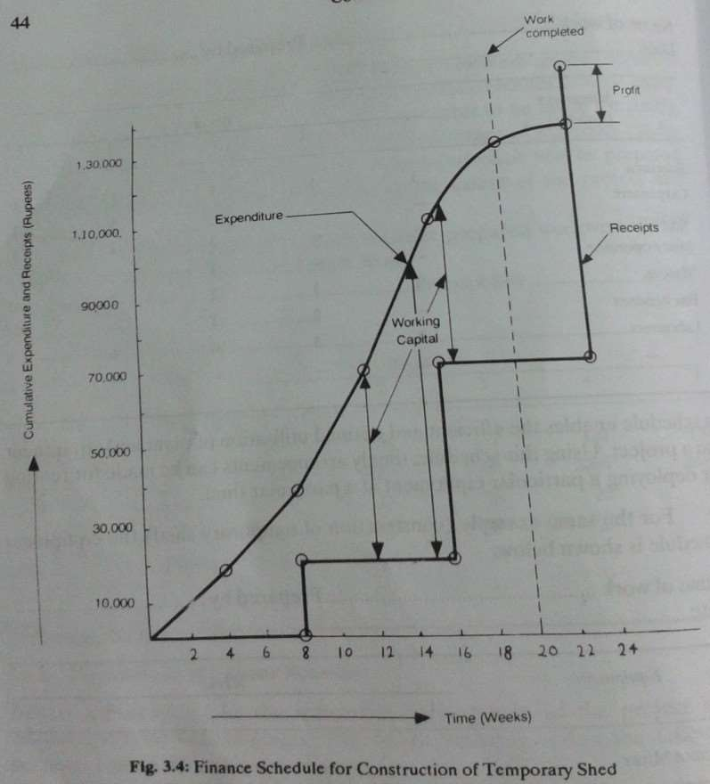

LIMITATIONSOFBARCHARTS:

Limitationsofbarchartsareasfollows:

- Interdependenciesofactivities
A construction project consists of a large number of activities. The bar chart doesnot showclearlythe interdependenciesamong the various activities. Thisis amajordeficiency.Themerefactthattwoormoreactivitiesarescheduledtostart atthesametime,doesnotmaketheminterdependentorcompletelyindependent. Consideraconstructionprojectinvolvingexcavatingfoundation,fixing shutteringandconcretinginwhichthetimeconsumedbyeachactivityisasunder:
Excavatingfoundation 20 weeks
Fixingshuttering 14 weeks
Concreting 16 weeks
If the activities are taken up in a series, the total time taken for completion of project will be 50 weeks. As we can easily see, fixing of shuttering may start after the completion of say half of foundation excavation. Similarly, concreting may start say 5 weeks

after fixing of shuttering. The bar chart of these activities is shown in figure 3.5. As per the bar chart, fixing of shuttering still has 4 weeks of work after excavation is over. If, however, excavation is delayed by1 or 2 weeks due to unexpected difficulties, its effect on fixing of shuttering is not clear from the bar chart.
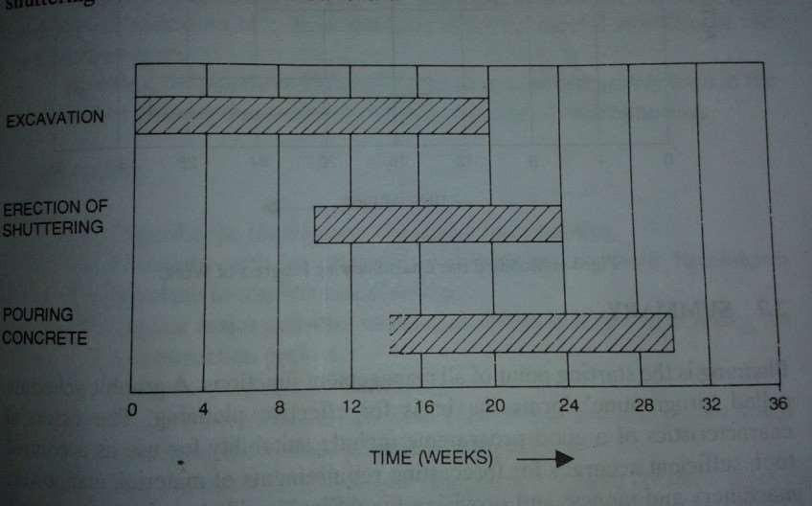

- ProjectProgress
Aconventionalbarchartcannotbeusedasanefficientcontroldevicebecauseit does not show the progress of work. A knowledge of the quantum of work completed or progress achieved is essential in any project. A conventional bar chart can be made more useful by modifying it as shown in figure 3.6. In the modified bar chart, the progress of work can be depicted by colouring/hatching blankbars.Forexample,onreviewingtheprogressafter16weeksoftheproject, excavation work is observed to be 2 weeks behind schedule as shown in figure 3.6.
- Quantitiesofitemsofwork
The bar chart depicts the time schedule for various activities but it does not indicate the quantities of work. The bar chart may be improved by showing quantities of work against individual items.
- CriticalActivities
Another limitation of the bar chart is that it does not indicate critical activities requiringcarefulattentionoftheconstructionteam.Knowledgeofcriticalactivities is essential for rescheduling or accelerating the project completion.

CONSTUCTIONSCHEDULINGBYNETWORKTECHNIQUES:

Definationofterms:
- Activity:Anactivityistheperformanceofaspecifictask,operation,joborfunction whichconsumestimesandresourcesandhasadefinitebeginningandend.An activity is graphically represented by an arrow drawn from left to the right. The length, shape andorientationofarrowhavenosignificance.Forexampleexcavatefoundation,laybrick work, backfill trench, fix shuttering etc are all activities.
Fix

shuttering 4(days)
(RepresentationofActivity)
- Event: Event (also called NODE) represents instant in time when certain activity has been started or completed. Inother words an event describesstart or completion of task. It is represented by a number enclosed in a circle. The beginning of an activity is marked by a tail event or preceding event and the end by a head event or succeeding event. While drawing network, it is assumed that, time flows from left to right.

Pourconcrete

1
2
2
TailEvent HeadEvent
(PrecedingEvent) (Succeedingevent)

(RepresentationofEvent)

- Network: A network is a diagrammatic representation of a work plan showing the activities, step-by-step, leading to the established goal. It depicts the inter dependencebetweenthevariousactivities,i.e.whichactivitiescanbedonetogether and which activities must precede or succeed others.

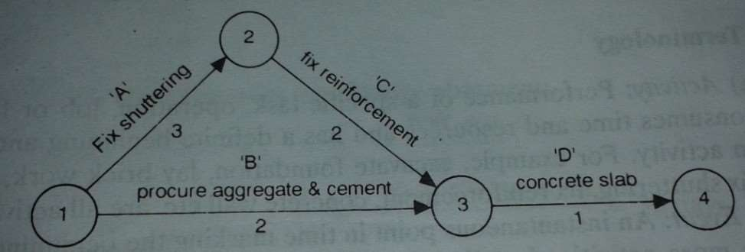

PERT ANDCPMTECHNIQUES:
Network techniques are effective tools for planning and scheduling and controllingconstructionjobs.Networktechniquesprovidearationalapproachtothe planning and construction work. The allocation of such techniques inevitable when there is a constrain or resources and need for higher productivity. The two commonly used network technique are CPM and PERT.
  - CPMStandsforCriticalPathMethod
  - PERTstandsforProgrammeEvaluationandReviewTechnique.
AdvantagesofCPMandPERTnetwork:
CPMandPERTnetworkareverypowerfultoolsandfacilitatethework management in the various phases of the project by the following ways:
PlanningPhases:Planningistheprocessofchoosingaparticularmethodandorderof workto be adopted for a project from all the various ways and sequences in which it could be done. The sequence of steps required to achieve the optimum result is the proper plan for the works and is shown schematically on the network diagram.
Furthermore,itpermitsthereadyevaluationandcomparisonofalternativeworksand helps in choosing the best plan based on minimum cost and minimum time.

OrganizingPhase:Ithelps in awardingthe contract tothe best and efficient contractor because thenetworkoftheprojectfurnished bythecontractoralongwiththetender is themirrorimageoftheresourcecapacityofthecontractorandthemethodologyof the project.
Scheduling Phase: Scheduling is the determination of timing of the operations comprising the project which helps in the preparation of various calendars, such as; fromthe startingdatetothefinishingdate,thedeliverytimeofthematerialsusedinthe project is clearly mentioned on material calendar.
ControllingandMonitoringPhase:Networkfacilitatesincontrollingtheexecutionof the project activities to ensure timely completion of the project through periodical reviewing and applying corrective measures.
EvaluatingPhase:Afterthe completion of theproject, the plannedand actualtie and costarecompared,thereasonsfordeviationareanalyzedandspecificdifficultieswhile execution are highlighted. These reports aremade available to the executive for use in futureprojects.

AcomparisonbetweenCPMandPERTisgivenbelow:

CPM | PER T
- CPMisactivityoriented.  - Singletimeestimatesareusedforthe various probabilistic. The  activitiesi.e.thetimeestimatesare determi- used for  nistic.  - CPMisusedforrepetitivetypesof projects  i.e. projects  wherethetimeestimatesforvarious activities prior  acrecueriathtelryk.nownorcanbedetermined | - PERTiseventoriented  - The time estimates for activities are followingthreetypeoftimeestimates are  eachactivity:  - Optimistic time  - Pessimistictime  - Likely time  - PERT is used for pioneering type of projectwhicharethefirstoftheironekind
- CRMplacesemphasisuponoptimizingalloca-(d)PERTlaysemphasison reducing project completion

tion of resources and minimizing overall timewithoutcost constraint. project cost.

NETWORKANALYSIS:
  - Earlieststarttime(EST):Theearlieststarttimeistheearliestpossibletimeat which an activity can start.
  - Earliestfinishtime(EFT):Theearliestfinishtimeistheearliestpossibletimeat which an activity can finish.
  - Lateststarttime(LST):Thelateststarttimeisthelatestpossibletimebywhichan activity can start without any delay of project time forecast on the basis of earliest occurrence time to the final event.
  - Latestfinishtime(LFT):Thelatestfinishtimeisthelatestpossibletimethat an activity can finish without any delay in completion of the project.
FLOATS:Floatindicatestherangewithinwhichthestartandfinishtimeofanactivity may vary without affecting the completion time of the project.
- Totalfloat(TF)ofanactivityistheexcessofthemaximumavailabletime over the activity time.
- Freefloat (FF) of anactivityis theexcessof available time over theactivitytimewhen alljobsstartasclearlyaspossible.Theterm“free”indicatesthattheuseofthisfloatdoes not affect the succeeding activities.
- Independentfloat(IF)ofanactivityistheexcessofminimumavailabletimeover activity time. In some cases the absorption of this float neither predecessor nor successor activity that’s why, it is called independent.
Exp.1.FindthecriticalpathandprojectdurationofthegivenCPMproject.AlsocalculateEST,
EFT,LST,LFTandTF,FF,IFinatabularform.

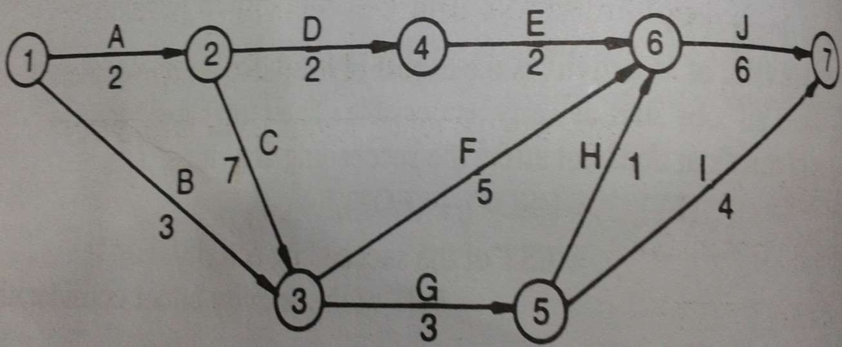

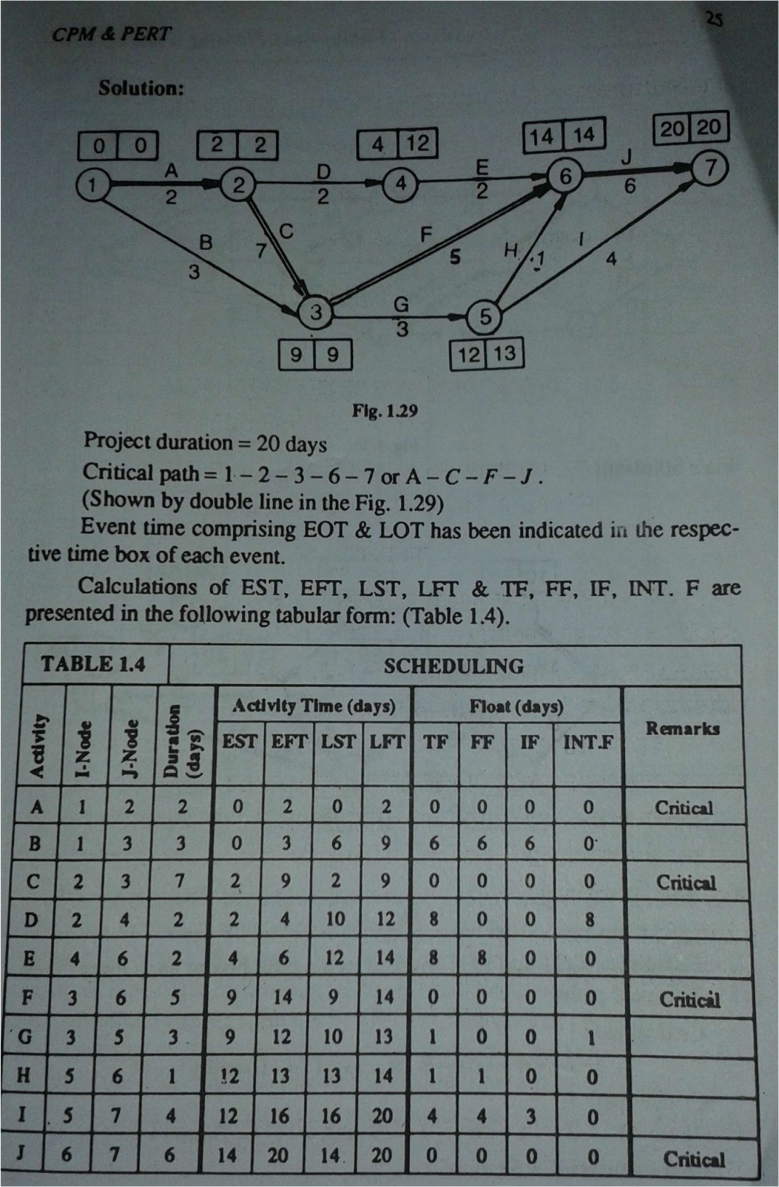

CHAPTER-3
MATERIALSANDSTORESMANAGEMENT

Definition

The International Federation of Purchasing and Materials Management accept the definition of materialsmanagementgivenbelow.
Accordingtoit,materialsmanagementisatotalconcepthavingitsdefiniteorganizationtoplan andcontrolalltypesofmaterials,itssupply,anditsflowfromrawstagetofinishedstagesoasto deliver the product to customer as per his requirements in time. This involves materials planning , purchasing , receiving, storing, inventory control, scheduling, production, physical distribution and marketing.Italsocontrolsthematerialshandlinganditstraffic.Thematerialsmanagerhasto manage allthesefunctions withproperauthorityand responsibilityin thematerial management department.
CLASSIFICATIONOFSTORES.

Scientificclassificationofvariousitemsofstoresisessentialforagoodsystemofstorekeeping. Materialsin storesareclassifiedeitheronthebasisoftheirnatureorontheirbasisoftheiruse. Theformermethodofclassificationismostcommonlyused.Forexamplethematerialmaybe classified as construction materials, consumable stores, spare parts, abrasives, lubricating oils , etc. After dividing all items of stores into various classifications, the next step is to codify alphabeticallyornumericallyeachitemofstoresbygivingitadistinctivestorescodenumber. Decimalsystemofcodificationismorecommonlyused.Underthismethodofcodification,the whole numbersare usedto indicatethemain group and decimals toindicate primary, secondary andothergroups.Forexamplematerialsmaybeclassifiedasfollows.
Sectionbody-1i.e.,maincodeconsistsoffirsttwodigits.

Sectionbody-2 i.e.,sub-codeconsistsofthenexttwoorthreedigitsdependinguponthe requirement.
Section body -3 i.e.,detailsofthesizes,qualityetc.Lastoneortwodigitsdependinguponthe requirement

Followingaretheadvantagesof asystemofclassificationandcodification.

- Ithelpsinmaterialcontrol.

- It givestheadvantages of abbreviation becauselengthydescription of an item of storesreplacedbya distinctivestorecodenumber.
- Acodingsystemhelps,inthemaintenanceofmechanisedaccounts.

- Secrecyofdescriptionscanbemaintainedbecauseadistinctivestorecodenumber (amdnotdescriptionoftheitemofstores)isused.
- Thebiggestadvantageofcodificationisthedistinctivecodegiventoeachitemof stores and avoidance of duplication due to multiple names which results in a reductionofitemsofstorescarried.
- Itfacilitates theidentification of various items of stores resulting into prompt issueof stores. This is particularly useful in those cases where the same material is known bymore than onname.
TYPESOFSTORES

Therearetwotypesofstorescontingentonthefollowingconsiderations;

  - . FUNCTIONAL–dependingontheuseto whichmaterial isput –chemicals, tool, rawmaterials stores etc.
  - .PHYSICAL– dependinguponitssizeandlocation-centralstores,decentralisesstoreand centralstoreswithsub-stores.Thesearediscussedbelow;
    - CentralisedStores:-Theusualpracticeinmostoftheconcernsistohaveacentralstore. Incaseofsuchastore,materialsarereceivedbyandissuedfromonestoresdepartment.All materials are kept at one central store. The advantages and disadvantages of this type stores are as follows;
Advantages:-

      - Better control can be exercised over stores because all stores are housed in onedepartment.

      - Betterlayoutofstoresispossible.

      - Lessstoragespaceasstorearekepttoaminimum.

      - Investmentinstocksisminimised.

      - Economyincost.Examplesarereducedclericalcostsandeconomyinrecordsare stationery
      - Economyinstaffandconcentrationofexpertsinonedepertmentwillleadto developmentofhightechnicalskill.
      - Lessbotherationininventorychecksasthestoresarelocatedinoneplace.

Disadvantages:-

- This system of stores increases transportation costs because one central store may notbeneartotheeverydepartmentofthefactory.
- Delayandinconveniencemaybecausedtodepartments(situatedatadistancefrom the central store) in drawing materials fromthe centralstores.
- Greaterrisks of lossincaseoffire becauseallitemsofstores arekeptatoneplace.

- Breakdown in transport may stop production in departments because of difficulty ofgettingmaterialsfromthecentralstores.
    - DecentralisedStores:-

Under this type of stores , independent stores are situated in various departments. Handling ofstoresisundertakenbytheshopkeeperofeachdepartment.Thisdepartmentrequiring storescandrawfromthemtheirrespectivestoressituatedintheirdepartments.The disadvantage of centralised stores can be eliminated if there are decentralised stores. Such typeofstoressetuptomeettherequirementsofmaterialsofeachproductiondepartment arenot popularbecauseof theheavyexpenditureinvolved.
    - CentralisedStoreswithSubStores

In large factories, departments are situated at a distance from the central stores; so in orderto keep the transportation cost of handling charges to minimum, sub-stores ( in addition to the central storesnear the receiving department)should be situated near the production department.
For each item of materials, a quantity is determined and this should be kept in stock in sub- storeatthebeginningofanyperiod.Attheendofaperiod,theshopkeeperofeachsub- storewillrequisitionfromthecentralstorethequantityofthematerialcontinuedtobring thestockuptothepredeterminedquantity.Inshort,thistypeofstoreoperatesinasimilar waytoapettycashsystem;sothissystemofstoresisalsoknownastheimprestsystem of store control.
IssueofMaterials

Purchaserequisitionorindent

The purchase officer does not initiate any action for the purchase of items on his own accord. With thehelpofpurchaserequisitions,thepurchaseofficercomestoknowthetypesofmaterialsor itemsneededintheorganization.
Thepurchaserequisitionisreceivedfromthefollowingsections.

    - fromofficesectiontopurchasetheofficeequipment.

    - fromadvertisingdepartmentorsalesorresearchsection.

    - fromplanningandpatterndepartmentforcastings.

    - from production department to purchase the plant and machinery or any other equipment.
    - fromstoresectionforregularstockmaterials

Apurchaserequisitionisaformusedasaformalrequesttothepurchasingdepartmentto purchase items. This form is prepared by the storekeeper for regular stock materials and by the departmentheadfor special items not stockedas regular items. The requisition is provided byanexecutive,such astheplantsuperintendentor worksmanager.

The purchase requisition is generally prepared in triplicate. The original copy is sent to the purchasingdepartment,theduplicateiskeptbythestorekeeperorthedepartmentwhich initiates the requisitions and the triplicate is sent to the authorisingexecutive.
The purchase requisition initiated by the storekeeper for regular items of materials is called regular purchase requisition and the purchase requisition and purchase requisition prepared by the department head for special materials is known as special or occasional purchase requisition. Regular purchase requisition are prepared when the item of materials reach at the orderinglevels,i.e.thelevelatwhichtheorderforfreshsupplyshouldbeplaced.Thisisdone sothattheremaybenoshortageofmaterialsandproductionmaynotbeheldupforwantof materials.Thespecimenformofapurchaserequisitionisgivenbelow.
It is clear from the specimen of the purchase requisition that it provides the following three basicinformationswhichassistintheworkofpurchasedepartment

      - Whattypeofmaterialistobepurchased?

      - Whenis tobepurchased?

      - Howmuchistobepurchased?

The purchase departmentis to make timely purchases toavoidthe situation of rush ordersto the extent possible because it costs more to make purchases by rush orders. The purchase departmentshouldbeinconstanttouchwiththesuppliers,themarkettrendsandsocio- politicalconditionssothattimelystepsmaybetakentoproceduretheitems.Anticipating advanceneedswilldeterminethekindoforder.
SwadeshiCompanyLtd.
PurchaseRequisitionorIndentRegular

No......................... ................................ Date........................
Special Date by which materials are required...................
SerialNo. | Descriptionof Articles | StoreCodeNo. | Quantity Required | Remark
Requestedby............................................... Approvedby.................................
ForuseinpurchaseDepartment Quotationsinvitedon..........................
From:1...........................
- ..........................
- ..........................
OtherAction.....................
PurchaseOfficer

PurchaseBudget

Purchasebudgetismainlydependentonproductionbudgetandmaterialrequirement budget. The material requirement budget gives information about the quantity of materials required during the budget period to attain the production target. The following factors are should be taken intoconsiderationwhilepreparingapurchasebudget:
- Quantityandqualityofeachmaterialneededaccordingtotheproductiontarget.

- Capitalitems,toolsandgeneralsuppliesrequiredduringthebudgetperiod.

- The present stock position and materials expected to arrive, already covered by purchaseorders.

- Thedatesonwhichpurchaseitemsarerequired.

- Pricesofitemstobeboughtandpositivequantitiesofdiscounts.

- Sources ofsupply.

- Availabilityofcashto settleaccountsofsuppliers.

- Transportrequirements.

- Inspectionandreceivingarrangements.

- Storagecapacity.

StoresAccountingProcedures

NeedforStoresAccounting

There are twoaspectsof store accounting i.e., value of the materialsstored and quantityof the materialsstored.Storesaccountingisnecessaryisregardtovalueduetothefollowingreasons:
    - Itis necessarytoindicatethevalueofstocks

(beingassetsofthecompany)intheaccountsofthecompany.

    - Itprovidesameansincalculating thecostofgoodsmanufactured.

    - Itprovidesabasisforcontrolofinventorybyvalue.

Asregardsquantityofmaterials,itisnecessarytoensure,thatallthematerialsreceivedhave beenaccountedfor.Similarlyallreceiptsandissueshavebeenenteredinstockledgeror registerandhavebeenaccountedfor.
Thefollowingaremainpurposesforwhichstockrecordsarenecessary:

- Theyindicatetheamountofanymaterialinstockatanytimewithoutanyphysical checking.
- Theyhelptotallythestockasshownbystoresaccounts. Allreceipts and issuesand issuesenteredinstockrecordsaresubsequentlypostedinvaluetostoresaccounts.

- They help in determining, the ordering quantity in order to maintain the stocks at therequired level.
- Theyhelpincomparingthequantitiesofallitemsinthestoresascertainedby physicalcheckingwiththatofquantitybalancesasperstoresrecords.
- Theyhelpthestoresstaffinlocatingthegoodsinthestore house.

- Theyservethepurposeofapricelist,asunitpricesgiveninstorescanbeusedfor pricingallstoresdocumentswhichareultimatelypostedtotherecords.
STORESRECORDS

Thefollowingarethemostimportantrecordsusedinthestores:

- BINCARD :- the cardis generallykept in thebin alongwith particularitem. To hold the bincard, usuallythere is a metal holder attached tothe bin. These cardsare very simpleandgivedetails regarding codenumber,theunit of issues, the quantityofthe receivedand issued and the balanceremainingin thebin.
- STOCKCARD:-stockcardsarekepttogetheratoneplaceinthestoresoffice.This officeshouldbewithinthestoresbuildingandnotfarawayfromtheotherofficesof thecompany.Thisis necessarytokeepthe proximitybetweenthestores documents and thestoresthemselves. Stores cards canbe of threetypesi.e., (i)showingonly quantities,(ii)shoeingquantities,andunitprice,and(iii)showingquantity, unit price,valueofeachtransactionandthevalueofbalanceinstock,(iv)isthebestasit givesalldetailsbutitrequiresgreatereffortandexpertisetomaintain.Entryofevery receiptandissueofstoremustbedoneintimeandnotpostponedtothenextday.
- STORESTRANSFERNOTE:-thisformisusedfortransferofmaterialsfromone storetoanotherstore.
- MATERIALRETURNNOTE:-thisformisusedforreturnofitemsofsurplus materialfromproductionorengineeringdepartmenttothestoresdepartment.

- GOODSINWARD OR RECEIPTS NOTE:- this form is used for recordingreceipts ofvariousitemsofstoresinthereceiptsection.
- MATERIALREJECTIONNOTE:-thisnoteisissuedbytheinspectiondepartment andgivesvariousreasonsorrejectinganitemofstore.
- SCRAPNOTE:-Thisnoteisusedforsendingthescraptothestores.

- MATERIAL REQUISION FORM :- this form is used for indenting or requisition of materialsfromthestores.
- GATEPASS:-inordertopreventpilferage,itisnecessarythatagateisissuedfor takinganyitemoutofthestoresandmustbepresentedatthegate.Usuallymaterial requisitionformormaterialtransfernotecanbeusedasagatepass.
- INVENTORYFORM:-thisformisusedinstocktaking

- STOCK VALUATION FORM:- this form is usually used for valuation of stocks in handattheendoftheyearsothat it’s value maybeincludedin the annualaccounts.
- TEMPORARY LOAN VOUCHER :- this voucher is used for issuing tools to the workerswhicharetobereturnedtothestoresattheendoftheday.
- PERMANENTLOANVOUCHER:-thisvoucherisusedforissuingtoolsrequired fordailyuseorforalongperiodbyanemployeeorsection.
BINCARD

Abincardmakesarecordofthereceiptandissueofmaterialandiskeptforeachitemof storescarried.Quantityofstoresreceivedisenteredinthereceiptcolumnofthebincardand thequantityofstoresissuedisrecordedinthestorecolumnofthebincardandabalanceof the quantity of the stores is taken after every receipt or maintained by the storekeeper and the storekeeperisanswerableforanydifferencebetweenthephysicalstockandthebalance shown in the bin card. These cards are used not only for recording receipts andissuesofstores butalsoassistthestorekeeper tocontrolthestock.Foreachitemsof

stores, minimum quantity, maximum quantity and ordering quantity are stated requisition for thepurchaseofmaterialintime.
Abincardisalsoknownasbintagorstockcardandusuallybunguporplacedinshelf, rack, bin where thematerials has beenkept. Bincards can also be in theform of loose sheets whichcanbemaintainedintheledgerkeptinthestores.
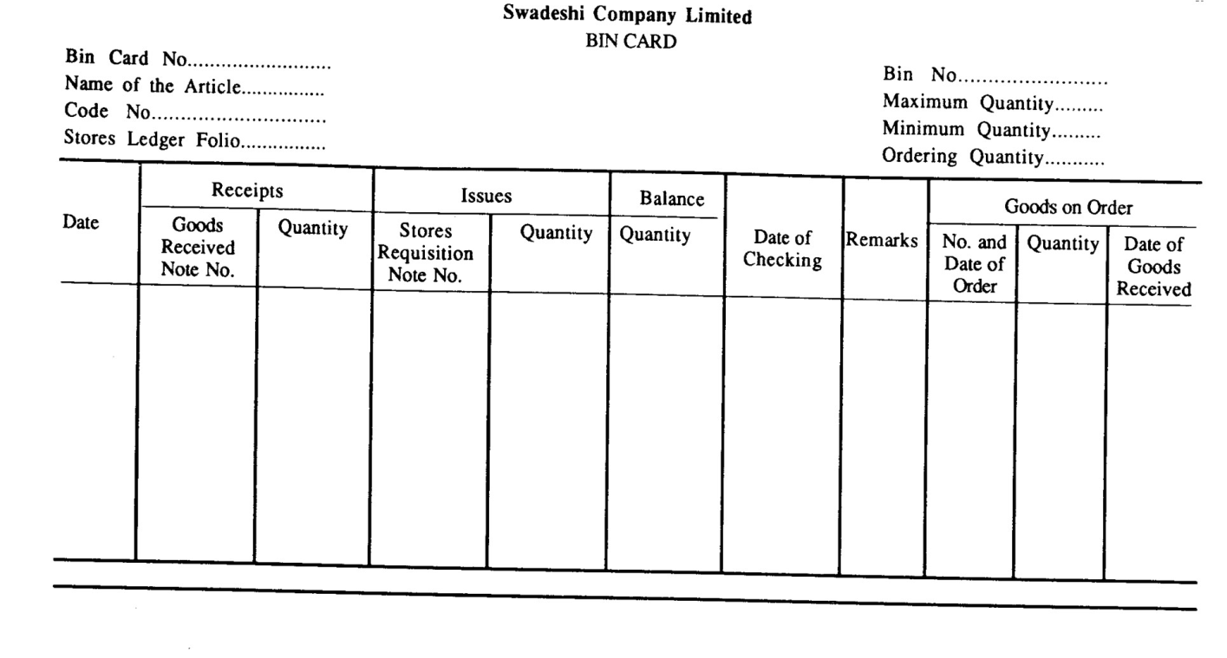

STORESLEDGER

Thisledgeriskeptinthecostingdepartmentandisidenticalwiththebincardexceptthe receipts, issues and balances are shown along with their money values. This contains a account foreveryitemsofstoresandmakesarecordofreceipts,issuesandbalances,bothinquantity andvalue.Thus,thisledgerprovidestheinformationforthepricingofmaterialsissuedand themoneyvalueatanytimeofeachitemofstores.

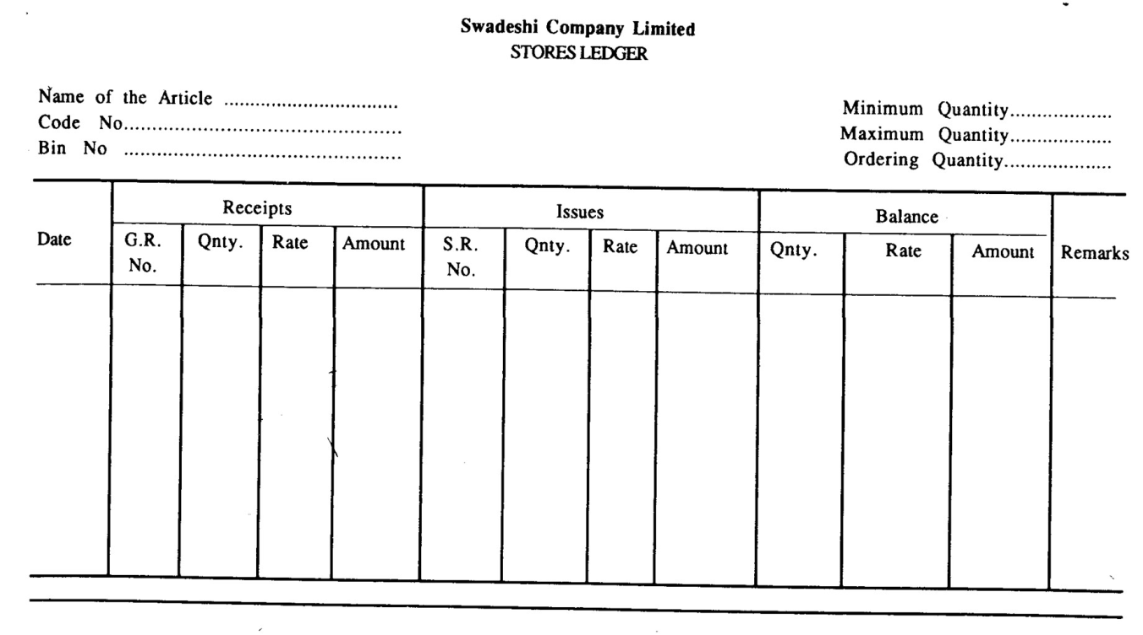
vs.StoresLedger –

Thedifferencebetweenabincardandthestoresledgercanbesummarisedasfollows:

Bin Card

BinCard | StoresLedger
- Arecordofquantitiesonly.  - Maintainedbythestorekeeper.  - Normallypostedjustbeforethe transactiontakesplace.  - Eachtransactionisindividually posted.  - Usuallykeptinsidethestores. | - Arecordofbothquantitiesand values.  - Maintained by theCosting Department.  - Always posted after thetransaction transactiontakesplace.  - Transactions may be summarised andpostedperiodically.  - Keptoutsidethestore.

InspectionofStores:-

Ineveryenterpriseitispossiblethatthebalanceofstockshownbystockcardsmaydiffer fromtheactualbalanceofstockascertainedbyphysicalverification.Itmaybeduetothe following reasons:
Avoidablecauses

- Clericalmistakesi.e.,wrongpostingnon-postingofentries,wrongcastingetc.Such errorscanbecorrectedandactualbalancecanagreewithbookbalancebymakingthe requiredcorrectionincardsorstoresledger:
- Pilferageandthefts.

- Carelessnessinmaterialhandling.

- Shortorover–issueof materials.

Unavoidablecauses:

- Actualbalancemaybelessduetoshrinkage andevaporation.

- Actualbalancemaybemoreduetoabsorptionofmoisture.

- Actualbalancemaybemoredue tobreakdownoffire,riotsetc.

- Materialmaybelostduetobreakingofbulkmaterialintosmallerpartsforissue.For example,someironislost dueto breakingupbigironrodsintosmallerparts.
Physicalstocktakingis veryimportantforaconcernasitserves thefollowing purposes:
  - Itverifiestheaccuracyofstockrecords.

  - Itsupportsthevalueofstockshowninthebalancesheetbyphysical verification.

  - Ithelpstodisclosethepossibilityoffraud,theftorloss.

  - Ithelpstorevealtheweaknessinthesystemforthecustodyandcontrolof stock.
Inshortthedifficultyandeffectivenessofstorekeepingmethods,controlsand procedurescanberevealedbythesizeandnumberofsurplusesand efficiencies by stock taking.

CHAPTER-4 CONSTRUCTIONSITEMANAGEMENT
4.0Factorsinfluencingselection,designandlayoutoftemporaryfacilitiesandservicesatconstruction site
Everysite,whetherlargeorsmall,requirestemporaryserviceswhicharedesignedandprovided by thecontractor.On asmallsite, thetemporary servicesco nsis tofa c c e s s roads,water supply, electric supply, sewer connections etc. On a large construction site,temporaryservices includeanumberoffacilitiessuchastelephoneconnection,batchingplant,tubewells,serviceroads, repairandconstructionyards,materialstorageyards,canteenandmedicalfacilitiesetc.Thereisno specificor fixed pattern for the type of temporary servicesrequired at a site. These services depend onthe followingfactors:
- Sizeandnatureoftheproject
- Locationoftheproject
- Projectcost
- Specificneeds
- Numberofworking shiftsperday.
Varioustemporaryservicesrequiredatthesitearebrieflydescribedbelow:-
- WaterSupply
Water supply is essential for all construction sites. For large construction sites, tube wells may be bored which could be later used on a permanent basis. Water supply is required for industrial and drinking purposes.Industrialwatersupply is required forrock drilling,piledriving,feedwaterforboiler plant and transportingmaterialsbypipelinesetc.Drinkingwatersupplyisrequiredfortheworkareas,offices, canteenetc.Toobtainwatersupplyconnections,thecontractororprojectmanagerhastoapplytothe publicHealthEngineering Departmentstating thepurposeandquantity ofwaterrequired.
- Electricityconnection
Itis requiredforbothlarge aswell as smallprojects. Inordertoobtain an electricityconnection, the contractororprojectmanagerhastoapplytotheElectricityBoard/Departmentstatingthequantityof electricityrequiredandtheplacewherethetransformeristobeinstalled.Fromthetransformer,the contractorhastomakehisownarrangementsforsupplyofpowertovariouslocationsonthesite.
- RepairandConstntctionYards
Suchtypesofyardsareessentialforrepairandmaintenanceofequipmentandmachineryandasa working areaforbar benders, carpenters, weldersetc. Theseyards are setup on the construction sitefor smooth and unobstructedconstruction activity.

- Material Stores
Suchstores are usually constructedwithbrick walls andG.l. Sheetroofing.G.I.sheets are preferred forroofingpurposesbecauseoftheirhighre-usability.Thestoresareusedforthestorageofcement, electrical materials, hardware, paints, tools, spare parts, stationery etc. Sometimes A.C. sheets are also usedfor roofing purposes.
- ApproachandServiceRoads
Approach and service roads are provided for trucks to transport construction materials such as sand, aggregate, cement etc.tothe site.Theseroadsareusuallyprovidedontheperipheryoftheconstruction site.Inlargeprojects,theseroadsmayalsorunthroughtheconstructionsitesothatmaterialsmaybe dumpedatthe requiredlocations avoidingre-handlingshiftingofmaterials.
- SewerageandSanitationarrangements
Appropriate sewerage and sanitation arrangements are essential at all work sites. Adequate arrangementsshouldbemadeforthedisposalofsewagetosomesuitableplace.
- SiteOffice
Depending on the size and nature of the project, a site office isestablishedfortechnical and supporting staff.Forlargeprojects,thesite office of the ExecutiveEngineer,AssistantEngineer andother staff is constructed for coordination, supervision and control of the construction activity. A project conference/display room is also provided for large projects. Site offices are temporary structures provided with G.I. or A.C. sheet roofing.
- LabourHuts
Formedium and large projects, temporary huts are constructed withbrick masonryinleancement mortarormudmortarandG.l.sheetroofingtoprovideshelterforlabourers.Thesehutsshouldbelocated awayfromtheconstructionactivityzoneforsafetyreasons.

Principlesofstoringmaterialattheconstructionsite
Thematerialsatthesiteshouldbestoredinsucha mannersoastopreventdeteriorationor mixing offoreign matter. So following are thepoints ofprimeimportance to be considered for storing and stacking of materials.
    - Materialsstoredatthesiteshouldbeprotectedfromtheatmosphericagenciessuchasrain, sun, wind and moisture.
    - Materialssusceptibletofireshouldbestoredsoastopreventfirehazards.Petroleum productsandexplosivesshouldbestoredaccordingtotheexistingrulesandregulations.

    - Materials like precast beams, slabs and pieces of timber, which are likely to be affected bythe subsidenceofsoilorsupport,shallbestoredbyadoptingsuitablemeasuresagainstthisrisk.
    - For the storage of materials which are easily and immediately affected by the contact of moisture, specialprecautions aretobe taken. Forexample cement bags areshouldbe stacked on raised platform, with adequatewater proofcover, having notmorethan 12 bagsin astack andatleast30cmclearancefromanywall.
Similarlylimeshouldbestored ina suitable shed toprotectit from dampness.
Brick and tiles shouldbe stackedona levelground limiting theheightofstacksto 1.5m and one metre.
Fineand coarse aggregateshallbe stacked on a hard surfacein regular stacks ofsize 2m × 2m×5mandinsuchawaysoastopreventtheadmixtureofvegetableandotherforeign materials.
    - Materialsconstantly inuse shallbe relativelynearer to theplaceof use, but nottoo close. Similarmaterialsshouldbestackedcloseby.
    - Heavyunitsshouldbestackednearthehoistandtheramp.
    - Perishablematerialswhich normally deteriorateduring storageshall bekeptconstantly moving, byreplacing oldmaterialswithfresh stocks.Freshly arrived materials shallneverbe placedovermaterialswhichhadarrivedearlier.
    - Fireextinguishersandfirebucketsshouldbeprovidedwherevernecessaryforsafety.

Thefollowingbasicfactorsshouldbetakeninrespectofreceipt,storageandissue ofstores:
      - Thereshouldbeonlyonein-gateandoneout-gateforentryandexitofstoresunlessthestores themselves are classified into separate groups and are handled by separate sections such as iron,steel, timber, brick, cement and aggregates and miscellaneous section in which caseeach group mayhaveitsownentryandexitgatesandconnectedsecurityarrangements.
      - Entryofallconsignmentsisrecordedatthein-gate.
      - Nostores/consignmentsaretakenoutunlessauthorisedbyasupportingoutpass/gatepassslip.
      - Thattotalstorageaccommodationshouldbedividedintothefollowingthreesections.
        - Receipt Depot
        - HoldingDepot
        - IssueDepot
Thefollowingfactorsshouldtakenintoconsiderationsothatthestoresareprotectedfromthe weatheringactionofelementssuchaswind,rainandsunandthatthesequenceofarrangementshould providefirstinfirstoutprinciplesothatstoresdonotdeteriorateduetolongstorage.
- Inflammablematerial (POL,explosives)should bestored separatelyandstorage licensefor suchcommodity should be obtained and bylaw/storage regulation prescribed fromtime to timeshouldbeadheredto.

- Storesmorefrequentlyrequiretobeissuedshouldbestoredrelativelyneartotheexitend.
- Storage yard for timber and similar other materials should have adequate anti-fire measuressuchasfireextinguishers,sandbucketetc.
- Coarseandfineaggregatesshouldbestackedinbinandundergroundpitsrespectively.
- Materialslikecement,limeshouldbeprotectedfromcontactofmoisture.
- Cementbagsshouldbestackedclearofftheground by providing donngeof stone slabs,steel girdersortimberbeams/ballies.Theyshouldbestackedatleast30cmawayfromthewall andtheheightshouldberestrictedto12bags.

4.3-(I)Locationof Equipment
With the ever-increasingcost of labour , it becomes necessaryto use more and more mechanicalequipment in association with the available man power forconstruction work. Only byverycarefulconsiderationtherighttypeofequipmentischosenforanyparticularproject.
Correctlychosenandwelloperatedplantwillenableaconstructionprojecttobecompleted quickly and economically.
Atthesametimenocontractororownercanownalltypeofequipmentneededforthe job,due to limited resources and also due to thereason that some of equipments may remain idle,whentheyarenotinuse.Thustheownerorthecontractor willpurchasesome ofthe equipmentsandothershewillhireorhewillgivefurthercontractforsuchitemswhichwill involve the use of equipments to such an organizations taking such works.

Thefollowingpointsmaybeconsideredforthelocationof equipment.

  - For the owned equipments suitable sheds may be provided near the entrance so that it can beguardedwithoutanyadditionalchowkidar.
  - Itshouldbeneartotheconstructionsite.
  - Itshouldbeneartothematerials.
  - Forthehiredequipments,suitableplacemaybeleftvacantwhereitcanbeaccommodated aspertheequipmentschedule
  - Fortherepairofequipmentprovisionmaybemadeinthesheditself.
  - The project equipment should be provided permanent shed for static equipment and temporarygaragesformobileequipment.
  - Allequipments receivedintheproject shouldhave initial inspectioncarriedout. Inthe case ofnewequipmentthisinspectioniscarriedoutjointlybytheprojectworkshopandthe representativeofthefirmfromwhichitisobtained.Theequipmentshouldbetaken complete with historysheet, logbook, maintenancemanualand operation manual.A trial demonstration should invariably be insistedupon.

  - Adequateprovision for fast moving parts as spares should bemade along with the procurement.
  - Washingramps,platformsshouldbeprovided.
  - Responsibilityforworkshopcoverandregularinspectionshouldbefixed.
4.3-(II)Organizinglabourat site
Thisisanothertaskforthesupervisorystafftoorganizethelabourproperlysothatthe maximumoutput may be taken from them. The supervisor maydivide the labour intogroups withaproperleaderwhocaneasilycontrolandpassinstructionstothemclearly.

Supposeone and ten labourers are put for laying foundationconcrete. The division of the labourers will be:
    - Saythreelabourersareputforbringingtheaggregates.
    - Twolabourerswillbedeputedforbringingcement.
    - Twoformixingtheingredientsforthefirst batch.
    - Twofor thetamping purposes.
    - One forbringingwater.
Afterthe material is put on the platform for mixing,these three labourers can be putonsomeotherworkifanotherbatchisnottobeprepared.Similarlyaftermixing, onelaboureroutoftwoandonewhoisbringingwaterisnowfree,canbeputfor carryingthemixedconcretetothesite.

Fromthis it isclear thatitistheduty ofsupervisor toorganisethelabourin such awaysothatthereshouldbenowastageandworkshouldbedoneefficiently.
However,thefollowingpointsmaybekeptinmind,whileorganisinglabouratsite.
- Thesupplyoflabourshouldbeuninterruptedwhenneeded.
- Un-necessaryrehandlingofmaterialshouldbeavoided.
- Thematerial required during the day shouldbe takenonceforallfrom thego-downasitwill avoidfrequentmovementoflabour.
- Labourshould notremain idle forwantof material.
- Itiseconomicaltohavesomepermanentlabour.
- Increaseanddecreaseoflabourshouldbesuitablydone.
- Drinkingwatershouldbemadeavailableatsitetoavoidwastageofusefultimeoflabourers.
- Theprogressofthelabourershouldberecordedandcomparedinordertocompletethejobatthe right time.

The organisation of labourfora project involvesthefollowing: 1.recruitment of labour
This is particularlyimportant in the case of departmentallyrunprojects. If locallabour is available,itsavesconsiderableamountofexpenseandadministrativearrangements.Inprojectsin remoteareasorintheforwardareaswherelocallabourisnotpossible,labourrecruitingzoneshavebe establishedandaspecialtrainingcellintheprojecttotakecareofthelabourfromtherecruitingzone totheworksitehastobeestablished.
- provisionofaccommodation,andwelfareactivitiesincludingmedicalfacilities.
When labour isan imported one,thetransitcellmakesthe transitarrangementwhereas the administrativecellmakesarrangementfortheirliving,eatingandmedicaltreatment.Sometimesall suchfacilitiesconsisting oftransport,accommodation ,messing andclothing are provided free as part ofagreementwiththeworkersandentire expenditureisdebitedto the project.

- Arrangementfortraining
Labour isprimarilyclassifiedintoskilledand unskilled.Whereastheunskilledlabourcan be deployed directly on the job under supervision of technicalsupervisory personnel, the workers required to do specialised/skilled jobs such as carpenters, masons and other trades-men have to betradetested at the time ofrecruitment. In caseskilled trademen are not available semi-skilled are initiallyrecruitedona lowergrade,giventraining and thendeployedon jobon highergrade after qualifyinginthetradetest.
- Whiledeployingworkmenonproductionjobsthefollowingpointsshouldbeconsidered:
  - Workshouldbedividedintoanumberofteamsdoingsimilarwork.
  - Productionofsuchteamsisregularlyassessedandreasonsforshortfallifanyinvestigated.
  - Workincentiveforhigherproductionisprovided. Asmallincentive helps increase output considerably.
  - Grievance/complaintsofworkersareheardfromtimetotimebyhavingopenmeetings whereeveryindividualcanbringouthispoints.
  - Properwelfareactivitiesareprovided.

Chapter-5.0 ConstructionOrganisation

LineandStaffOrganisation:

Line organisation aims at having direct responsibility for attaining the objectives of the enterprise while staff organisationreferstothoseelementsoftheorganisationthathelpthelinetoworkmoreeffectivelyinattainingthe primaryobjectives of an enterprise. Line functions cover production, sales and sometimes finance whereas staff functions cover purchase, accounts, personnel, plant maintenance and quality control. Line organisation establishes a direct relationship of authority and responsibility between the superior and subordinates.
When the size of organisation expands for large and complex projects, the keymen are tobe assisted by specialistsindifferentfields.Staffpeopleinanorganisationareexpertswhodonothavelineauthoritybutwhose function is largely advisory. The activities such as research, design, planning, scheduling & recording of performance are executed by staff. Line people maintain discipline and stability in an organisation.
Thestructureoflineandstafforganisationisillustratedbelowforbetterunderstandingoflineandstaff relationship.
ChiefEngineer
StaffFunction€Surveyor of WorksArchitectVigilance Administration Wing Design Wing Accounts Branch◻Stafffunction

SuperintendingEngineer-I SuperintendingEngineer-IISuperintendingEngineer-III

Line Function

ExecutiveEngineer-IExecutiveEngineer-II

Asst.Er.-I Asst.Er.-II Asst.Er.-IAsst.Er.-II
Merits:
- Effectiveuseofexpertadvice.
- Lineexecutivesarerelievedofsomeoftheirloadsandmaydevotemoreattention towards production.
- Wastageofmaterialsandmachinehoursare eliminated. 4- Improved product quality.
5-Duetostaffexpertise,efficientuseofhumanandphysicalresourcesis possible.
Demerits:
- Increaseofcostduetohighsalariesofstaffpeople
- Staff peopledonothaveauthoritytoenforcetheirdecisions.
- Theremaybeconflictbetweenlineandstaffpeoplesincedutiesandresponsibilitiesare not clearly defined.
- Excessdependenceoflinepeopleonstaffmayresultinlosingtheirinitiativeanddrive.

:PrinciplesofOrganisation:
Organisationprincipleisageneralruleortruthappliedundersimilarconditionsanywhere to achieve effective result. A few common principles followed in an organisation are:
    - Considerationofobjectives-Objectiveshouldbedeterminedanddefinedclearly.
    - Thescalarprinciple-Thelineofauthorityfromtoptobottomshouldbeclearlyindicated
    - Principle of balance between authority and responsibility- Authority is the right to work, act, decide and power to command. Responsibility is the obligation of a sub-ordinate to do any job allotted to him by his superior. Hence, authority and responsibility should go handinhandandmustbebalancedrationallytoproducethebestresults.Authoritywithout responsibility is meaningless or vice-versa.
    - Principles of unity of command- Unity of command states that each sub-ordinate should report to only one superior. In order to avoid indiscipline, delay, disorder, a sub-ordinate should receive orders from only one superior and not from a number ofsuperiors.
    - Principle of span of control- This principle states the number of sub-ordinate who can effectively be supervised by a superior. An ideal span of control depending upon the complexity of work should be adopted to obtain optimum result.
    - Deparmentation-Thisreferstodivisionof work inanorganisationintoseveralsections ordepartment.Thefunctionsandscopeofworksineachdepartmentshouldbeclearly defined.
    - Principleof specialisation-Activitiesoftheorganisationshouldbegroupedasperthe functions and assigned to individuals in accordance with their specialisation.
    - Communication-Transmittinginformationandinstructionswithintheorganisationandto out side persons connected with the organisation is essential to achieve thegoals.
    - Flexibility and stability- Flexibility specifies the capacity to adjust work assignment, personnelandfacilitiestotemporarychangesinthevolumeofwork.Stability,ontheother hand, referstothecapacityto withstand thelosses of keypersonnelwithout seriousloss to the effectiveness of the organisation.
    - Effective Delegation: Effective Delegation gives a change to sub-ordinates to think and developanytaskwhichtheycandecidethemselvesandperformefficientlyandeffectively.
    - Continuity-Theorganisationstructureshouldbedynamicsoastomaintainalinkbetween the past and the future.
Leadership
Leadership is the process of influencing the activities of an individual or a group towards the achievement of goal in a given situation. Since all the successful manages must have leadership quality, it thus becomes absolutely necessary to know about leadership.
StylesofLeadership-Stylesarethewaysinwhichtheleaderinfluencesthefollowersand the various styles in this respect are:
- Autocratic or Authoritarian Leadership- The leader concentrates all the authority and all the decision making powers in himself. There is no participation by his sub- ordinates. He is the sole unifying force in the organisation.
- DemocraticorConsultativeor participativeLeadership-Theleadertakesdecisionafter consulting his followers with their active participation in decision making process. He works through the people instead of working over the people. He develops a team spirit among the followers.
- Free-reinorLaissezfaireLeadership-Thisisdescribedas“No leaderat all”because the leader delegates the authority for decision making in to the hands of the sub- ordinates completely.
- Bureaucratic Leadership- It is characterised by high degree of reliance on rules, regulations and procedures. The process of administration, thus, is reduced a series of routineactions.

- Manipulative Leadership- It is based upon the belief that employees should be manipulated by the leader so that the goal of the leader may be attained. It exploits the aspirations of the employees.
- Expert Leadership- Such leadership exhibits the knowledge, skill and ability of the leader irrespective of his age,gender, physical and other related attributes. The sub- ordinates are treated as fellow employees with the mix of skills and their needs in a situation.
Roleofa Leader
- Tohelpindefiningthemissionof thegroup.
- Tocreateacongenialworkingenvironmentcommittedtoattainmentofgoals.
- Toactasaninterpreterof themessageandbehaviourofothergroupsandindividual who may have some influence on the group.
- ToCo-ordinatetheactivitiesofgroupmemberstowardstheachievementof organisational goal .
- Toprovidetheneededresourcesforthegroup.
- Toplan, organisethework,delegateauthorityandcontrolpositionactivities.
- Toquicklyadjusttochangingcondition inenvironment.
- Tohaveforesightandtoforeseenewtrendsandopportunities.
- Tounderstandindividualsandrecognisetheirproblems,motivate themtoworktogether.
- Tomakedecisions withouttheinfluenceofpersonalandemotionalinterests.
:PrincipleofEffectiveSupervision:
    - Co-ordinatetheactivitiesofthegroupengagedinaccomplishmentoftask assigned. 2- Serve as a vital link between management and working force. 3-Implementthepoliciesoftheorganisationwiththehelpoftheemployees.
- Nocommunicationgapbothverticallyupwardanddownwards
- Toplananddevisemethodstoboost productiveefficiencyandproductquality.
- Developwaystominimisewasteandscrap.
- Tolistenpatientlytheemployeesandincorporatetheirsuggestionsandcomplaints.
- Toencourageinterchangeofgoodemployeesthroughpromotionandtransfertothe befitting positions.
- Toensuresmoothflowof worksasperthe scheduledplan.
- Tokeepabreast withmoderndevelopmentsinthefieldofwork.

:MOTIVATION:
Motivation refersto theway on which urges, drives, desires, aspirations,and strivings or needs direct, control or explain the behaviour of human beings”
ClassificationofMotives:
- PowerMotive:Theabilitytoinduceorinfluencebehaviourispower.Peoplewithahigh power need have a great concern for exercising influence and control. Such people generally seek positions of leadership and they are forceful, outspoken and hard headed and demanding in nature.
- Affiliation Motive: People like to interact and be with others in situations where they feel they belong to and are accepted since they are social animals. Affiliation motive plays a very complex but vital role in human behaviour. People with high need for affiliationusuallyderivepleasurefrombeinglovedandtendtoavoidthepainof being rejected. They maintain pleasant social relationship, enjoy a sense of intimacy and understanding and enjoy consoling and helping others in trouble.

- Achievement Motive: Some people have an intense motive to achieve. It is based on the n- Ach hypothesis developed by David McClelland. He has identified four basic characteristics of high achievers
  - ModerateRisk:ModerateRisksituationiswithinone’sreachasagainsthighrisk situation which may not fulfil one’s mission.
  - Immediatefeedback:Immediateandprecisefeedbackinformationisnecessary to evaluate the progress of work towards achieving goal.
  - Accomplishment:Accomplishmentoftaskintrinsicallysatisfyingnotnecessarily associated with material rewards is the motive behind the people with affiliation motive.
DifferentapproachestoMotivation:
- Carrot and Stick approach: The carrot and stick approach of motivation comes from theoldstorythatthebest waytomakeadonkeymoveistoputacarrotout infront of him or jabhim with stick from behind.The carrot is therewardformoving and stick is the punishment for not moving. In motivating people for desirable behaviour, some rewards such as money, promotion and other financial and non-financial factors and some sticks i.e. punishmentsare usedto push the people for desired behaviour or to refrain from undesiredbehaviour.
- Contingency approach: Since individuals differ, it is not possible to motivate them by a single method. Depending on the situation, the contingency approach is made to motivate people.This approach suggests that in motivating people, allthecontextual variables must be specified and their inter relationship should be established. What would be the best motivational strategy, depends on the factors like individual personality, organisational climate and type of incentives available.
- Theory‘X’Approach:
  - Theory‘X’assumeshumanbeingsdonot liketowork.
  - Peopledonothaveambitionsandtrytoavoidresponsibility.
  - Peoplehavelittlecapacityfor creativity.
  - Peoplelackselfmotivationsandrequireexternalcontrol.
Withtheaboveassumptions,itisdifficulttoextractworkfromthepeople.Work can be extracted by way of directing, controlling, threatening and punishing. Accordingly, a leader has to act in an authoritarian style.
- Theory‘Y’Approach:
  - Doingwork,physicalormental,istheinherentqualityoftheaveragehuman

beings.

  - Peopleexerciseself-directionandself-control.
  - Peoplehaveamissionforego-satisfactionandself-actualisation.
  - Peopleliketo learnnewthingswhileworking.
Theassumptions oftheory‘Y’suggestanewapproachinmanagement.Itemphasiseson

theco-operativeendeavourofmanagementandemployeestogetmaximumoutput with minimum control and direction.
HUMANRELATIONS:
Individuals in an organisation are much more than a productive factor. They are the members of social systems of everyenterprise.Human relations assumethat happy employees areproductiveemployees.Duerecognitionmustbegiventotheskill,experienceandqualification ofemployees.Theemployeesneedgoodpay,jobsecurity,betterfutureprospects,betterservice conditionandliving environment, opportunitytoparticipateinmanagement andotherincentives. Employeesaredistinguishedfromnon-humanfactorssuchascapital,machine,buildingetcsince they have feelings, sentiments, rationality and ambitions which should be duly recognised by management.

Human relations in an industry comprises of relations with sub-ordinates, peers(co- employees) and supervisors. A cordial and congenial human relations not only maintains disciplinebutalsoboostthemoraleoftheemployeestoattainmoreproductivity.Managementis a function of assistance rather than dominance. If any problem faced by the employees, managementmust develop amechanismtorealise thetraits/feelingsof each employee so asto findoutanamicablesolutiontotheproblems.Dutiesandresponsibilitiesoftheemployeesshould beclearlyindicatedsothattherewillbenodifficultiesinfindingouttheerringemployeesresorting to indiscipline.
GROUPBEHEAVIOURS:
Groups consist of individuals. Group behaviour means behaviour of its members. Practically,eachmemberofthegroupaffectsthebehaviourofothermembersand,inturn,isalso affectedbythem.Thefactorstobeunderstoodwhilestudyinggroupbehaviouraregroupnorms, group cohesion, group role, group conflict and group decision making.
    - Groupnormisarulethattellstheindividualhowtobehave inaparticulargroup.
    - Group cohesion means the degree to which group members are attracted to each other and remain within the group. Cohesiveness binds all the group members to work as one man to attain the set goals.
    - GroupRoleisbrieflyindicatedbypositiontitleandelaboratelyspecifiedbyjobdescription. Group roles are prescribed by the organisation in order to make division among workers and assign them responsibility.
    - Inter-group behaviour – Organisation being a system, both individuals and groups both individuals and group cannot remain independent but dependent on each other. One group may depend on others for raw materials, information and otherassistance.
    - Inter-group conflicts- Inter-group conflicts arise due to inconsistency. One union vs. another union, one functional group like production vs. another functional group like marketing are the examples of inter-group conflicts.
    - Group Decision making-Decision making is a process wherebya final but best choice is madeamongalternatives available. Groupdecisionismadethroughconsensusmoodor through majority vote.
CHARACTERISTICSOFGROUPBEHEAVIOUR:
- Twoormorepersons
- Collectiveidentity
- Interaction
- Commonpurpose

MOBPSYCHOLOGY
Mob psychologyis the studyof men at works in groups and relationship between groups.Itstudieshumanbehaviour ingroupsto obtain informationthat can beappliedto resolve industrial/organisational problems. It aims at resorting the mental health of upset and confused groups.
HANDLINGOFGRIVANCES
Agrievanceisdefinedasanyfeelingofdiscontentordissatisfaction,expressedor notandwhethervalidornot,arisingoutofanythingconnectedwiththeworkingplacethat an employee thinks, believes or even feels is unfair, unjust or inequitable.
STEPSINVOLVEDINGRIGANCEHANDLING PROCEDURE:
  - An aggrieved employee presents his grievances in writing to his foreman or supervisor and to union representative who is also a full time employee of theorganisation.
  - The grievance is looked into by the middle management and, if not settled, is forwarded to the top management and to union officials.

  - Topmanagementortopunionofficialdiscussthegrievanceand,iffailtosettlethe issue, the next step is to submit the same to an impartial arbitrator for a finaldecision.
  - Failuretosettle theissuetimelymayresult instrikes,picketing,gheraoorlockout.
Agoodgrievancehandlingprocedureshouldbei)simple,easytounderstandandoperate
ii) settlegrievances of the lower level iii) depending uponthe natureof grievance, refer it to the appropriate authority.
LABOURWELFARE:LabourWelfaremaybecategorisedintothreeclasses, suchas:
(1)Economic(a)Groupinsurance(b)RetirementandPensionPlans(c)Healthand Accident Services (d) Credit Unions (e) Paid holidays (f) Profitsharing
2.Recreational(a)Sports(b)Socialget-together(c)Specialinterestgroupssuchas athletic programmes, dramatics, flying and particular hobbies.
(3)Facilitative(a)Housing(b)Transport(c)EducationalfacilitiesandLibraryservices(d) MedicalServices(e)Canteens,CafeteriaandLunchWagons(f)Companycheapstores
(g)Discountonpurchaseofcompanyproducts(h)RestroomsandLockerrooms(g)Legal and Financial counselling.

CONFLICTSINORGANISATION
Genesisofconflicts:Conflictariseswhenindividualsorgroupsencountergoals that both parties cannot obtain satisfactorily. The various sources of conflicts are:
- Structuralfactors(i)Specialisation(ii) Interdependence(iii)Commonresources(iv)
Goaldifferences(v)AuthorityRelationships(vi)Statusinconsistencies
- Personalfactors(i)SkillsandAbilities(ii)Personalities(iii)Perception(iv)ValuesandEthics
  - Emotions(vi)Communicationbarrier(vii)Culturaldifferences.
IntraPersonalConflict:Whenconflictoccurswithinanindividual,itiscalledinterpersonal conflict.Forexample,whenachildgetsseekatschool,theparentsoftenmustleavework to care for the child.
Inter Personal Conflict: Conflict between two or more people is called inter personal conflict. Individual differences create inter personal conflict.Wide differences arenoticed between people in terms of personalities, perceptions, values and attitudes.
Inter group conflict:When conflict occurs between groups or teams, it is known as inter group conflict. Such conflict arises when one group sets out to undermine others, gain power and improve its image. Such group conflict of negative consequences like aggression, hostile and prejudice towards the other groups.
Resolvingconflicts:
Severaltechniqueshavebeenenvisagedforresolving conflict.Thestylestoresolveconflictsare:
(1)Avoiding(2)Accommodating(3)Competing(4)Compromising(5)Collaborating
- Avoiding is a deliberated decision to side step a conflictful issue, postponed addressing it till later or withdraw from a conflicting situation. When parties are very much angry and need time to cool down, it may be the best to use avoidance.
- Accommodating:Inthisstyleonepartyiswillingtoself-sacrificeintheinterestofother party.
- Competing:Thisstyletries tomeetone’sgoalsattheotherparty’sexpense.
- Compromising:Eachpartytriestogiveupsomethingtoreachasolutiontotheconflict. Give and take policy dominates the behaviour of conflicting parties.
- Collaborating:Itinvolvesattemptstosatisfytheneedsofboththeparties.

TEAMBUILDING

Ateam isagroupwhosemembershavecomplementaryskillsandarecommitted to a common purpose or set of performance goals for which they hold themselves mutually accountable. Team building involves certain stages to proceed from beginning to its building
- ProblemSensing&Identificationwithaviewhowtosolvetheproblemandimproveteam effectiveness.
- Examining perceptual differences: Efforts are made to reduce for remove individual differences in realising the problems through specially designed communication and trainingsessions.
- Feedback:Thefeedbackgiventomembersmayincludetheirfeelings,approach,andway, staying with the topic and going off on tangents. Feedback provides the members opportunity to evaluate, introspect, understand and know themselves.
- Developing Argumentative skills: The basic objective of this stage-cum-process is to increase the ability among people as to howthey shouldinteract with others and engage in constructive behaviour.
- FollowupAction:-Thetotalteamisconvenedtoreviewwhathasbeenlearntandtoidentify what the next steps should be. Follow-up action also helps in overcoming the drawback involved at the initial stages of team building.
*************

CHAPTER6:

Construction Labour and Labour Management

Labourmanagementinbuildingconstructionmeanscontrollingthemanpowerproblems,improving labour productivity and reducing time and cost overrun of projects. To improve the labour performance, there will be needed a good labour management practice.
Preparinglaborschedule:Inanyconstructionproject,itisnecessarytoestimatetherequiredlabour, required for completion of the project. This can be done with the help of construction schedules. Separate schedules are prepared for labour, material and equipment. These schedules help in procurement of labour, material and equipment at proper time and their efficient usage and storage. Labour Schedule (MLS)shows the construction project standard specification of the quality of manpower required for the execution of project.Labour schedule, helps in providing future labour requirements and efficient and optimum deployment of labour force where ever necessary.
Conventionally, productivityin manyindustriesincludingconstructionhasbeen evaluatedasthe ratio of input versus output i.e. the quantity of the input delivered by a certain resource against the quantity of the value created by that resource. Quantitatively, there are many ways to define productivityincluding physicalmetricssuchasthequantityofconcretepouredinanhourbyasingle unit of labor.
Thetwokeymetricsof laborproductivityinclude:

    - Effectiveness–howmuchworkaunitoflaborcanaccomplishinacertainconstruction process.

    - Efficiency–thequantityofwork completedbyaunitoflaborinagivenperiodoftime.

Morethanlaboreffectiveness,laborefficiencyisusedintheconstructionindustrytocalculateoverall output with respect to the resources spent. Efficiency is generally used to measure and monitor performance.
Toovercomethebarriersandchallengesinimprovinglaborproductivityintheconstructionindustry, below steps can be adopted:
    - Providing adequateandtimelytrainingtolaborers
    - Motivatingworkerscontinuedtomaintainefficiencyuntiltheprojectcompletion
    - Acquiringmaterialsandservicesinadvancethroughsmart procurement
    - Reimbursingworkersaswellasvendorson time
    - Organizingandimplementingamethodicalworkflowtoensureefficiency
    - Providingappropriateandon-timesupervisionthroughouttheproject
    - Ensuringpreparationofsitelayoutinadvanceandmaintainingworkdiscipline
    - Providing basicfacilitiestothelaborersworking onthesite
    - Completinglegaldocumentationpriortothestartofthe project
    - Planningandimplementingfundsmanagementinadvance
    - Determiningoptimalmachineryusageandautomationthroughadvancedequipmentplanning

Labor characteristics
Someofthetopcharacteristicsofaconstructionworkerareasbelow:
    - Safe:Keepingeveryonesafeonconstructionsitesshouldalwaysbeanumberonepriority. With heavy materials and potentially dangerous equipment all around, it is very easy for someoneto be accidentallyinjured.Therefore, it is crucial that all construction workers are completely up to date on their health and safety training and know how to behave competently in any situation.
    - Physically fit: Construction can be a very demanding job so it is essential that staff are healthyandcapableofcarrying outtheirworkinasafemannerthatisn’tgoingtocause them any physical damage or injuries – an on-site accident could lead to huge compensation claims that an employer will want to avoid!
    - Ahardworker:Itdoesn’tmatterwhetheraconstructionworkerhasdecadesofexperience or none at all, if they are willing to work hard all day then they are an asset to a
businessandtheirattitudewillbegreatly appreciated.
    - Passionate:Anemployerwillbelookingforstaffwhoaregenuinelypassionateaboutwhat they do as this will guarantee a happy, motivated workforce and more productive work days.
    - Friendly:For most projects a construction worker will be required to work in teams, and most likely have to deal with the client as well. For this reason, it is essential that the worker is happy, friendly and polite. While it is impossible to expect everyone to get on at alltimes,beingabletobecivilwhenyoudisagreewithsomeoneandgetalong withpeople is a big part of the job and will make everyone’s lives easier.

Wages andtheirpayments

Thefollowing pointshighlightthetopthreemethodsofwagepayments.Themethodsare:1.TimeRate System 2. Piece Rate System
Method#1.TimeRate System:
Under this method of wage payment, the workers are paid the wages on the basis of time. In this systemofwagepayment,theworkersarepaidthewagesonthebasisoftimeas,perhour,perday, per week, per fortnight or per month etc. This system does not consider the production of the employees during this time.
Theamountofwagesunderthissystemiscalculatedasunder:
Wages=Timespentbytheworker×Rateofwagesaccordingtotime. Suitability of Time Rate System:
ThissystemofWagePayment isparticularlysuitableinthefollowingcircumstances:
- Whenitis not possibletomeasuretheproductionin termsof unitsorinanyother terms.
- Whentheworkisofhighstandard.

- Whenitisnot possibletodividetheproductionintounits.

- Whentheproductionisofthenaturethat itrequiresefficiencymorethanthespeed.

- Whenthe worker is undertraining.

MeritsofTimeRate System:
- Simplicity:

Itisveryeasytocalculatetheamount of wageunderthissystem.
- CertaintyoftheAmountofthe Remuneration:
Thissystemofwagepaymentprovidescertaintyoftheamountofwagepaymenttothe employee. It develops the feeling of confidence and certainty among them.
- HighQualityofProduction:
Asthissystemofwagepaymenthasnoconcernwithquantityofproduction,qualityof production produced by the workers under this system is very high.
- ProperUtilisationoftheFactorsofProduction:
Asthissystemisnotrelatedwithspeed,theworkersperformtheirworkinveryconfident manner. They make the best Utilisation of the factors of production.
- Co-OperationbetweenLabourandCapital:
Thissystemofwagepaymentbringstheindustrialpeacebecauseitsatisfiestheworkersand the industrialists. Thus, it develops harmony and cooperation between labour and capital.
- BestSystemforArtisticWork:
Thissystemof wage paymentismostsuitableforartisticwork.
- Co-OperationandUnityofWorkers:
Asalltheemployeesdoingtheworkforsamenaturegetthesameamountofwages,this system develops the feeling of co-operation and unity among the workers.
- SuitablefortheHealthofWorkers:
Thissystemof wagepaymentissuitablefromthepoint of viewof healthofworkers.
DemeritsofTimeRateSystem:
- NeedofIntensiveSupervision:
Thissystemrequiresintensivesupervisionoverworkers.Itincreasesthecostofsupervision.
- LackofIncentive:
Thissystemofwagepaymentmakesequalpaymenttoboththeefficientandinefficient workers. Therefore, efficient workers do not get any incentive for more production.
- EncouragementofLabourUnions:

Thissystemencourageslabourunions.Sometimes,theselabourunionsmisusetheir powers.
- Misuseof TimebyWorkers:
Underthissystemof wagepayment,theworkersdonotmakeproperUtilisationbytheir time.
- FallintheQuantityofProduction:
Underthissystemofwagepayment,thequantityofproductiondecreasesbecausethe workers do not get any incentive for increasing the production.
- HighCostof Production:

As theproductionis lowandthepaymenttotheworkerismore,thissystemincreasesthecost of production.

- ItKillstheEfficiencyofWorkers:
Asthissystemdoesnotmakeanydifferencebetweenefficientandinefficientworkers,itkills the efficiency of efficient workers.

- IncreaseinCostPerUnit:
Thissystemincreasesthecostperunitofproduction.Underthissystem,thecostperunitof production is uncertain because the quantity of production differs from time to time.

- DifficulttoMeasurethe Efficiency:
Underthissystemof wagepayment,itisverydifficulttomeasuretheefficiencyof workers because all the workers of equal status are paid the wages at equal rate.

Method#2. PieceRateSystem:
Under this system of wage payment, the workers are paid the wages on the basis of quantity and qualityofworkperformedbythem.Underthissystem,theratesofwagesaredeterminedaccordingto quantity and quality of work and the workers are paid according to these rates.

Theamountofwagestobepaidtoaworkerunderthissystemiscalculatedasunder: Wages = Units of production × Rate per unit.

SuitabilityofPieceRateSystem:
Thissystemof wagepaymentisverysuitableinthefollowingconditions:
- Whenthe workisofstandard nature.

- Whenthework canbemeasuredeasily.

- Whenthereisagreatneed ofincreaseintheproduction.

MeritsofPieceRateSystem:
- IncentivetoMoreWork:
Thissystemencouragestheworkerstodomoreandmorework becausetheygettheirwages according to their work.

- ProperUtilisationofMachines:

Under thissystem,theworkersusetheirmachines and equipmentwith proper care because theyfeelthatif theirmachineisoutoforder,theirworkwillbeheldupandtheirwageswillbe low.

- IncreaseintheQuantityofProduction:
Thesystemofwagepaymentgetsmoreproductionbecausealltheworkersmaketheirbest efforts to increase the production.

- BestUtilisationofTime:
Astheworkersarepaidaccordingtotheirwork,theymakethebestpossibleutilisationoftheir time. They do not want to waste their time.

- DecreaseintheCostofProduction:
Thissystemdecreasesthecostofproductionbecausethemaximumproductionisdoneby the workers in the minimum time. It decreases the cost per unit of production also.

- DecreaseintheCostofSupervisionandAdministration:
Thissystemofwagepaymentminimisestheneedsofsupervision.Itreducesthecostof supervision.

- EasyandSimple:
Thissystemof wagepaymentisveryeasytounderstandand verysimpletocalculate.

- ImprovementintheStandardofLivingofWorkers:
Workers get more wages because they produce more. It increases their efficiency and productivity.Itincreasestheirremunerationalsowhichimprovestheirstandardofliving.

- MobilityofWorkers:
Thissystemofwagepaymentincreasesthemobilityofworkersbecausetheycanchange their enterprise easily.

- MeasurementoftheEfficiencyof theWorkers:
Thissystemprovides anopportunitytomeasuretheefficiencyoftheworkers.Itmakesproper distinction between efficient and inefficient working staff of the enterprise.

- Justified:
Thissystemofwagepaymentjustifiedalsobecausetheworkersarepaidthewages according to the work performed by them.

- HelpfulinMaintainingIndustrialPeace:
Thissystembringsindustrialpeacealsobecauseitsatisfiesboththeworkersandthe employer.

DemeritsofPieceRateSystem:
- LackofUnityamongWorkers:
Thissystemlackstheunityandmutualco-operationamongworkers.Theyfeelthemselves competitor to each other.

- LossofWorkersonthe Failureof Machinesetc.:
Itbecauseof anyreason,themachinesfailorthepowerfails,the work ofworkersisheldup and they lose their wages.

- Misuseof theFactorsofProduction:
Theworkersdonotpayproperattentiontowardsthefactorsofproduction.Theyonlywant to increase the speed of production.

- AdverseEffectontheHealthofWorkers:
Thissystemmotivatestheworkerstodomoreandmorework.Itaffectsthehealthofworkers adversely.

- LowQualityofProduction:
Thissystemofwagepaymentdoesnotpayanyattentiononthequalityofproduction.Asa result of it the quality of production falls down.

- UnsuitableforArtisticWork:
Thissystemisnotsuitableforartisticworkbecauseartisticworkcannotbepaidonlyonthe basis of quantity of production.

- UncertaintyofWages:
Astheamountofwagesdependsuponthequantityof production,theactualamountofwages to be paid is always uncertain. The workers also cannot estimate their remuneration in advance.

Labor incentives
Underthesesystems,boththetimeandspeedareconsideredasthebasisofwagepayment.
Thesesystemsprovideincentivestothe workers to produce more and moremaintainingthe qualityas well.Theworkersarepaidbonusorpremiumfortheadditionalwork.Itisimportanttonotethatalmost all the systems incentive wages provide for minimum guaranteed wages to the workers.
CharacteristicsofanIdealIncentiveWageSystem:
ImportantcharacteristicsofanIdealIncentiveWageSystemareasunder:
- Itmustbeeasytocalculateandto understand.
- Thestandardsofworkmustbedeterminedonscientificbasis.
- Itmustestablishdirectrelationshipbetweeneffortsandremuneration.
- Itmustgiveaguaranteeofminimumwagetoalltheworkers.
- Itmustbeintheinterestsofboththeemployersandtheemployees.
- Itmustbeflexiblebutstable.
- Itmustbeframedinthemannersothatitmaybeusedwidelyforalltheactivitiesoftheenterprise.
- Itmustbehelpfulinincreasingtheproductionaswellasproductivity.
AdvantagesofIncentiveWageSystem:
- Thereisincreaseinthe prospect of workerstoearnmore.As shown byF.Herzberg good salaryisone ofthehygienefactorsin theabsenceofwhichpeopleareunhappyand dissatisfied.Wageincentive offersthemtheprospectofearningmore.
- Thescientificworkstudywhichisdonebeforeintroducingawageincentiveplanbringsabout improvementsinmethods,workflow,andman-machinerelationshipandsoon.
- ThereiseffectivereductioninthesupervisioncostsClosersupervisionofemployeesbecomes unnecessary because workers become more responsible. Rather than the supervisor chasing the workersthe workers themselves sometimes chase the supervisor for materials, tools, etc.
- Employeespromptly expose all such problems before management which retard their earnings.Managementbecomes more alert in areas such asflow of process materials, adequate spares,etc.
- Employeesareencouragedtobecome“inventive”.Theyinventandadoptwaysandmeanstoachieve theirproductiontargetswithlesserexertionandlesserexpenseofenergy.Theycomeforwardwithnew ideas and suggestions.
- Thereisimprovementindisciplineandindustrialrelations.Go-slowandsimilarother techniquesarenotresorted to bytheworkerstoexpress their dissatisfaction with management policies andpractices. Thereisincreaseinworkers’punctualityanddecreaseinabsenteeism.
- There develops a feeling of mutual co-operation among the workers as their operations are interdependentand any hold-up at one point may affect the production and earning at other points.Effects of Incentive Wage System:
Experiencehasshownthatincentivecompensationisnotanunmixedblessing.Itmayproducecertain ill-effectsunlessprecautionarystepsaretakentochecktheminadvance.
Theseill-effectsareasunder:
- There is tendency among the workers to sacrifice qualityforthe sake of quantity. This calls fora very strictsystemofcheckingandinspection.
- In the absence of adequate provisions incentive payment bringsabout certain rigidity in the operations.Thismakesitdifficultforthemanagementtorevisenormsandratesfollowingchangesin technology,methods,machines,materialsetc.
- Employeesveryoftenaskforcompensationwheneverproductionflowisdisruptedduetothefault of management.
- Unlessgreatervigilanceisexercisedthereisadangerofworkersdisregardingsafetyregulations.
- Unlessamaximumceilingonincentiveearningisfixedsomeworkerstendtooverworkand

underminetheirhealth.
- Jealousiesmayariseamongworkersbecausesomeareabletoearnmorethanothers.Inthecaseof groupsystems,thefastworkersmaybedissatisfiedwiththeeffortsoftheslowermembersofthegroup; whereheavyworkisinvolvedolderworkersinparticulararelikelytobecriticisedforbeingtooslow. Onelikelyeffectofthisisthesplittingupoftradeunions.
- Theintroductionofasystembyresultsincreasestheamountandcostofclericalworksinceit involvesconsiderablymorebookkeeping.Thisisparticularlytruewhentheproductionissubdividedinto many processes.

Motivation-Classificationofmotives,differentapproachestomotivation
Motivationhasbeendefinedas“providingadrivetoacttosatisfyneedsordesires”.Withinthecontext of work,Pinderstatedthatworkmotivationisasetofenergeticforcesthatoriginatebothwithinaswell as beyond an individual’s being, to initiate work-related behavior and to determine its form, direction, intensity, and duration. Motivation is intangible,a hypothetical construct that isused to explain human behaviour. Motivation is commonly sourced from intrinsic or extrinsic motives. Intrinsic motivation involves people doing an activity because they find it interesting and derive spontaneous satisfaction fromtheactivityitself.Extrinsicmotivation, incontrast,requiresaninstrumentalitybetweentheactivity and someseparableconsequencessuchastangibleorverbalrewards;hence,satisfactioncomesnot from the activity itself but rather from the extrinsic consequences to which the activity leads

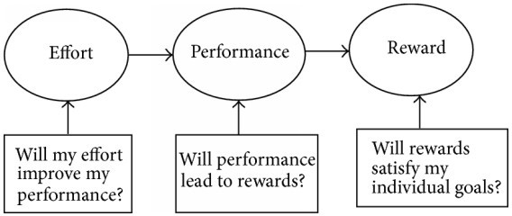

Classificationanddifferentapproaches

Workermotivationcanbebasedonbelow5maincategoriesandrelatedsub categories:

- Employeedevelopment:
  - jobadvancement;
  - varietyof knowledge;
  - participativedecisionmaking;
  - highlevelofknowledge;
  - developingcompetencies;

  - senseofachievement.

- Workclimate:
  - varietyoftasks;
  - socialinteraction;
  - feedbackfromwork;
  - significantjob;
  - communicationflow.
- Perceivedequity:
  - adequatepay;
  - adequaterecognition;
  - freedomatwork;
  - feedbackfromcolleagues.
- Workobjectivity:
  - completepieceofwork;
  - clarityofgoal.
- Jobsecurity:
  - jobsecurity.

Differentapproachesformotivation:
- employeeattitudescanbepositivelyinfluencedthroughstaff-orientationprogramsand an overall atmosphere of trust;
- achievementchallengesareeasilybuiltintoprojectwork;
- appreciationforeffortshouldbeclearlyexpressedthrougha varietyofmeans; (4)responsibility reduces boredom and frustration, if work is properly allocated;
(5) money acts as a strong or weak motivator, according to economic circumstances; (6)advancementpossibilitiesarereducedforemployeeswhereworkisshort-termor overspecialized;
- participationindecisionmakingcangenerateastrongcommitmentfromemployees;
- competitionstimulatesinnovationandaffectsgreateroutput;
- socialrelationshipsatworkareimprovedbycompany-sponsoredeventsandcourses.

CHAPTERNO-7
EQUIPMENTMANAGEMENT

INTRODUCTION

Goodprojectmanagementinconstructionmustvigorously pursuetheefficientutilizationoflabor,materialandequipment.
Theuseofnewequipmentandinnovativemethodshasmadepossiblewholesalechangesin constructiontechnologiesinrecentdecades.Theselectionoftheappropriatetypeandsizeof constructionequipmentoftenaffectstherequiredamountoftimeandeffortandthusthejob-site productivity of a project.
It is therefore important for site managers and construction planners to be familiar withthecharacteristicsofthemajortypesofequipmentmostcommonlyusedinconstruction.

PREPARINGEQUIPMENTSCHEDULE
Ancivilengineeringprojectneedsavarietyofequipmentanditisimperativeforengineeror contractor to know what type of equipment and what number of the equipment and for how many days (with exact dates) for each will be needed for the purpose. So that he may arrange them timely byhiring/purchasingorbyanyothermeansandtheworkmaynotbedelayedbecauseofnon- availabilityofequipment.Soanequipmentscheduleistobepreparedtoensuretheefficiencyin stipulated time.
EQUIPMENTSCHEDULE
Thisscheduleindicatesthe numberof equipments of various types to be used duringdifferent periods.Suchanarrangementensuresefficientuseofequipments.Italsocontainsinformation suchasownershipofequipment,renttobepaidforhiredequipment,conditionofworkingetc.
Anequipmentscheduleformatisgivenbelow.

NO. UNITS | DESCRIPTIONOFEQUIPMENT | MODEL  NUMBER | SERIALNO.ORCOUNTYIDNO. | ACQUISITION  COST | DATE  PURCHASED | CONDITIONOFEQUIP.  NEWORUSED | EQUIPMENTASSIGNEDTO:  (NameorPosition)

IDENTIFICATIONOFDIFFERENTALTERNATIVEEQUIPMENT

Factorsbehindtheidentificationofalternativeequipment
    - EconomicConsiderations
    - Company-Specific
    - Site-Specific
    - Equipment-Specific
    - ClientAndProject-Specific
    - Manufacturer-Specific
    - LaborConsideration

EconomicConsiderations
Theeconomicconsiderationssuchasowningcosts,operatinglabourcostsandoperating fuelcostsofequipmentaremostimportantinselectionofequipment.
Besides,theresalevalue,thereplacementcostsofexistingequipment,andthesalvage valueassociatedwiththeequipmentarealsoimportant.
Company-Specific
Theselectionofequipment byacompanymaybegoverned byitspolicyon'owning'or 'renting’.

Whileemphasison'owning'mayresultinpurchaseofequipmentkeepinginmindthe futurerequirementofprojects,theemphasison'renting'mayleadtoputtingtoomuchfocuson short-termbenefits.
Site-Specific
Site conditions-both ground conditions as well as climatic conditions-may affect the equipment-selection decision.
Forexample,thesoilandprofileofasitemaydictatewhethertogoforacrawler-mounted equipmentorawheel-mountedequipment.Ifthereisapowerlineatorinthevicinityofsite,one maygofora fixed-base kind of equipment ratherthana mobile kind ofequipment.
Equipment-Specific
Constructionequipmentscomewithhighpricetags.Whileitmaybetemptingto gofortheequipmentwithlowinitialprice,itispreferabletooptforstandardequipments.
Suchequipmentsaremanufacturedin large numbersbythemanufacturers,and their sparepartsareeasilyavailable,whichwouldensureminimumdowntime.Besides,theycanalso fetchgoodsalvagemoneyatthetimeoftheirdisposal.
ClientAndProject-Specific

The owner/client in a certain project may have certain preferences that are not in linewith theconstructioncompany'spreferredpoliciesasfarasequipmentprocurement is concerned.
The schedule, quality and safety requirementsdemanded of a particular projectmay insomecasesforcethecompanytoyieldtothedemandsoftheclient.
Manufacturer-Specific

Aconstructioncompanymayprefertobuyequipmentfromthesamemanufactureragain andagain,andthattoofromaspecificdealer.Thismaybetobringinuniformityintheequipment fleet possessed by the company or becausethe company isfamiliar with the working style of the manufacturerandthedealer.
LaborConsideration

Shortage of manpower in some situations may lead to a decision in favour of procuring equipment that is highly automated. Further, the selection of equipment may be governed bytheavailabilityornon-availabilityoftrainedmanpower.
IMPORTANCE OF OWNING & OPERATING COSTS IN MAKINGDECISION FOR HIRING & PURCHASE OFEQUIPMENT
Totalequipmentcostcomprisestwoseparatecomponents

    - Ownershipcost
    - Operatingcost

- OWNERSHIPCOST
Thisshouldexpressed asan hourly costandusedforestimating andforchargingequipmentcostto projects, it does not include job overhead orprofit. Therefore iftheequipment is toberented toothers,profitshouldincludetoobtainanhourlyrentalrate.Ownershipcostsare“fixed”costs. Almostallofthesecostsareannualinnatureandinclude:
  - InitialCost
  - Depreciation
  - InvestmentCost
  - InsuranceTaxandStorageCost

INITIALCOST
Onanaverage,initialcostmakesupabout25%ofthetotalcostinvestedduring the equipment’s usefullife. This cost is incurred for getting equipment into contractor’syard, or construction site, and having the equipment ready for operation. Many kinds of ownershipand operating costs are calculated using initial cost as a basis, and normally this cost can be calculated accurately.Initialcostconsistsofthefollowingitems:
      - PriceatFactory+extraequipment+salestax
      - Costofshipping
      - Costofassemblyanderection

DEPRECIATION
Thedeclineinmarketvalueofapieceofequipmentduetoage,wear,deteriorationand obsolescence.Depreciationcanresultfrom:
- Physicaldeteriorationoccurringfromwearandtearofthemachine
- Economicdeclineorobsolescenceoccurringoverthepassageoftime

However, thereis always someuncertaintyabout the exact length of theuseful lifeoftheasset andaboutthepreciseamountofsalvagevalue(i.e.thedemandforequipmentafteritsuseful period),whichwillberealizedwhentheassetisdisposed.

INVESTMENTCOST
Investment or interestcostrepresents the annualcost (converted into an hourlycost) of capitalinvestedinamachine.Ifborrowedfundsareutilizedforpurchasingapieceofequipment, theinvestmentcostissimplytheinterestchargedonthesefunds.Ifitispurchasedwithcompany assets,aninterestratethatisequaltotherateofreturnoncompany investmentshouldbecharged.

INSURANCETAXANDSTORAGECOSTS

- Insurance cost represents the cost incurred due to fire, theft, accident and liability insurance for the equipment.
- Taxcostrepresentsthecostofpropertytaxandlicensesfortheequipment.
- Storage cost includesthecost of rent andmaintenancefor equipmentstorage yards, the wages of guards and employees involved in moving equipment in and out of storage, and associateddirectoverhead.

- OPERATINGCOST
Operatingcostsarealsocalled“variable”cost.Becausetheydependonseveralfactors such as the number of operating hours, the types of equipment used, and the location and working conditionoftheoperation.
  - Maintenance&Repaircost
  - Tirecost
  - Consumablecost(Ex-fuel/energyconsumption,lubricatingoil)
  - Mobilization&Demobilizationcost
  - EquipmentOperatorcost
  - SpecialItemscost

INSECTIONANDTESTINGOFEQUIPMENT

Inspectionandtesting,includingcleaningisrequiredinordertokeepworkequipmentin goodworkingorderandtoensurethatitremainssafe.Ifinspectionandtestingisnot

carriedoutproperly,twotypesofriskcanbecreated:

- The performance of theequipment, including any safety features, may deteriorate tothewheretheusersareputatrisk;
- Thepersonscarryingouttheinspection,testingandmaintenancemaybeputatrisk

Itisessentialthatanappropriate‘competentperson’,conductstheinspectionand/or
testingofequipment.Butthereremainsaresponsibilityonallpersonneltoidentifydefectiveor potentially defective equipment, whenever this may come to their attention and to take appropriate action.
Equipmentfailingtomeettherequirementsofaspecificinspectionand/ortestshallbedealtwith immediatelyeitherbyrectifyingthefaultorreportingitasappropriate.Considerationshallbe given astowhethertheequipmentmayremaininservice.
It is essential that all inspections and/or tests together with any maintenance activities or repairs of equipmentberecorded.Asaminimum,suchrecordsshallincludethe
following:
- informationonthetypeandmodelofequipment;
- anyidentificationmarkornumberthatithas;
- itsnormallocation;
- thedatethattheinspectionwascarriedout;
- whocarriedoutthe inspection;
- anyfaultsfound asaresultoftheinspection;
- anyactiontakenregardingsuchfaults;
- towhom,andbywhom,thesefaultshavebeenreported;
- thedatewhenrepairsorothernecessaryactionwerecarriedout

The inspection and/or test frequency/schedule identified for each particular item of equipment shall beregardedasaminimumrequirementandshouldbeincreasedforequipmentthatisused extensively or where an item of equipment may have been used beyond its recommended working limits or for a purpose for which it was not intended. When determining the frequency of inspection and/ortest,considerationshouldalsobegiventothefollowing:
- Intensityofuse–frequencyandmaximumworkinglimits;
- Operatingenvironment,forexample,marine,outdoors;
- Legislativerequirements;
- Manufacturersguidance;

- Varietyofoperations–istheequipmentperformingthesametaskallthetimeordoesthis change?
- Risktohealth and safety frommalfunction orfailure.

JOB LAYOUT FOR DIFFERENT CONSTRUCTION SITESEGO DAM SITE,
MULTISTORIEDBUILDINGS,BRIDGECONSTRUCTIONSITEETC.

Thecontrollingcontractormustconsidermanyfactorswhenlayingoutasite tosupportconstructionoperations
  - Siteandbuildingsizeandconfiguration
  - Locationofadjacentroads,buildings,andutilities
  - Soilconditionsandexcavationrequirements
  - Constructionsequenceandschedule
  - Locationofundergroundutilities
  - Equipmentrequirements
  - Materialquantity,storageanddelivery
  - Workerparking
  - Toolandequipmentstorage
  - Constructionoperationsfacilitiesandtrailers
  - Sanitaryfacilities

Q1.Preparethejoblayoutforaneightstoreyedbuildingschemewiththefollowing data:

Plotarea 50mX36m
Buildingarea 30mX20m
Ans.
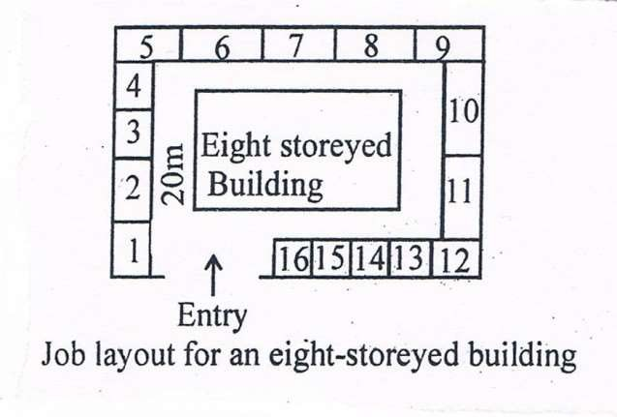
Fig.1showsthelayoutoftheprojectunderconsideration.Theentryisone-wayandthenotations on the figure indicate the following:
- :Watchmanroomor cabin
- :Officesforcontractors,engineers,etc.
- :Storeforplumpingitems,wood, electricfittings,etc.

- : Storefor cement
- And12:Spaceforsurplusearth
- :Storeforlesscostlymiscellaneousitems
- And14: Spaceforcoarseaggregate
- And15:Spaceforsand
- And16:Spaceforbricks
- :Spaceforcentringmaterial
- : Spaceforconstructionmaterial
13 :Spacefor steel

Q2. Preparethejoblayoutfor adamsite.

Ans.
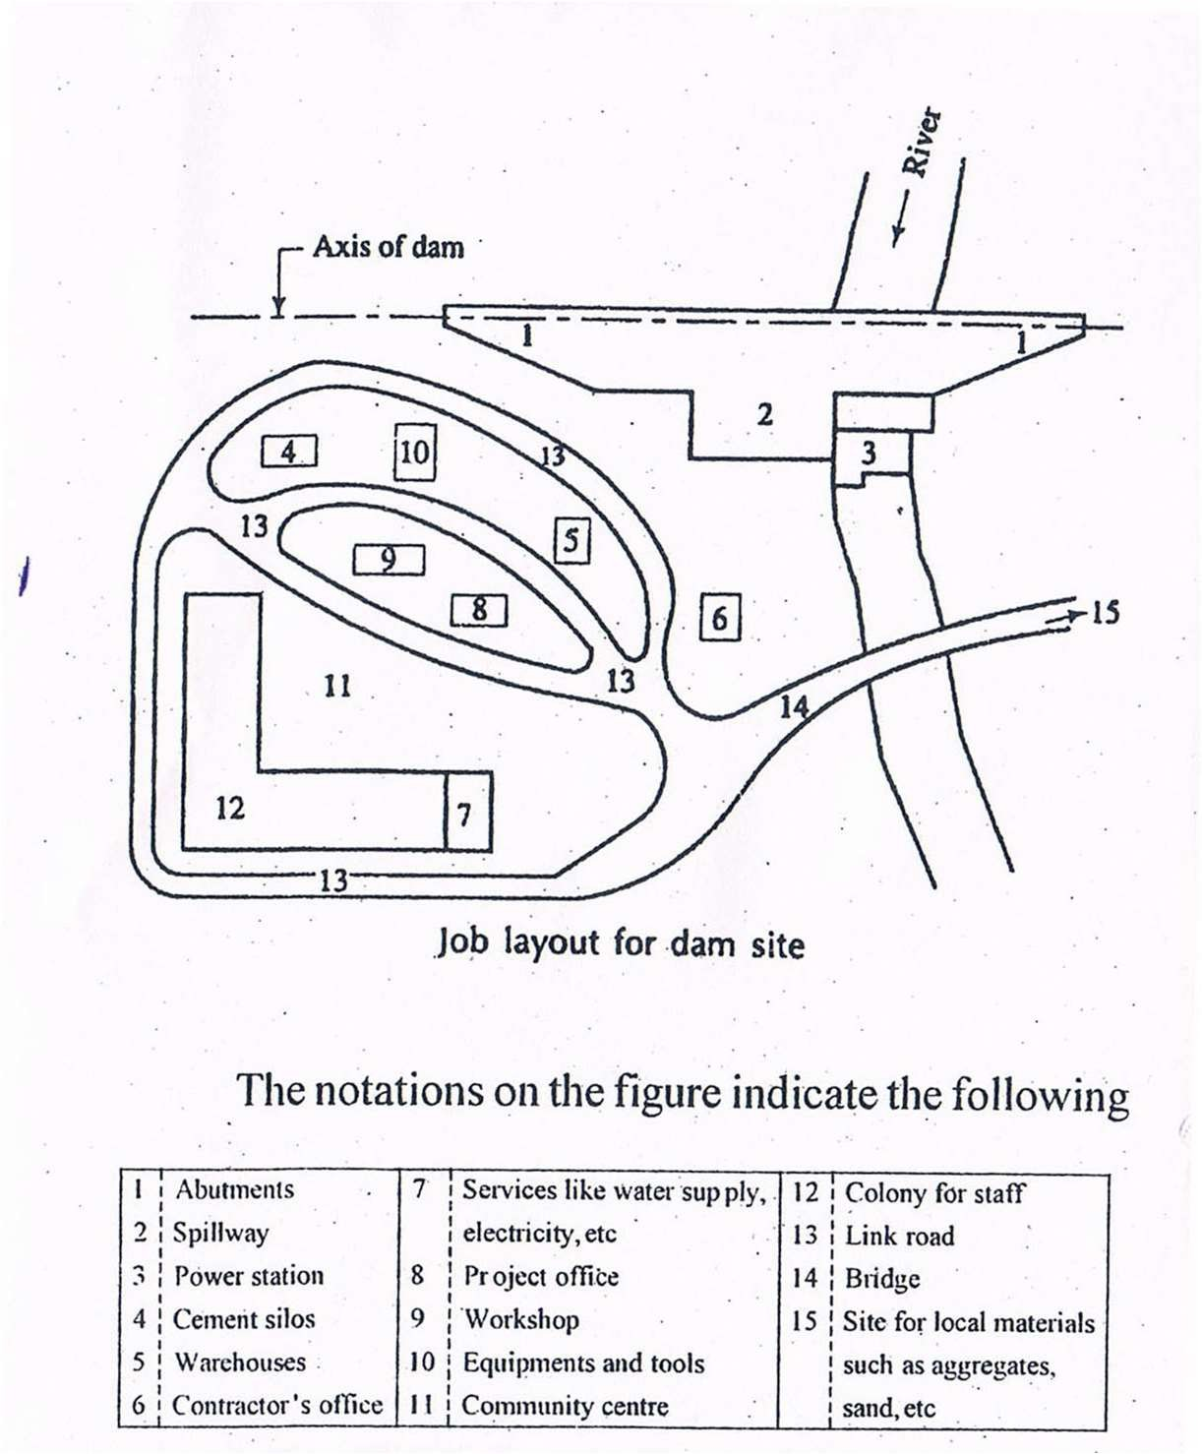

EQUIPMENTMAINTAINANCEANDMINORREPAIRS

OBJECTIVES

- Tooptimizeutilizationtoobtainmaximumreturnforcapitalinvested.
- Costefficiency.
- Betterutilizationresultinquicktime.
- Optimalservicehandlingandrapidturnoverminimizescost.
- Qualitycareand satisfaction
- Usersafety

Performancestobecarriedoutformaintainanceandrepairofequipment

  - Maintenancescheduleisreviewedtodeterminemaintenancerequirements.
  - Toolsandmaterialsrequiredformaintenanceandrepairareidentifiedandobtainedand usedaccordingtomanufacturerspecifications..
  - Lock-outorisolationproceduresarefollowedpriortoconductingplantmaintenance accordingtomanufacturerspecifications,organizationalrequirementsandlegislation and codes.
(There are many types of potentially hazardous energy including, electrical, thermal, chemical, pneumatic, hydraulic, mechanical and gravitational energy. All such forms of energy must be locked out/isolated, blocked or released to ensure that machinery or equipment does not turn on or move during installation, repair or maintenance.)
Supervisoryprocessesandchecksandmeasuresareimplementedtoensureworkis completed within time available.
Lubricationisappliedtomovingpartsaccordingtomanufacturerspecifications.

STUDYMATERIAL
Sub:ConstructionManagement6thsemesterCivilEngineering CHAPTER8:QUALITYCONTROL

Meaning
Quality may be defined as fitness for purpose as lowest cost. Quality means degreeofperfection.Itcanbedeterminedbysomecharacteristicssuchasdesign, size, materials, chemical composition, machine functioning, work man ship finishing and other properties.
Quality control is concerned with making things right rather than discovering and rejecting those made wrong. Quality control is techniques of management for achieving required standard of products.

Factorsaffectingquality:-
    - Marketresearch,i.e.,demandofpurchases
    - Moneyi.e.capabilitytoinvest
    - Managementi.e.Managementpoliciesforqualitylevel
    - Productionmethodsandproductdesign

Objectivesofqualitycontrol:-
    - Tosetupstandardsofqualityacceptabletothecustomeraneconomical to achieve an maintain
    - Tolocateanidentifytheprocessfaultssoastocontroleffectivesscrapanwaste

    - Totakenecessarycorrectivemeasuressoastomaintainthequalityofthe products
    - Toensurethatsubstandardproductsdonotreachthecustomers.

Advantages:-
    - Qualityofproductisimprovedwhichinturnincreasessales
    - Goodqualityproductimprovesreputation
    - Inspectioncostreducestoagreatextent
    - Uniformityinqualitycanbeachieved
    - Improvementinmanufactureanconsumerrelations

Conceptofqualityin constructions:-
Def.
According to Philip Crosby “quality is performance to customer requirements” According Avi Garrin “quality is excellence in certain dimensions”

Basicfeaturesofquality:-
    - Qualityiswhatcustomersays,perceivesanbelievesitis
    - Qualitysatisfiesbothinternalandexternalcustomer
    - Qualityshouldbepresentintheprocessaswellasstheproductorservice
    - Qualityisgoingthingsrightthefirsttime,everytime
    - Qualityisawayoflife.

Qualityistheessenceofaconstructionwork.Themainobjectivesoftheinspection and quality control is to achieve sound construction work which results in a structure of good strength and good life at a reasonable rate.

Majoritemsof control:-
Majoritemsofconstructionshouldbecontrolledlikematerials,equipmentand construction work.
    - Materials
All the materials should be inspected and tested a per standard specifications laid own. The samples of materials should be selected at random and checked.
    - Equipment
The equipment purchase should confirm to the specifications and laid standards, as per terms and conditions given in supply order.
    - Constructionwork
Different standards and specifications are followed in different types of works. The inspection checking and testing of construction work is carried out at suitable intervals during course of construction.

Qualitystandardsduringconstructions:

    - Executionofworkasperspecifications
    - Preparingtestcubesforstrengthofconcreteandthemtestedonduedates.
    - Testingof other materials incorporate in the work as per i.e. standards.IndianStandardInstitution(I.S.IrenameasBIS)Bureau of IndianStandards.
- Inspection
Itisaprocessofsortingwellfromalot.
- Qualityassurance
Itmeanstoprovidethenecessaryconfidence tothe customer as well as to topmanagementthatallconcernedarecarryingouttheirjobeffectivelyand that the product quality is as per customer’s satisfaction with economy.

STUDYMATERIAL
Sub:ConstructionManagement6thsemesterCivilEngineering
CHAPTER9:MONITORINGPROGRESS

9.1
Progress of any work may be defined as an achievement at regular intervals of time when compose with the estimated work. Progress reports are prepared at regular intervals to have better control of progress.

Purpose
  - Itgivesinformationtotheplannerastowhethertheworkisbeingoneasperschedule
  - Itgivesassurancetotheownerastowhether heisgettingbackfor what heisspending.
  - Itpermitscollectiveactiontobringtheworkonscheduleifthesameisbehindschedule.
  - Itformsthebasisof makingpayments.
Programme:
It is a comprehensive plan designed to implement the policies and accomplish the objectives. It is a combination of goals, policies, task assignments, resource flows, etc. It is a concrete well definedscheme designed to accomplish a specific objective. In business programmes are used in various areas,
e.g.developinganewproduct,trainingprogramme,advertisingprogramme,expansionprogramme,etc.

Featuresofa programme:
- Itisasingleusebutcomprehensiveplan.
- Itisbasedonthe objectivesandpolicies oftheorganisation
- Itisanactionplanindicatingtheactivitiestobeperformedandtimeforactivitiestobe performed and time for each activity.
- Itisdesignedtoensuresmoothandefficientfunctioningoftheorganisation.
Aprogrammeservesasausefulguideindaytodayoperations.Itisactionbased and result oriented.

Methodsofrecordingprogressofwork:
C Job dairy: it is most important documents. It records attendance record, progress of work one,recordofpaymentsmade,receiptanissueofmaterialstothework,inspectionreport, officecorrespondencerecordetc.Ithelpsinsolvingdisputeswithcontractorsandcanbe produced as evidence in the court of law.
C Register of instructions: The site engineer records his observations regarding quality and progress of work in this register. This is the channel of communication between the engineer and the contractor at the site of work.

C Progress reports: The engineer prepares the progress report, progress charts at regular intervals tokeeptheowner and homeofficefully informed.The reports can be submitted daily, weekly, fortnightly and sometimes monthly.
CConstructionreports:Thedailyreportsregardingprogressofconstructionmaterialusedare to be entered in prescribed forms regularly. The construction reposts are intended to recorded time, quality and quantity of work and general conditions to ensure satisfactory progress on work as per laid specifications.
C Abstract of quantities and cost: The materials issued to the work are also recorded in this register. These are further posted on registers and indicate the up to date progress of work.

9.2WorkStudy:
Work study is to determine the best method of performing each operation and to eliminate wastage so that production increases with less fatigue. According to the British standard institution,workstudyisageneraltermforthosetechniques,particularlymethodstudyandwork measurementandwhichleadsystematicallytotheinvestigationofallthefactorswhichaffectthe efficiency an economy and the situation being reviewed in order to effect improvement.
Work study is the study of human. Work in all aspects in order to improve productivity. Work study is a systematic an analytical study of work process and work methods with the objective of increasing efficiency and reducing costs.

Objectivesofworkstudy:
- Theoptimumuseof plant andequipment
- Themosteffectiveutilisationofhumaneffort
- Determinationofefficientworkmethods
- Theevaluationofhumanwork
- Establishmentfstandsofperformance
Workstudyisavitaltoolof improving productivityandcosteffectiveness.Workstudy makes improvements in the areas of:
- Workenvironment
- Plant layout
- Materialhandling
- Employeesafety
- Equipmentutilisation

Proceduresofworkstudy
- Definetheproblem
- Obtainallrelevantfact
- Examinethefactscriticallyandobjectively
- Considerthealternativeandecidewhichonetofollow
- Act onthedecision
- Followup the development

WORKSTUDY

- METHODANALYSIS
- WORKMEASUREMENT

  - Method analysis/method study: It is to find out better ways of doing work. It leads to standardization of methods and procedures. It is also known as workimprovement.
  - Workmeasurement: it refers to the study of work content of a job so as to lay down fair days. It is closely related to method analysis.

Workstudyisfurtherdividedintotwogroups:

    - Method/motion study: the analysis during the execution of the project would invariably slow slackness or comparatively less output in certain fields
C Method adopted for the job C Qualityof finished products C Specifications of materials

    - Workmeasurement/timestudy
CDetailsofworkingconditionsi.e.altitudeofplace, humidityofatmosphere,sourceofpoweretc
CRecordoffailuresduringcollectionofdata/observationand causeof failure
CRecordofactualhoursofwork done duringthedatacollectionorperiodofobservation
CSpecified timeofcontinuousoperation.

9.3Analysisofprogress:
Thestagesofanalysisofprogressas follows:
    - Proper accounts of the material purchased, and consumed on the work as per material schedule is kept.
    - Proper record of labour employed, payment made to them and progress of work one b them are recorded and compared with the labour schedule and corrective action taken.
    - Thedeploymentofequipmentasperequipmentschedule must be checked.
    - Progress of construction should be compare with construction scheduleandincasetheworkbehindschedulethecausesmust beinvestigated.
Takingcorrectiveaction:
Someofthestepstakenarementionedbelow:
    - Thestoresmustbeprocuredwellaheadofrequirement.

    - Ifanyequipmentisnotreceivedintime,alternatearrangementsshouldbemade promptly to procure the some from other sources.
    - Properwatchandwardshouldbearrangedtoeliminatethechancesofpilferageof materials, etc.
    - Incentiveschemeshouldbeintroducesforachievinghigheroutputsandbetterefficiency. Analysis of Financial Progress Corrective Measure
    - Administrativeapprovalofthework.Theexpenditureofeachitemofworkisrestrictedby its administrative approval.
    - Invitingopentenders/bidssothatasfaraspossibleonlythebidinvolvingminimum expenditure is accepted.
    - Keepingoverheadsorunproductiveelementstothebareminimum.
    - Providingregularaccountsandgettingtheexpenditureauditedatregularintervals.

CHAPTER10:SafetyManagementinConstruction

Importanceofsafety
Constructionisoneofthemostdangerousindustrysectors.Millionsofconstructionindustryaccidents occurintheworldcausingdamagesandinjuriestoworkersandconsequentlyeconomicallossesinevery year.Constructionsitesaredynamicandcomplicatedsystems.Themovementandinteractionofpeople, goods,andenergymakeconstructionsafetymanagementextremelydifficult.Duetotheever-increasing amount of information, traditional construction safety management has operated under difficult circumstances.Theconstructionindustryhastraditionallybeenconsideredashazardousoccupationdue tothehighincidenceofoccupationalinjuriesandfatalaccidents.

causesandeffectsofaccidentsinconstruction works
Causesofaccidents
    - Lackofpropertraining
    - Deficientenforcementofsafety
    - Lackofsafetyequipment
    - Unsafemethodsorsequencing
    - Unsafesiteconditions
    - Notusingprovidedsafety equipment
    - Poorattitudetowardsafety
    - Isolatedfreakaccident
Effectsofconstructionaccidents
    - Timelossofprojectexecution
    - Reputationoffirm
    - Mentalillnessofworkers
    - Costofmedicalexpenses
    - Costofrecruitingnewworker
    - Costoftraininggiventonewworker
    - CompensationCost
    - Repairs
    - AdditionalSupervisioncost
    - Productivityloss
    - Costofaccidentinvestigationtime

Safetymeasuresinworksitesforexcavation, scaffolding, formwork, fabrication and erection,
demolition
UseProperSafetyEquipment
First ofall,personal protectiveequipment (PPE)isa mustwhenworkinginany industrial orconstructionsetting, especially at height.

Manyscaffold-relatedinjuriesinvolvefallingobjects,sowearingahardhatcangoalongwaytowardpreventing seriousinjury.Non-slipfootgearandfallarrestequipmentarealsoessentialwhenworkingonplatforms.
- MindLoadLimits
Scaffoldingmaterialsanddesignsaremadewithspecificload-bearingcapabilitiesinmind.Choosingcomponentsthat aren’tsufficientforthetypes ofloadsyouintendtousein yourworkwillposeaseriousrisktoemployees.Platforms may crack, break, orotherwise collapse entirely, causing severe injuries for anyone working in the vicinity.
- KnowRelevantRegulationsandStandards
Each industry hasitsregulationsandstandardstofollow, andthosemayvaryfrom statetostate(orevencity tocity). Many of those regulations involve scaffolding, so it’s important to know what the laws in your area dictate before setting up platforms.
Youcouldpreventanaccidentand,attheveryleast,avoidliabilityforfailingtomeetprescribedstandards.Inaddition, youshouldtrainyourworkerstorecognizeandminimizetheassociatedrisksandhazardsofthetypeofscaffoldingthat you’re using.
- InspectScaffoldingMaterials
Beforesettingupyourworkplatforms,youmustinspectallofyourmaterialsbeforeconstruction.Makesurenoneof thepartsyouusehaveanydefectsordamagethatcouldcompromisethestructuralintegrityof yourscaffolds.
Also, all partsshould besourced fromthe same manufacturerand designedto beused together.Mismatching parts can poseasignificantscaffoldinghazardandleadtostructuralfailure.
- BuildProperly
Follow instructions provided by the manufacturerwhen building your scaffold. Check the types of bracing and fasteners andensurethatyou’rebuildingthescaffoldaccordingtothemanufacturer’sexactspecifications—donot take shortcutsnorcreateyourowndesign.
Whenbuildingscaffold,youalsowanttoensuretheareaiscompletelysafe.Alevelgroundsurfaceworksbest(if possible),andyoushouldtrytoavoidintersectingwithpowerlinesonyourwayup.
Wheneveryoubuild,move,ordismantleascaffold,OSHAregulationsrequireacompetentpersontobepresentand supervise.A competentpersonissomeonewhohasreceivedOSHA-approvedtrainingandtheaccompanyingtitle. Be sure to check for the following:
Legbracesshouldbecorrectlyinstalledtotheframeofthescaffold. Thestandards,planks,andscaffoldarelevelandtrue.
Planks,brackets,toeboards,andtubesshouldbeinstalledrigidly,andthewedgesshouldbevery tight. Mudsillsandbaseplatesshouldbethecorrectsizeandinstalledrigidlytothescaffoldframe.
Thereshouldbeatleast10’ofclearancebetweenelectricalhazardsandscaffoldsasperOSHAregulations.Ifthe distanceislessthan10’,thenyou’llneedtoshutofftheline.
- InspecttheSiteandEquipment—Again
Afterthescaffoldhasbeenerected,theneedforinspectionsdoesn’tgoaway.Theareashouldbecheckedover regularly for hazards, defects, debris, or other factors that could cause a problem.
Agoodtimetoperformtheseinspectionsisatthestartoftheworkdaytoensuretheareaisclearforthatday’sshift.
- KeepVehiclesandHeavyEquipmentClear
Vehiclesandheavyequipmentshouldalwaysbekeptclearofthescaffoldbase.Settingupbarrierscankeepthewhole structurefromtoppling.Itmaybenecessarytohaveheavyequipmentnearby.Inthosesituations,makesurethe equipmenthasclearance.
- StayOrganized
Tools and equipmentshouldbekeptorganizedandputaway afteruse.Attheendof eachday,checkthatthereareno toolsormaterialsleftontheplatform—cluttercouldleadtotripandfallinjuries,ortheymayposeahazardforthose working on lower levels.
- MindtheWeather
Whenworkingatheight,youwanttomakesuretheworkingconditionsaresafe.Workingduringharshweather conditionsorotherenvironmentalhazardscanincreasetheriskofseriousinjury.Forinstance,highwindscouldrisk injurytothoseworkingonthescaffold.Ifastormhasbroughtdownapowerline,thatcouldalsocreateascaffolding hazard.
- BeFully Licensed
Beingfullylicensed—andworkingwithlicensedcontractors—helpspreventinjuriessinceeveryoneworkingonthe siteisawareofthepotentialhazardsandthebestwaystoavoidthem.Theprocessofbecominglicensedofteninvolves educationandtraining,whichhelpsyourteamworksafely.

- ClimbResponsibly
Those who scale your scaffolding should exercise propersafetytechniques when doing so.One tip is to make sure employeesalwayshaveatleastthreepointsofcontactwiththestructureatalltimes,meaningeitheronehandandtwo feetortwohandsandonefoot.
Inaddition,somepartsofthescaffold,suchascrossbraces,shouldn’tbeusedforclimbing—they’renotusually designedtosupportsheerweightontheirown.

Developmentofsafetyconsciousness
Quality and safety are key issues in the present construction industry. ISO 9000 has been promoted in the constructionindustrytoensurethequalityofconstruction workdonebythecontractors.Besides,a safe workenvironmentisverynecessarytoerasethehigh-riskimagethatiscloselyassociatedwiththe constructionindustry.Safeworkenvironmentmayalsobereferredtoasconstructionsafetywhichisa standard of quality that is indicated in the contract and required by the client. Often projects are becoming more complex, and safety has becomethe main focus in ensuring thesafetyof the construction personel and properties. Developed countries such as the UK and Australia have enforced safety rules in contractors’worksonsite.Revolutionandchangesinsafety systemmanagementhavebecomeamandatein practicing safety action that can be managed interminably. The construction industry is labour intensive based on wet trades. This factor contributes to the low quality of work due to the workers’ lack of expertise and training, whileat the sametime exposes them to accidents easily.
Overallsafetyculturecanbedescribedasasetofbeliefs,norms attitudesand socialtechnical practices thatareconcernedwithminimizingtheexposureofindividuals,withinandbeyondanorganization, to conditions considereddangerous orinjurious.
Safetyislookedintofromtheculturalpointofviewassharedcharacteristicsofagroupdynamicrelating to a system (e.g., group, community, race, nation, religion) which include beliefs, values, attitudes, opinionsandmotivations.Organizationswithgoodsafetycultureshaveemployeeswithpositivepatterns of attitudes towards safety practice. These organizations have mechanisms in place to gather safety-related information,measuresafetyperformanceandbringpeopletogethertolearnhowtoworkmoresafely. Employees’perceptionsofsafetycultureasfollows:
- managementattitudestowardssafety;
- perceivedlevelofrisk;
- effectsofworkpace;
- managementactionstowardssafety;
- statusofsafetyadviserandsafetycommittee;
- importanceofhealthandsafetytraining;
- socialstatusofsafety andpromotion.
Stepstopromotesafetyawareness:
- Leadership - Improved safety culture can be achieved through close cooperations between leadersand the workers;
- Involvement-Animportantindicatortoapositivesafetycultureinanorganizationisthe involvementoftheleadersandtheworkersinsafetymanagement.
- Recognition systemsandacknowledgement - Therecognition received would onlybeeffectiveif itismeaningfulandgivenasanacknowledgementtotheworkproduced.
- Training - Training hasalways beena high priority, andtheeffectivenessof safetytraining has been proven to increase knowledge andawarenessof workers on safeworking culture;
- Communication-Communicationinvolvesallaspectsofworkinanorganizationandisableto

connectallentitiesatalllevelsonsafety aspects;
- Teamwork - Team members are involved in conveying their opinions on works that theydoand strategiestosolveproblems
- Motivation-Leadersthatconsidertheideasoftheworkersandsensitivetotheirneedswillbe abletoelevatethemotivationleveloftheworkerstoproduceworkofbetterquality;
- HealthandSafetyCommittee-Functionstoimprovecertainaspectoftheworkenvironmentand developsafetyvaluesineverydayworkpractice,andestablishingsafetyasthemaingoaltobe achievedbythecommittee
- Workenvironment -Theworkenvironment should conformtothe standard ofsafetyand health at all times
- Policy and safety planning - Policy pertains to the principle that supports behavior towardssafety,asinmakingsafetypoliciesasamarketingadvantagefortheorganization.

Safetylegislation-Workman’scompensationact, contract labor act
The compensation act for workmen was formed after it came into notice thatthe laborers werebecoming exposed to the danger by using more sophisticated and advanced machinery.
Accordingtothecompensationactof1884,theemployerwouldtakeresponsibilityforthe compensationofitsworkmenonlywhensomemajororfatalaccidentsoccuronroad.However, in1885,theminingandfactoryinspectorsrealizedthatthisFatalAct,1885,isnotsufficient.
TheGovernmentgaveitahearingear,whentheLegislativeAssemblymembers,representatives of employer, experts inmedicine, workers, and insurance expertsformeda committee that providedareportthatledtotheWorkmen’sCompensationAct,1923.
Whenthisactwaspassed,itputastopandprovidedrelieftotheworkerswhowouldhave gonethroughtheprocessingofcourtthatis generallyexpensive.It wasan effortto seek compensation whenever they encounter some injury during employment.
ScopeofWorkmen’sCompensationAct
The workmen’s compensation act, 1923, isapplicable for those workers who areworking with anindustrythatismentionedintheact.Underthisact,theprotectionofworkmenfrominjuries andlossescausedthroughanaccidentincourseofandarisingoutoftheemploymentsubjecttospecificexpectationsasmentionedintheact.
TheobjectiveoftheWorkmen'sCompensationAct
TheWorkmen’sCompensationAct,1923wasmajorlyformedtoprovidecompensationtothe workmenatthetimeofanaccident.
Theactmentionsthatitisthedutyandresponsibilityoftheemployertoincludethewelfareof theworkerswhenaninjuryistheresultoftheemploymentinthesamewaytheemployerhas reservedtherightofmakingprofits.Themainaimofthisactistoensurethattheworkmen have sustainable life even after encounteringan employment-related injury.
TheLiabilityoftheEmployerforCompensation
Tomaketheemployerpaytheworkerscompensationatthetimeofinjuryordeathsufferedby theemployeeorworkmanshouldbeaconsequenceofsomeaccidentincourseoforoutof his/heremploymentdependsonthefollowingfourconditions.
ApplicabilityoftheWorkmen’sCompensationAct
This act is applicable acrossIndiaexcept for Jammu and Kashmir. This act does not applyto the areasthatarecoveredbytheEmployeesStateInsuranceAct,1948.

ContractLabourAct:
Theactappliestoallthosefirmswhichhavetwentyormoreworkmen,presentlyemployedor previouslyemployedonanydayofthepasttwelvemonths.Italsoappliestoeverycontractorwho employsoremployedtwentyormoreworkersonanydayofthepasttwelvemonths.Itdoesnotapplyto firmswherecasualorirregularworkisperformed.Thisagainhassub-sections:-
- If the establishment performed for more than one hundred and twenty days in the past twelvemonths,itcannotbeconsideredasanintermittentone.
- Iftheestablishmentperformsformorethansixtydaysinayearandisseasonal,itcannotbe consideredasanintermittentone.
ProcedureforRegistrationoftheCompaniesHiringContractLabours
Everyfirmwhichemployscontractlaboursforitsworkhastoacquireacertificateofregistrationfrom the appropriate government. Given belowis the procedure for the registration of such companies:
TheemployershouldgototheregistrationofficewiththeapplicationforregistrationinFormno.1 alongwiththereceiptrepresentingthepaymentoftheprescribedfee.
Iftheapplicationreceivediscompleteinallrespects,theregistrationofficerregistersthecompanyand grantsthecopyoftheregisteredcertificateinForm-II.
LABOURLAWADVISORIN INDIA
DetailsofTheCertificateofRegistration Nameandaddressoftheestablishment.
Amaximumnumberofworkerstobehiredascontractlabours. Typeofbusinessandanyotherrelevantinformation.
LicenseforTheContractor
Every contractor working foranestablishmentwhohires twenty or moreworkersonany day ofthe pasttwelvemonthshastoobtainapermitforengaging contractlabourregistration.Thelicensingofficer providesthislicense asper the provisions of section 12 ofthecontract labour act.Undersuchsection, a permitmaycontain conditions about the hours ofwork,fixation of wages,and other necessaryfacilities tothecontractlabours.

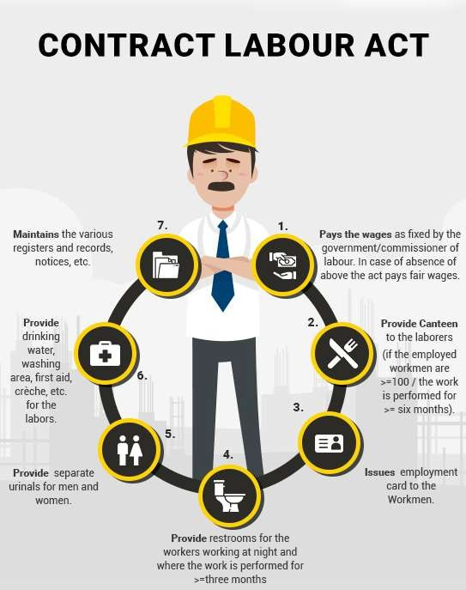
ProcedureforGrantofLicense
Givenbelowistheprocessforapplyingforalicensefromalicensingofficer:-
ThecontractorhastorequesttheLicensingAuthorityalongwiththeapplicationforthegrantofa license in Form no. IV
AsecurityfeeofRs.20hastobedepositedatthetimeofapplication. Thereceiptofthefeepaidtothelicensingofficerhastoberetained.
AcertificatebytheemployerinFormVstatingthathehasemployedtheconcernedcontractorforhis establishment.
The licensing officer may make further necessary investigations andgrantthe license in Form VI, which hastoberenewedbefore30daysoftheexpirydatealongwiththeprescribedfee,failingwhichthe contractorwillhavetopay25%morefeethantheordinaryamount.
DutiesoftheContractorandTheEmployer
Theemployershouldensurethatthecontractordoesthefollowing:-
- Paysthewagesasfixedbythegovernmentor
- Paysthewagesasfixedbythecommissioner oflabour.
- Intheirabsence,paysfairwagestothelabours.
- Providesthefollowingfacilities:
  - Canteen to the labours (if the employed workmen are 100 or more and the work is performedfor six months or more).
  - Issuesemploymentcardtothelabours.
  - Restrooms for the workers working at night and where the work is performed for threemonths or more.

  - Requirednumberofseparateurinalsformenandwomen.
  - Drinkingwater,washing,firstaid,crèche,etc.forthelabours.
  - Maintainsthevariousregistersandrecords,notices,etc.
ViolationsTotheContractLabourAct
Anypersonwhoviolatesanypartofanyclauseof theactwill be punishedwith custodyformorethan threemonthsorwith afineofRs1,000ormaybeboth,dependingontheseverityoftheviolations.
Ifapersonbreaksanyrulesundertheactforwhichnoadditionalfineisprovided,thenheorsheshall be sentencedto threemonthsimprisonment or afine ofonethousandrupees or both.

CHAPTER11:Role of Vulnerability Atlas of India in construction projects

IntroductiontoVulnerabilityAtlasofIndia,Concepts ofnatural hazardsanddisastersandvulnerabilityprofileofIndia.Definitionof disaster related terms.
TheIndiansub-continent,likemanyotherregionsintheworld,isvulnerabletoanumberofnatural hazardssuch as earthquakes, landslides, tsunamis, floods, cyclones, storm surges and thunderstorms. Highvulnerabilityofits physicalandsocio-economicprofilecharacterizethedisasterscenarioofthe subcontinent which has been, traditionally, facing different types of natural calamities that often turn intodisasters,causinghighlossoflifeandproperty.Indiahaswitnessedseveraldisastersleavingatrail ofdestructionandirreparablelossoflives.
BMTPChas prepared thethird edition of the Vulnerability Atlas ofIndia which includes hazard maps of earthquakes, wind, cyclones, floods, landslides, thunderstormsand vulnerability risk tables based on availablelatest datainorder to helpin enhancing preparedness ofGovernments and various other agencies in mitigatingnatural disasters. The Atlas is a useful tool not onlyforpublicbut also for urban managers and National and State Authorities dealing with disaster mitigation and management.
NaturalHazardsareelementsofcircumstancesintheNaturalenvironmentthathavethepotentialto causeharmtopeopleorpropertyorboth.Thesemaybeswiftorpermanentaspectsoftherespective environmentalsettingslikecurrentsintheoceans,steepslopeandunstablestructural featuresinthe Himalayasorextremeclimaticconditionsindesertsorglaciatedareas.
Naturaldisasterisanundesirableoccurrenceresultingfrom forcesthatarelargelyoutsidehuman control,strikesquicklywithlittleornowarning,whichcausesorthreatensseriousdisruptionoflifeand propertyincludingdeathandinjurytoalargenumberofpeople,andrequirestherefore,mobilisationof effortsin excessofthatwhicharenormallyprovidedbystatutoryemergencyservices”.
VulnerabilityprofileofIndia

Indiahasbeenvulnerable,invaryingdegrees,to alargenumberofnatural,aswellas,human-made disasters on account ofits unique geo-climaticand socioeconomicconditions. It is highlyvulnerable to floods, droughts, cyclones, earthquakes, landslides,avalanches andforest fires. Out of 36 states and unionterritoriesinthecountry,27ofthemaredisasterprone.
Indiaisoneofthe ten mostdisaster-pronecountriesoftheworld.Thecountry isprone todisasters duetoanumberoffactors;bothnaturalandhumaninduced,includingadverse Geo-climaticconditions, topographic features,environmental degradation, population growth, urbanization, industrialization, non-scientificdevelopmentpractices,etc.

Disasterrelatedterminology:

- Acceptablerisk:The level of potential losses that a societyor community considers acceptable givenexistingsocial,economic,political,cultural,technicalandenvironmentalconditions.
- Capacity: The combination of all the strengths, attributes and resources available within a community, societyor organization thatcan beused to achieve agreed goals.
- Capacitydevelopment: The process by which people, organizations and society systematically stimulateanddeveloptheircapacitiesovertimetoachievesocialandeconomicgoals,including through improvement of knowledge, skills, systems, and institutions.
- Climatechange:
- TheInter-governmentalPanelonClimateChange(IPCC)definesclimatechangeas:
  - “achangeinthestateoftheclimatethatcanbeidentified(e.g.,by usingstatisticaltests)
  - bychangesinthemeanand/orthevariabilityofitsproperties,andthatpersistsforan
  - extendedperiod,typicallydecadesorlonger.Climatechangemaybeduetonatural
  - internalprocessesorexternalforcings,ortopersistentanthropogenicchangesinthe
  - compositionoftheatmosphereorinlanduse”.
- TheUnitedNationsFrameworkConventiononClimateChange(UNFCCC)defines
  - climatechangeas“achangeofclimatewhich isattributed directlyorindirectlyto human
  - activitythataltersthecompositionoftheglobalatmosphereandwhichisinadditionto
  - naturalclimatevariabilityobservedovercomparabletimeperiods”.
  - Contingencyplanning:Amanagementprocessthatanalysesspecificpotentialeventsor
  - emergingsituationsthatmightthreatensocietyortheenvironmentandestablishes arrangements
  - inadvancetoenabletimely,effectiveandappropriateresponsestosucheventsand situations.
- Copingcapacity:Theabilityofpeople,organizationsandsystems,usingavailableskillsand resources,tofaceandmanageadverseconditions,emergenciesordisasters.
- Criticalfacilities:Theprimaryphysicalstructures,technicalfacilitiesandsystemswhichare socially,economicallyoroperationallyessentialtothefunctioningofasocietyorcommunity, bothinroutinecircumstancesandintheextremecircumstancesofanemergency.
- Disasterrisk:Thepotentialdisasterlosses,inlives,healthstatus,livelihoods,assetsand
- services, which could occur to a particular community or a society over some specified future time period.Disasterriskmanagement:Thesystematicprocessof usingadministrativedirectives, organizations, and operational skills and capacities to implement strategies, policies and improved copingcapacitiesinordertolessentheadverseimpactsofhazardsandthepossibilityofdisaster.
- Disasterriskreduction:Theconceptandpracticeofreducingdisasterrisksthroughsystematic efforts,toanalyseandmanage thecausalfactorsof disasters,including throughreducedexposuretohazards,lessenedvulnerabilityofpeopleandproperty,wisemanagementoflandandthe environment, and improved preparedness for adverseevents.
- Earlywarningsystem:Thesetofcapacitiesneededto generateanddisseminatetimelyand meaningful warning information to enable individuals, communities and organizations threatenedby a hazard toprepare and toact appropriately and in sufficienttime to reduce the possibility of harmorloss.Emergencymanagement:Theorganizationandmanagementofresourcesand responsibilities for addressing all aspects of emergencies, in particular preparedness, response and initial recovery steps.
- Emergency services: The set of specialized agencies that have specific responsibilities and objectives inserving andprotecting people and property inemergency situations.
- Environmentaldegradation:Thereductionofthecapacityoftheenvironmenttomeetsocialand ecologicalobjectivesandneeds.

- Environmentalimpact assessment: Process by which the environmental consequences of a proposedprojectorprogrammeareevaluated,undertakenasanintegralpartofplanningand decision-makingprocesses with a view to limitingor reducingthe adverseimpacts of theproject or programme.
- Forecast:Definitestatementorstatisticalestimateofthelikelyoccurrenceofafutureeventor conditions for aspecific area.
- Hazard:Adangerousphenomenon,substance,humanactivityorconditionthatmaycauseloss oflife,injuryorotherhealthimpacts,propertydamage,lossoflivelihoodsandservices,socialand economic disruption, or environmental damage.
- Mitigation:Thelesseningorlimitationoftheadverseimpactsofhazardsandrelateddisasters.
- Natural hazard: Natural process or phenomenon that may cause loss of life, injury or other health impacts,propertydamage,lossoflivelihoodsandservices,socialandeconomicdisruption,or environmentaldamage.
- Preparedness: The knowledge and capacities developed by governments,professional response and recovery organizations, communities and individuals to effectively anticipate, respond to and recoverfrom,theimpactsoflikely,imminentorcurrenthazardeventsorconditions.
- Prevention:Theoutrightavoidanceofadverseimpactsofhazardsandrelateddisasters.
- Publicawareness:Theextentofcommonknowledgeaboutdisasterrisks,thefactorsthatleadto
- disastersandtheactionsthatcanbetakenindividuallyandcollectivelytoreduceexposureand
- vulnerabilitytohazards.
- Recovery:The restoration,andimprovementwhereappropriate,offacilities,livelihoodsand livingconditionsofdisaster-affectedcommunities,includingeffortstoreducedisasterriskfactors.
- Response:Theprovisionofemergencyservicesandpublicassistanceduringorimmediatelyafter adisasterinordertosavelives,reducehealthimpacts,ensurepublicsafetyandmeetthebasic subsistenceneedsofthepeopleaffected.
- Retrofitting:Reinforcementorupgradingofexistingstructurestobecomemoreresistantand resilienttothedamagingeffectsofhazards.
- Risk:The combinationof theprobabilityofaneventanditsnegativeconsequences.
- Sustainabledevelopment:Developmentthatmeetstheneedsofthepresentwithout
- compromisingtheabilityoffuturegenerationstomeettheirownneeds.
- Vulnerability:The characteristicsand circumstances of a community, systemor asset that make itsusceptibletothedamagingeffectsofahazard.

Earthquake hazard and vulnerability, Magnitude and intensity scalesofearthquake,seismiczones,earthquakehazardmaps,types of structures and damage classification, effects in housing and resistant measures.
Theseismicvulnerabilityofastructureis aquantityassociatedwithitsweaknessinthecaseof earthquakesofgivenintensity,sothatthevalueofthisquantityandtheknowledgeofseismichazard allowsustoevaluatetheexpecteddamagefromfutureearthquakes.

Magnitudeis a measure of earthquakesize and remains unchanged with distance from theearthquake. Intensitydescribesthedegreeofshakingcausedbyanearthquakeatagivenplaceanddecreaseswith distance from the earthquake epicentre. Magnitude measurement requires instrumental monitoring for itscalculation,however,assigninganintensityrequiresasampleofthefeltresponsesofthepopulation.
Thisisthen gradedaccordingtotheEMSintensityscale.

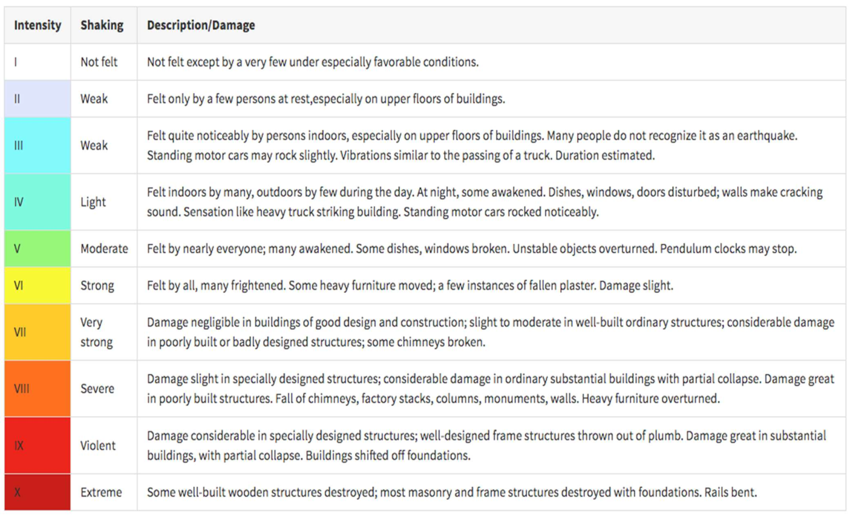
Aseismiczone is used to describean areawhere earthquakes tend to focus;for example, theNew MadridSeismic Zone in the Central United States.A seismic hazard zone describes anarea witha particularlevelofhazardduetoearthquakes.
Seismichazardisthehazardassociatedwithpotentialearthquakesinaparticulararea,andaseismic hazardmap showstherelativehazardsindifferentareas.The mapsare madeby considering what wecurrentlyknowabout:Pastfaultsandearthquakes.
Typesofstructureanddamageclassification:

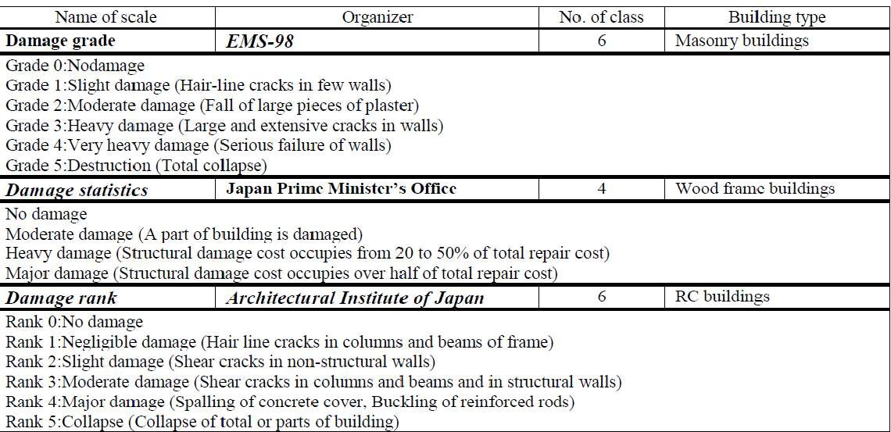
Earthquakeeffectinbuildings:

InertiaForcesin Structures
Thegenerationofinertiaforcesinastructureisoneoftheseismicinfluencesthatdetrimentallyaffectthe structure.Whenanearthquakecausesground shaking,thebaseof thebuildingwouldmovebuttheroof wouldbeatrest.However,sincethewallsandcolumnsareattachedtoit,theroofisdraggedwiththe base of the building.

Thetendencyoftheroofstructuretoremainatitsoriginalpositioniscalledinertia.Theinertiaforcescan cause shearing of the structure which can concentrate stresses on the weak walls or joints in the structure resulting in failure or perhaps total collapse. Finally, moremass means higher inertia force that is why lighterbuildingssustaintheearthquakeshakingbetter.

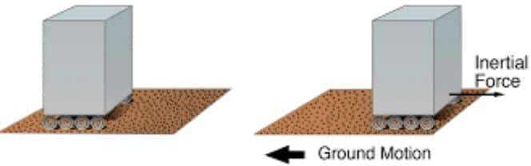
Fig.1:DirectionofInertiaForces
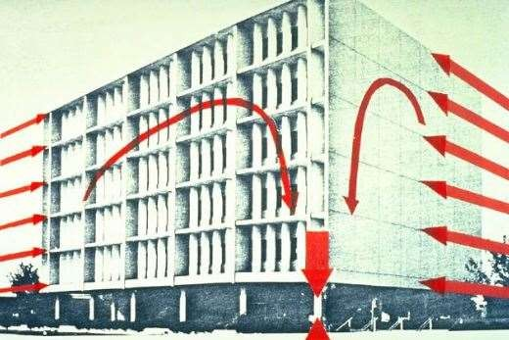
Fig.2: DevelopmentofGreatInertiaForcesintheSix StoreyofImperial CountyServices Building
    - EffectofDeformationsinStructures
Whenabuildingexperiencesearthquakeandgroundshakingoccurs,thebaseofthebuildingmoveswith the ground shaking. However, the roof movement would be different from that of the base of the structure. Thisdifferenceinthemovementcreatesinternalforcesincolumnswhichtendtoreturnthecolumntoits original position.

Theseinternalforcesaretermedstiffnessforces.Thestiffnessforceswouldbehigherasthesizeof columns gets higher. The stiffness force in a column is the column stiffness times the relative displacement between its ends.

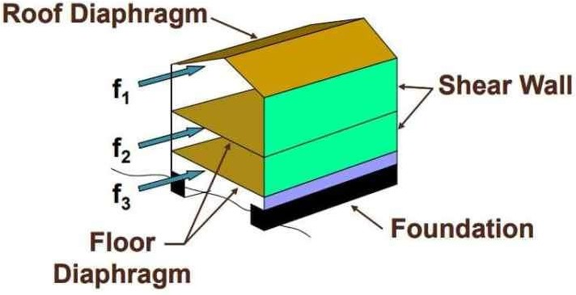
Fig.3:Lateral ForceResistingSystemin a House

HorizontalandVertical Shaking
EarthquakecausesshakingofthegroundinallthethreedirectionsX,YandZ,andthegroundshakes randomlybackandforthalongeachoftheseaxisdirections.Commonly,structuresaredesignedto withstand vertical loads, so the vertical shaking due to earthquakes (either adds or subtracts vertical loads)istackledthroughsafetyfactorsusedinthedesigntosupportverticalloads.

However,horizontalshakingalongXandYdirectionsiscriticalfortheperformanceofthestructuresince it generates inertia forces and lateral displacement and hence adequate load transfer path shall be provided topreventitsdetrimentalinfluencesonthestructure.

Properinertiaforcetransferpathcanbecreatedthroughadequatedesignoffloorslab,wallsorcolumns, and connections between these structural elements. It is worth mentioning that the walls and columns are criticalstructuralmembersintransferringtheinertialforces.Itisdemonstratedthat,masonrywallsand thinreinforce concrete columns would create weak points inthe inertia force transfer path.

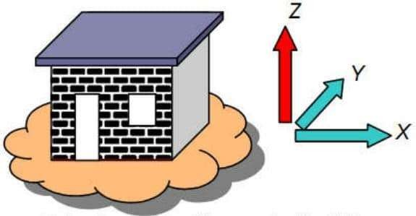
Fig.4:PrincipalDirectionsofaBuilding
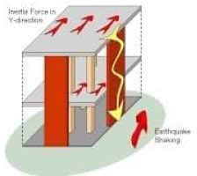
Fig.5: LoadPathforLateralInertiaForces
PrinciplesofConceptualDesignofEarthquakeResistant Structures
Thebasicprinciplesofconceptualdesignofearthquakeresistantstructuresincludes:

- Structuralsimplicity
- Uniformity,redundancyand symmetry
- Bi-directionalresistanceandstiffness
- Torsionalresistanceandstiffness
- Adequacyofdiaphragmsateach storeylevel
- Adequate foundations

StructuralSimplicityforEarthquakeResistantDesign
Structural simplicity pertains to the provision of obvious, simple and straightforward load path to transferseismicforcesfromdifferentpartofthestructuretoitsfoundation.Notonlydoestheloadpath needtobeclearandsimplebutalsoitscomponentsmusthavesufficientstiffness,ductilityandstrength.

This requirement should be examined by a structural designer who commonly designs the load path. Oneofthesignificantadvantagesofdirectloadpathisthatitwouldcontributeinthedecreaseofdoubts anduncertaintyintheevaluationofstrength,ductilityanddynamicbehavior.Incontrary,complicated load path is likely to cause stress concentration and toughen the estimation of strength, ductility and dynamicresponseofstructures.Itshouldbeboreinmindthat,acceptablestructureswithcomplexload path can be designed.
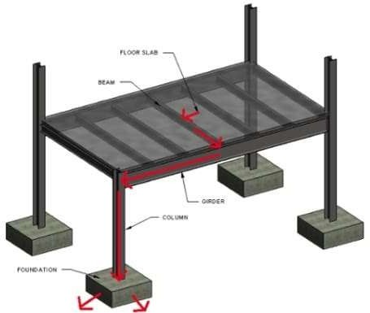

Fig.2:SimpleandStraightForwardLoadPathofStructure

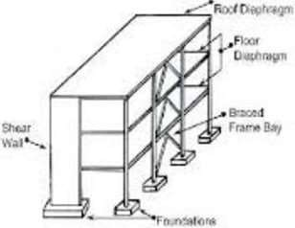
Fig.3:SeismicLoadPathComponent

StructuralUniformity,RedundancyandSymmetry
Itisproventhat,ifthestrength,stiffnessandmassofastructureisspreadsymmetricallyanduniformly in elevation and plan, it would show far better seismic performance in comparison with structure that does not have such properties. As far as strength and stiffness uniformity in elevation is concerned, it preventsthecreationofsoftstoreyinthestructure.Itshouldbeboreinmindthatnon-uniformitydoes not mean bad seismic performance, for instance, if such structure is isolated seismically then it would show satisfactory seismic performance.
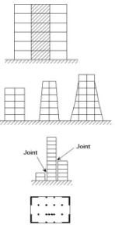

Fig.4:StructuralUniformityinElevationandPlan
Regardingbuildinguniformityinplan,itwouldputanendtothetorsionalresponseandhenceenhance dynamic performance of the structure. For the structures with irregular shape like T shape, it is recommendedtointroducejointstocreateregularshapesasillustratedinFigure7Figure8.Regarding Figure 5 and Figure 6, they explain regular plan shapes for building in seismic prone areas which are favoredplanshapeandirregularplanshapeswhichshouldbeavoidedtoinseismicareasunlessproper seismic joints are provided like in Figure 7 and Figure 8.
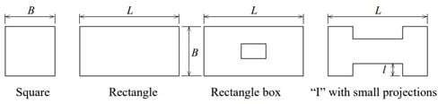

Fig.5:DesirableSymmetricalShapePlanforBuildinginSeismicProneAreas

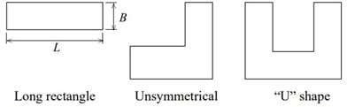
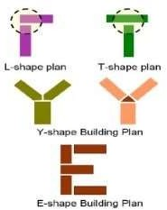
Fig.6:UndesiredShapePlanforStructureinSeismicRegions
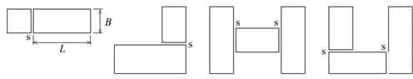
Fig.7: Provision of Seismic Joints for Decrease or Eliminate Torsional Motion due to Earthquakes

Fig.8: Provision of Seismic Joints to Decrease or Eliminate Torsional Motion due to Earthquakes
However, certain design problems at joints due to seismic movements may come-up and need to be tackled. Detailing of finishes, cladding, services across joints and impacts at the joint are examples of design problems which are likely to occur due to joint provision. A structure is said to be redundant if there are more than one load path in the building to transfer imposed seismic loads. So, if strength or stiffness of a specific load path is deteriorated, the load will be transferred though other load path. Therefore, redundancy would make the structure more reliable.

Bi-Directional Resistance and Stiffness of Structures duringEarthquakes
Normally,seismicloadsonbothhorizontalaxesofstructuresaresimilar,thatiswhytheprovisionof
similar resistant systems in both direction is recommended. So, the structural members need to be configured orthogonally guaranteeing similar resistance property in both major directions.

TorsionalResistanceandStiffnessof Structures

Lateral torsional deformation, which might stress various structural members in an un-uniform manner, could occur during earthquakes. The factor that leads to lateral torsional motion is the eccentricitybetweencenterofmassandstiffness.So,thisproblemneedtobetackledatthedesignstage.
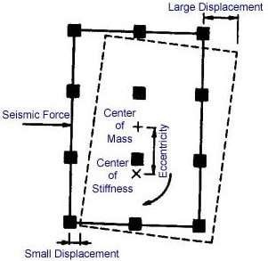

Fig.9: Center of Mass and Center of Stiffness in a Structure Subjected to Earthquakes and Suffered Displacements
Theeccentricitycouldbe decreasedatdesign stagebutitmaynotbecompletelyeliminatedbecauseof number of factors which are out of designer control. For example, non-uniform mass distribution and uneven stiffness deterioration of structural elements during earthquakes. Finally, this problem can be dealt with by arranging stiff and resistant members close to the periphery of the structure.

AdequacyofDiaphragmsatEachStoreyLevel
The influence of diaphragms on the seismic response of a structure is considerably crucial. Not only does it transfer seismic inertia load to the vertical structure members but also prevents considerable lateral movement of the such vertical elements. So, in order for the floors to perform their function properly, adequate in plan stiffness should be provided. In addition, to attention to the joint between floors and vertical structural members. These measures are specifically important if there is sizable opening diaphragm or in the case of considerably long in plan floor shapes. Finally, if the floor is constructed from precast concrete, it is necessary to provide sufficient bearing to avoid the loss of bearing during earthquakes.

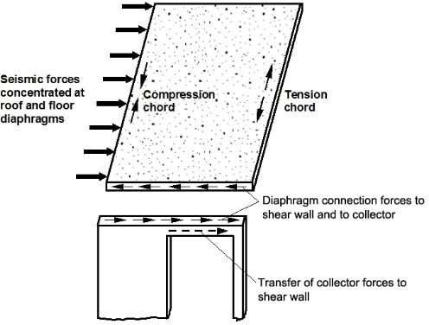

Fig.10:FloorandRoofDiaphragmAction

AdequateFoundationsforEarthquakeResistantStructures
Itis requiredto designandconstructfoundation andits connection to thesuperstructure, soas for the entire structure to experience uniform excitation during earthquakes. That is why it is advised to provide proper linkage between individual piles such as slabs or beams between piles. Added to that, whensuperstructureiscomposedofdiscretewallswithvariousstiffnessthenitisrecommendedtouse tough cellular foundation.

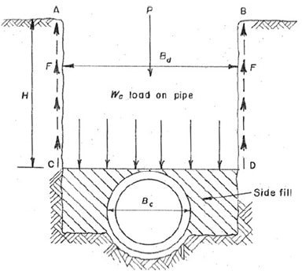

Fig.11:Connectionofindividualfootingwithtiebeamsorstructuralslabstoprevent possible relative movement during earthquakes
Wind / Cyclone hazardand vulnerability, wind speedand pressures, wind hazard and cyclone occurrence maps, storm surveys and cyclone resistant measures.
Wind/Cyclonehazardandvulnerability,windspeedandpressures,windhazardandcyclone occurrence maps, storm surveys and cyclone resistant measures.

Indiansub-continentistheworstaffectedregionoftheworld,havingacoastlineof7516kms.(5400 kmsalongthemainland,132kmsinLakshadweepand1900kmsinAndamanandNicobarIslands)is exposedtonearly10%oftheworld’sTropicalCyclones.Thereare13coastalstates/UTsencompassing 84coastaldistrictswhichareaffectedbySaffir-SimpsonHurricaneScaleSource:NWS,NOAA cyclones(Fig.1).FourStates(AndhraPradesh,Odisha,TamilNaduandWestBengal)andoneUT (Pondicherry)ontheEastCoastandOneState(Gujarat)ontheWestCoastaremorevulnerableto cyclonedisasters. 40% of thetotalpopulation lives within 100 km ofcoastline. Analysed data forthe period1980-2000showsthatonanaverage,annually370millionpeopleareexposedtocyclonesin India.

Atmosphericpressureand wind speed change across the diameter of ahurricane. To demonstrate,thediagrambelowshowsaroughprofileofwindspeed(blue)andsurface pressure (red) across a hurricane. Between 100 and 200 kilometers from theeye, the winds are fastenoughtoqualifyastropicalstormforce.Theatmosphericpressureherewillstillbe relativelyhighcomparedtothestorm'scenteratabout990 to1010millibars. However,the

pressuregraduallyfallsandthewindspeedrisesupongettingclosertotheeyewall.Itisonly overthelast50to100kilometersthatthelargechangesinpressureandwindspeedoccur.
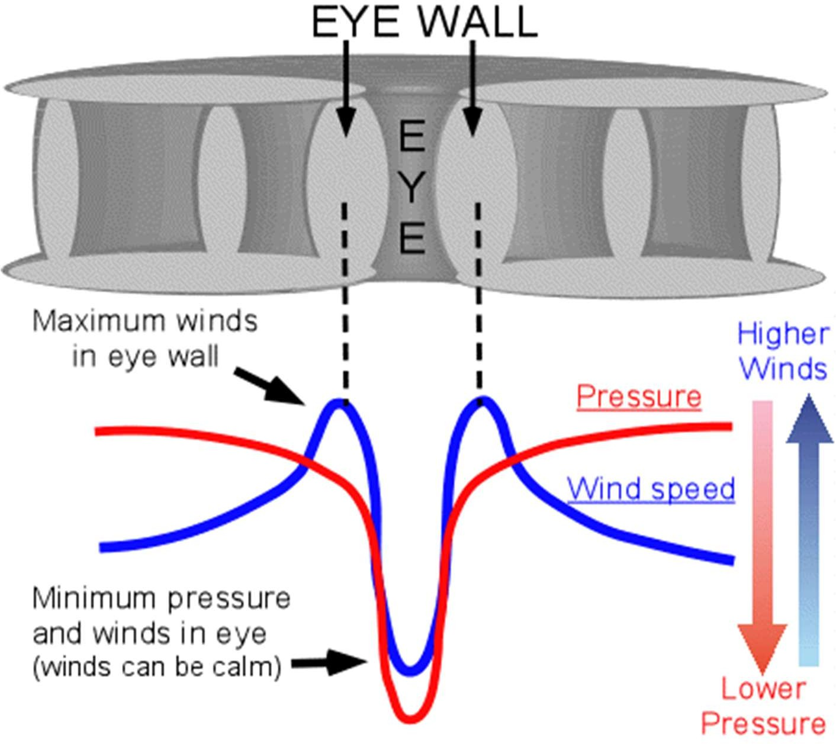
CycloneOccurrencemap

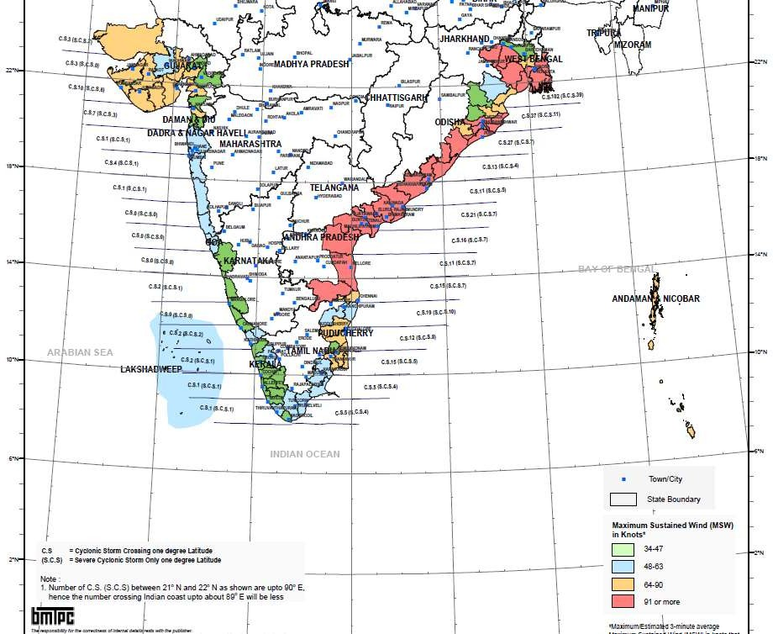

Stormsurvey:
Asurveyteam'smissionistogatherdatainordertoreconstructatornado'slifecycle,including where it occurred, when and where it initially touched down and lifted (path length), its width, and its magnitude.
Cycloneresistantmeasures:

- Choosethelocationcarefullytoavoidthefullforceofthewindorflood
- Usebuildinglayout witha simpleregular shape, to avoid concentration ofpressure.
- Buildtheroofatanangleof30°to45°topreventitbeingliftedoffbythewind.
- Avoidwideroofoverhangs;separatetheverandastructurefromthehouse.
- Makesurethefoundations,walls,androofstructureareallfirmlyfixedtogether.
- Reinforcethebracinginthestructure;strengthenwallsandjoints/junctionstoincreasestiffness.

- Makesuretheroofcoveringisfirmlyattachedtotheroofstructuretopreventitfromlifting.
- If doors & shutters cannot be shut, make sure there are opposing openings to reduce pressure build up.
- Usedoorsandshuttersthatcanbeclosed.
- Planttreesaroundthehouseaswindbreaksandreduceflowofwater,butnottooclose.

Floodhazardandvulnerability,FloodhazardandFloodproneareasofthe country, General protection of habitants and flood resistant construction
Fivefactorsthatdeterminefloodvulnerabilityincludethenatureofsoil,dwellingtype,employment status, education and rainfall. All these factors were ranked according to their importance by using a five- pointrankingscale,frommostimportanttosecond,third,fourthandleastimportant.Thenatureofthe soil was ranked asthemostimportantfactor, followedbydwellingtypes. Respondents’rankings were influencedbythecollapsedandcrackingoftheirhousesthatoccurredduringthefloodevent.
FloodproneareasinIndia:
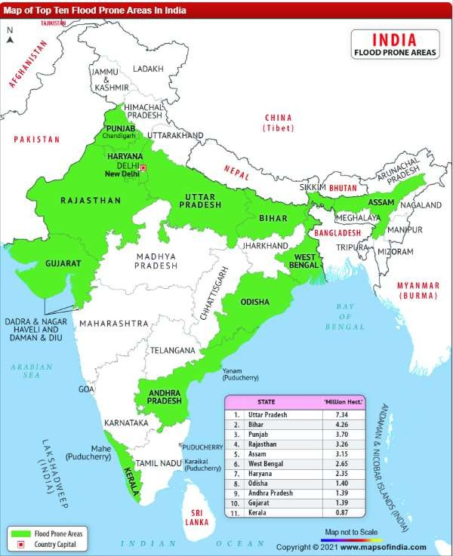
Thoughthenorth-Indianplainspronetofloodmore,the"Indiafloodproneareas"canbebroadlycategorized

inthreedivisions:

- Ganga Basin: The Ganga Basin gets flooded mostly in the northern part by its northern tributaries. ThebadlyaffectedstatesoftheGangabasinareWestBengal,BiharandUttarPradesh.Besidesthe Ganga, rivers like Sarada,Rapti, Gandak and Ghagra causes flood in easternpart of Uttar Pradesh. The Yamuna is famous for flooding Haryana and Delhi. Bihar experiences massive dangerous flood every year. River Burhi, Bagmati, Gandak, Kamla along with many small rivers contribute to that. In West Bengal, rivers like Mahananda, Bhagirathi, Damodar, Ajay etc. causes floods because of tidal effects and insufficient river channels.

- BrahmaputraandBarakBasins:TheriverbanksofBrahmaputraandBarakgetsfloodedduetothe Surplus water found in the Brahmaputra basin and the Barak basin. These rivers along with their tributaries flood the northeastern states like West Bengal, Assam and Sikkim. Jaldakha, Teesta and Torsa in northern West Bengal and rivers in Manipur often overflow their banks.
- CentralIndiaandDeccanRiversBasin:InOrissa,spillingoverofriverbanksbyMahanadi,Baitarni andBrahmanicauseshavoc.Thedeltaicareaformedbythesethreeriversisthicklypopulated.Even somesmallriversofKeralaandmudstreamfromthenearbyhillsaddontothedestruction.Southern andcentralIndiaobservesfloodscausedbyNarmada,Godavari,Tapi,KrishnaandMahanadidueto heavyrainfall.Cyclonicstormsin thedeltaic regionsof Godavari,MahanadiandKrishnaevenfloods the coastal regions of Andhra Pradesh, Orissa and Tamil Nadu occasionally.

Floodresistantconstruction:

ElevateAbovetheFloodLevel

Tostart,architectsshouldbuildthestructureabovethefloodleveltominimizedamageifaflooddoesoccur. One common way of elevating is by building the structure on columns or stilts. In other cases, the solid foundation can simply be raised higher.

BuildwithFloodResistantMaterial
Flood resistant materials are those which can last in contact with flood waters for at least 72 hours without significant damage. Floodwater can be both hydrostatic (standing water) andhydrodynamic (flowing water), and inmostcases willresultindisplacedfoundationwalls,collapsed structures,floating fuel tanks,scouring, andmore.‘Significantdamage’suggestsanydamagerequiringmoreworkthatcleaningorlow-costcosmetic repair, such as painting. To prevent these damages, flood resistant materials must be durable and resistant to excessive humidity. Examples include concrete, glazed brick, closed-cell and foam insulation, steel hardware, pressure-treated and marine-grade plywood, ceramic tile, water-resistant glue, polyester epoxy paint, and more.

RaiseorFloodproofHVACEquipmentandMechanical,Plumbing,and Electrical System Components
ocating service equipment above the flood protection level is generally the best way to protect it. Such equipment includes heating, ventilating, air conditioning, plumbing appliances, plumbing fixtures, duct systems, and electrical equipment including service panels, meters, switches, and outlets. If these componentsareinundatedinfloodwaterforevenashortperiodoftime,theycanbecomeseverelydamaged and will need to be replaced. Electrical equipmentin particular can potentiallycause fires if shortcircuited. It is best that these components are raised above the flood level, but if necessary, they may be designed to preventdamagefromflooding,whetherthroughwaterproofenclosures,barriers,protectivecoatings,orother techniques to protect vulnerable components. For precise requirements, architects should consultmunicipal codes.

AnchorFuelTanks
Unanchoredfueltanksareeasilymovedbyfloodwaters,whichcoulddrivethetankintowalls,damageother property, and cause contamination if the supply line tears free and fills the water with oil. Even buried tanks can be pushed to the surface due to buoyancy. Thus, it is imperative that fuel tanks are anchored, either by attachingthemtoconcreteslabsthatareheavyenoughtoresistfloodwaterforces,orbyrunningstrapsover them and attaching them to ground anchors.

InstallFoundationVentsoraSumpPump
An example of wet floodproofing is to install foundation vents, which allow flood water to flow through the home rather than pool around it.While this solutionmay seem like a counterintuitive one due to the damage it could do to the interior of the property, it actually provides an outlet for the flood water and relieves the damaging pressure that flood water puts on the windows and walls. If the interior – usually a subgrade basement – is prepared using flood damage resistant materials, hydrostatic openings, and protected key equipment, the damage can be limited, although post-flood clean-up will be necessary. Similarly, a sump pump is a type of equipment that pumps water out of basements where flooding happens regularly. Sump pumps with battery backup are highly recommended to allow them to continue functioning when the power goes out.

ConstructPermanentBarriers
Placingapermanentbarrieraroundthestructureinquestioncanpreventfloodwatersfrom reachingit.Such barriers should be constructed using a floodwall made of concrete or masonry, or by using a levee made of compacted layers of soil with an impervious core. While this solution may seem like the simplest or most obvious,bothfloodwallsandleveesrequireextensivemaintenance,andleveesneedasignificantamountof land and usable soil materials for construction.

InstallSewerBackflowValves
Sewerbackflowvalvespreventfloodedsewagesystemsfrombackingupintoahome.Incertainflood-prone areas,thisissueiscommon,andcancausedamagethatisbothdifficulttorepairandhazardoustooccupants’ health.Generally,gatevalvesarepreferredoverflapvalvesbecausetheyprovideabettersealagainstflood pressure.

GradetheLawnAwayfromtheHouse
Onefinalmethodthatarchitectscanusetomitigatedamagefromfloodingistogradethelawnawayfromthe house. If the lawn tilts toward the house, rainwater will pool around the home. Conversely, tilting it outward directs rainwater away. To this end, the lawn should use a heavy soil that contains clay content and sand, allowing the surface runoff to empty into a more appropriate place such as a street gutter.

Landslides,TsunamisandThunderstormhazardsandvulnerability, Landslide & Thunderstorm incidence maps, Measures against Tsunami Hazards
Landslide,whichistherapidslidingoflargemassofbedrocks.
LandslideVulnerabilityZones
VeryHighVulnerabilityZone:Highlyunstable, relatively young mountainous areas in the Himalayas and Andamanand Nicobar, highrainfallregionswith steep slopes in the WesternGhats and Nilgiris, the north-eastern regions, along with areas that experience frequent ground-shaking due to earthquakes, etc.and areas of intense human activities, particularly those related to construction of roads, dams, etc.are included in this zone.
HighVulnerabilityZone:Areasthathavealmostsimilarconditionstothoseincludedintheveryhigh vulnerabilityzonearealsoincludedinthiscategory.Theonlydifferencebetweenthesetwoisthe combination, intensityand frequencyof thecontrolling factors. All the Himalayan states and the states fromthe north-easternregions except the plains of Assam are included in the high vulnerabilityzones. ModeratetoLowVulnerabilityZone:AreasthatreceivelessprecipitationsuchasTransHimalayan

areas ofLadakhand Spiti (Himachal Pradesh), undulated yet stable relief and low precipitation areasin theAravali,rainshadowareasintheWesternandEasternGhatsandDeccanplateaualsoexperience occasionallandslides.LandslidesduetominingsubsidencearemostcommoninstateslikeJharkhand, Odisha, Chhattisgarh, MadhyaPradesh, Maharashtra, Andhra Pradesh, Karnataka, TamilNadu, Goa and Kerala.
Earthquakes and volcanic eruptions that cause the sea-floor to move abruptly resulting in suddendisplacementofoceanwaterintheformofhighverticalwavesarecalledtsunamis (harbour waves) or seismic sea waves. Normally, the seismic waves cause only one instantaneous vertical wave; but, after the initial disturbance, a series of afterwaves are createdinthewaterthatoscillatebetweenhighcrestand lowtrough inordertorestorethe water level.
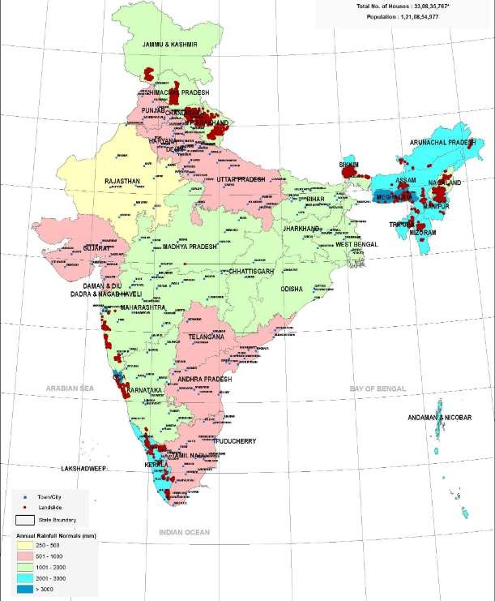

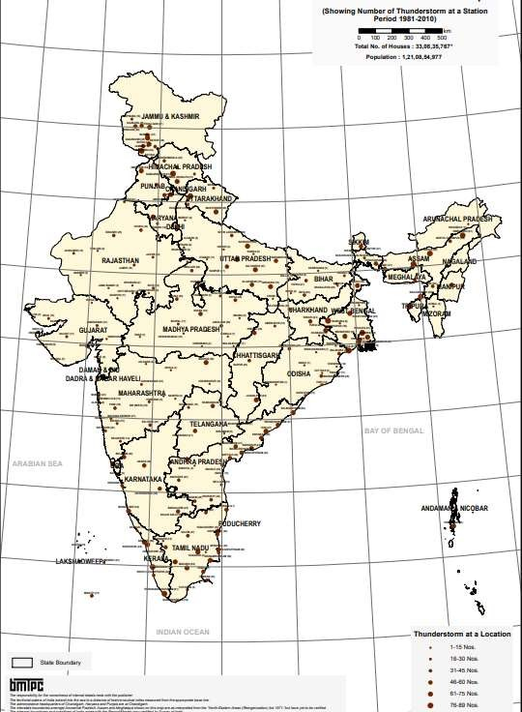
MeasuresforTsunamihazards:
Communitiesthatunderstandtheirtsunamiriskarebetterpreparedtoprotectthepublicinthe event of a tsunami. Protective measures include:
Planningandpracticingforresponsetotsunamis; Warning the public;
Establishing,marking,andpublicizingevacuationroutes;and
Educatingthepublic(residentsandvisitors)abouttsunamisandtsunamisafetybeforea tsunami strikes.

Other ways to prepare for and mitigate the potential impacts of a tsunami emphasize thoughtfulland-useplanningandbuildingdesignintsunamihazardzonesandincludethe following:
Improvingevacuationroutes
Buildingtsunamievacuationstructures
Limitingnewdevelopmentintsunamihazardzones
Designing,siting,andbuildingstructurestominimizetsunamidamage Adopting building codes that address tsunamis
Protectingandstrengtheningexistingstructuresandinfrastructurethatifdamagedwould negatively affect response and recovery
Movingimportantcommunityassetsandvulnerablepopulationsoutoftsunamihazardzones Planning for post-tsunami recovery

HousingvulnerabilityrisktablesandusageofvulnerabilityatlasofIndia, Inclusion of vulnerability atlas in Tender documents.
Vulnerability Atlas of India, brought out by BMTPC, is collation of the existing hazard scenario for the entire country and presents the digitized State/UT-wise Hazard Maps with respect to Earthquakes, Winds & Floods for district-wise identification of vulnerable areas. The latest edition contains additional digitized maps for Thunderstorms, Cyclones and Landslides.

The Atlas also presents the district-wise Housing Vulnerability Risk Tables based on wall types and roof types as per 2011 Census Housing data. The Atlas is a useful tool not only for public but also for urban managers, State & National Authorities dealing with disaster mitigation and management.

TheVulnerabilityAtlascreatedbyBuildingMaterialsandtechnologyPromotionCouncil(BMTPC) was updated in 2019. It was released by the Hon. Prime Minister on 2nd March, 2019 at New Delhi. This atlas gives the latest information regarding vulnerability of housing stock to earthquakes,cyclones;floods,landslidesandthunderstorms.TheStateGovernmentshavethe basic mandate for management of disasters and the executive actions are taken at thedistrict levels with the District Collector playing the pivotal role. This Atlas provides some ready information, though at macro-level, for use of the authorities involved in the tasks of disaster mitigation,preparedness and preventiveactions. A glanceat thehazard mapswill bring tothe noticeofthedistrictauthorities,thelocationandpercentareasofthedistrictsmostsusceptible to hazard occurrence, the probable maximum hazard intensities, the type of housing and its vulnerabilityandrisktothehazards.Knowingtheextentoftheproblemoffuturedisasters,the district authorities can formulate development plans for (a) preventive actions like hazard resistantconstruction,retrofittingandupgrading/retrofittingofexistingbuildings,(b)mitigating the intensity and extent of the disasters, (c) early warning system installation and drills for its use, (d) instituting a hierarchical structure for preparedness down to the village level, (e) training of manpower in various tasks in the emergency (f) implementation of land zoning regulationsinfloodplainsandcoastalareas,andbuildingbylawswithdisasterresistantfeatures in various towns and cities, etc. (g) supporting land use zoning and urban planning (h) integration of DRR with development and (i) supporting in locating industries and other development projects.Similarly,variousMinistriescanusethisatlastomakeallthestructures under their jurisdiction disaster resilient, infrastructure constructed and maintained by them hazard resistant and people/economic activities less susceptible. It is urged by the Hon. Prime Ministerthatalltheconstructionandbuildingrelatedtendersmayutilisethisvulnerabilityatlas as a guiding factor, to arrive at the cost which will include Disaster Resilience.

